TT Motorsports 95 - 04 Toyota Tacoma / 96-02 4runner Race Long Travel Kit

Installation Instructions: Do not attempt installation unless a professional AND have read through and fully understand these instructions. Please email me if you have any questions BEFORE installation so I can answer them for you. TTMotorsports805@gmail.com
Step 1: Put the Truck on Jack stands and level it side to side. Then remove all the factory front suspension and steering from the Rack n Pinion , but leave rack installed unless you must remove to get LCA bolts out, if so then reinstall after LCA is removed.
Step 2: Confirm you have all the suspension components.
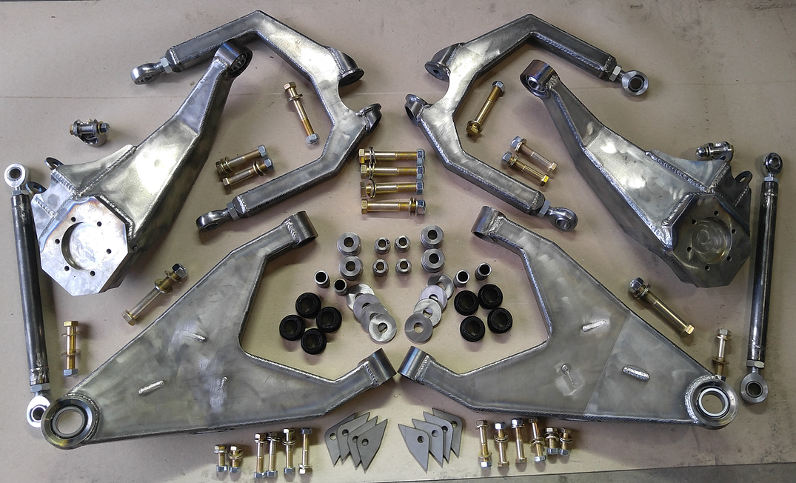
Kit will include
2 Upper Control Arms
2 Lower Control Arms
2 Upright Spindles
2 Tie rod Assembly’s complete with 7/8” Outer heim/jam nut and 3/4” Inner heim/jam nut combo
2 Heim Steering Inner Clevis to attach to rack with bolts AND mis alignment spacers for inner ¾” Inner Heim
8 Urethane Lower Control Arm Bushing
8 Lower Control Arm Cam Eliminator Washers
4 Lower Control Arm Inner Pivot inner sleeve’s for ¾” Bolts
6 Pairs of 14-10 Misalignment Spacers
2 Pairs of 16-10 Misalignment Spacers
2 Pairs of 1.5”- ¾” Misalignment Spacers
2 Custom Length Brake Lines for Tacoma Pickups (If purchased complete hub setup, otherwise won’t be included
Hardware
3/4"-16 | Qty
(4) 4.5" | 4
(2) 5" | 2
Washers | 12
Nuts | 6
5/8"-18
(2) 4.5" | 2
(6) 3.5" | 6
Washers | 16
Nuts | 8
1/2"-20
8) 2 3/4" | 8
Washers | 16
Nuts | 8
3/8" – 24 (IF Purchased complete Hub Setup)
(16) 1.25" | 16
Washers | 16

If missing ANY COMPONENT Contact me for replacement BEFORE starting installation.

Step 3: Once you confirmed that everything above is included you are ready to install which means it’s time to transfor your Tacoma into an offroad prerunner/race truck.

Step 4: Cut the stock coil buckets and UCA mounts. The truck I used for these instructions had a long travel kit and 4x4 before so it has double shear UCA mounts, which stock trucks don’t have but cutting the stock towers is the same.
First thing to cut is the plate above frame rail marked with white X in the photo below. Cut that out so you can access the rear of the tower with motor and such still in place.

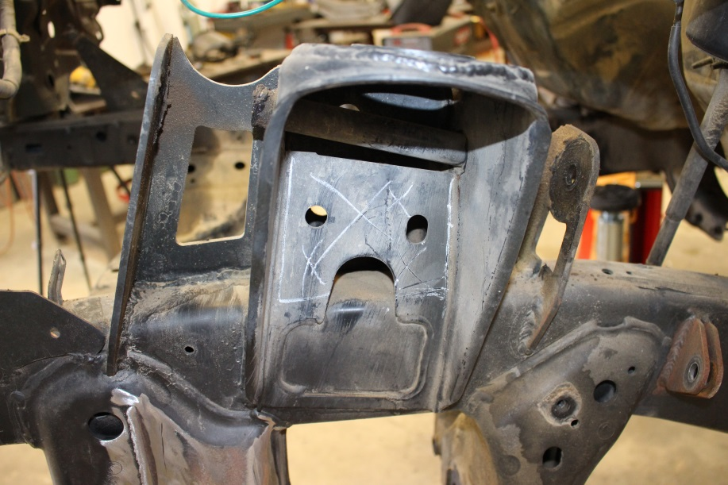
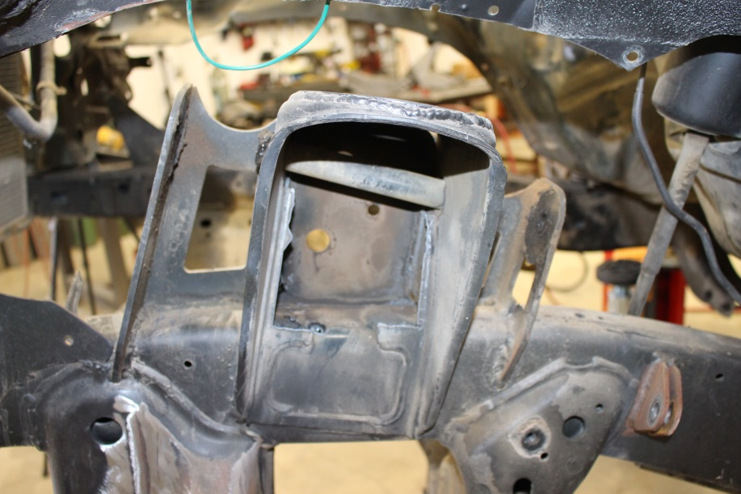
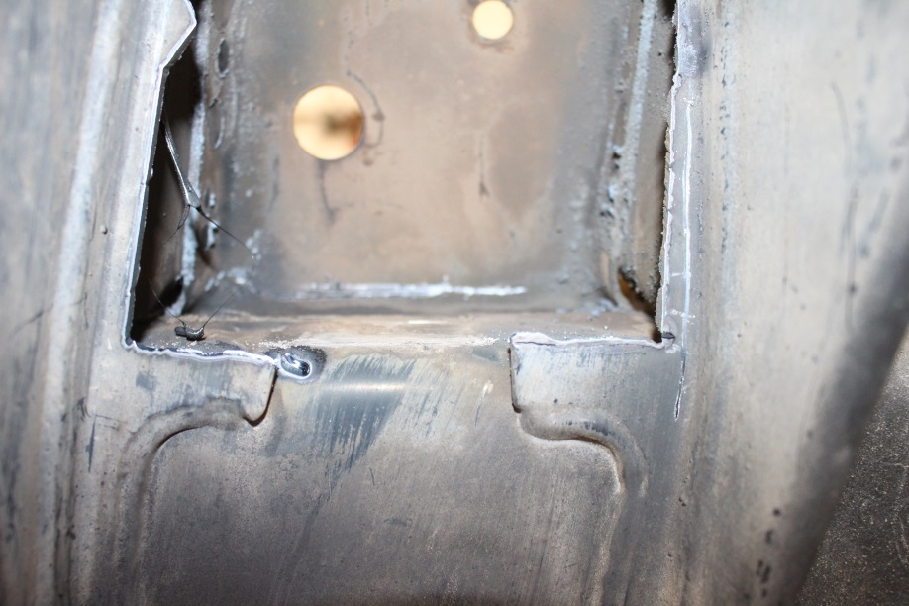

Step 5: Once that piece is removed you can see the inner plate of the tower much easier. I then used my plasma cutter to cut. Cut just above flush with top of frame rail to not interfere with engine mounts and just above the weld all the way around the tower so it can be removed. The welded piece on the frame I’ll show how to remove cleanly in next step.

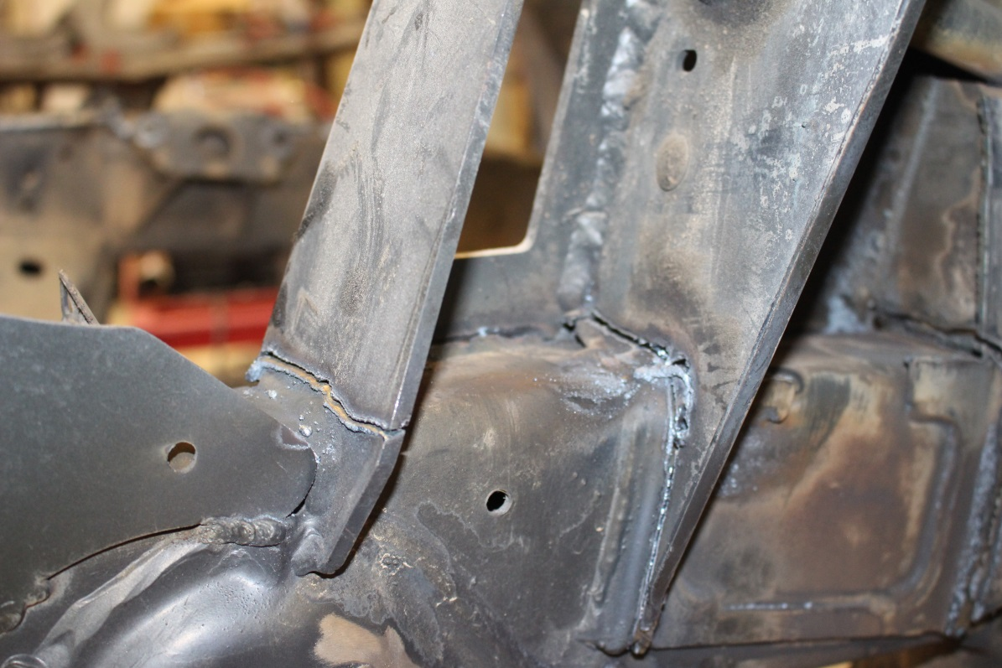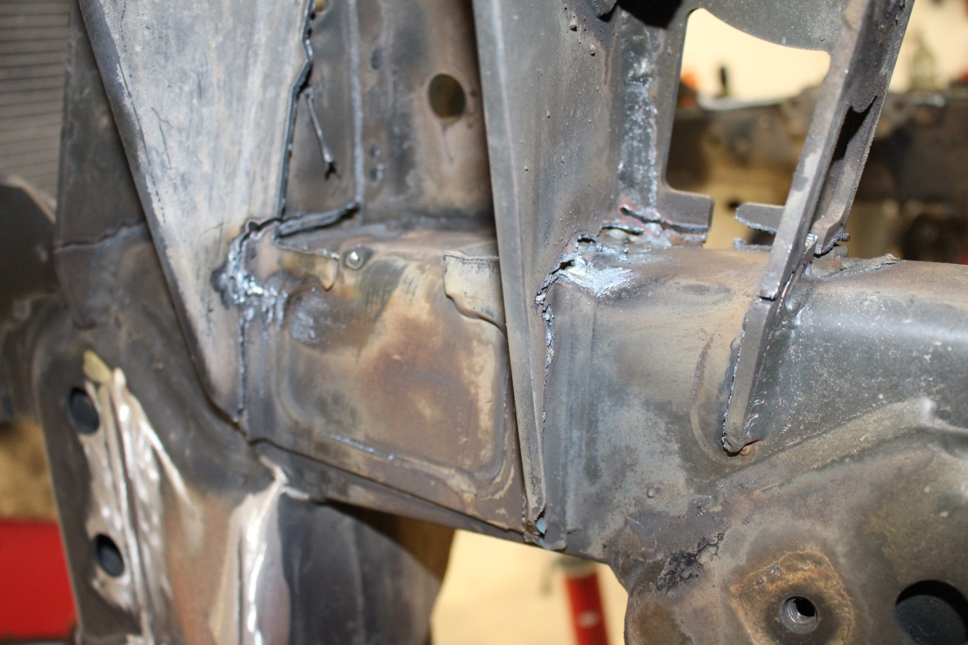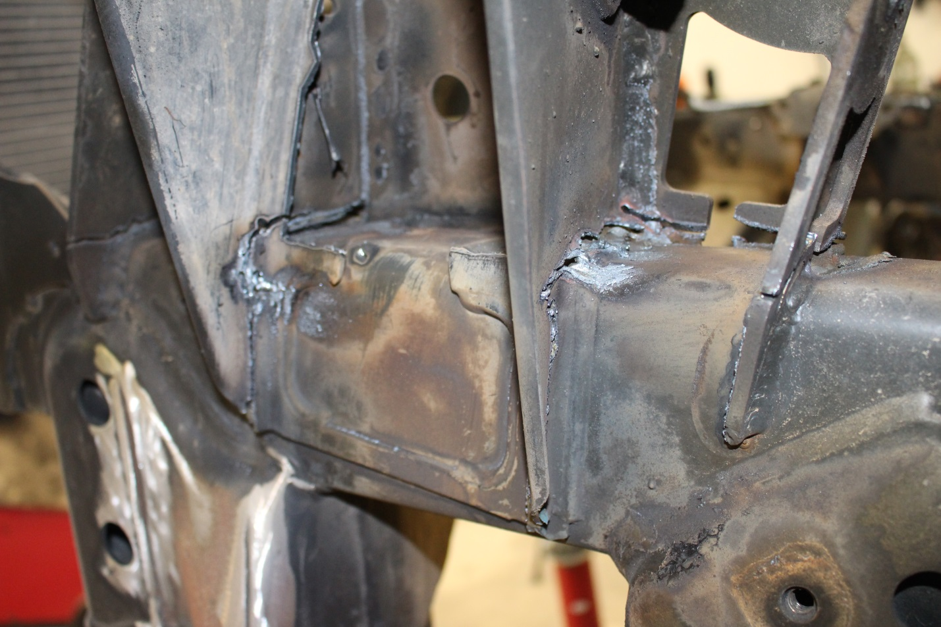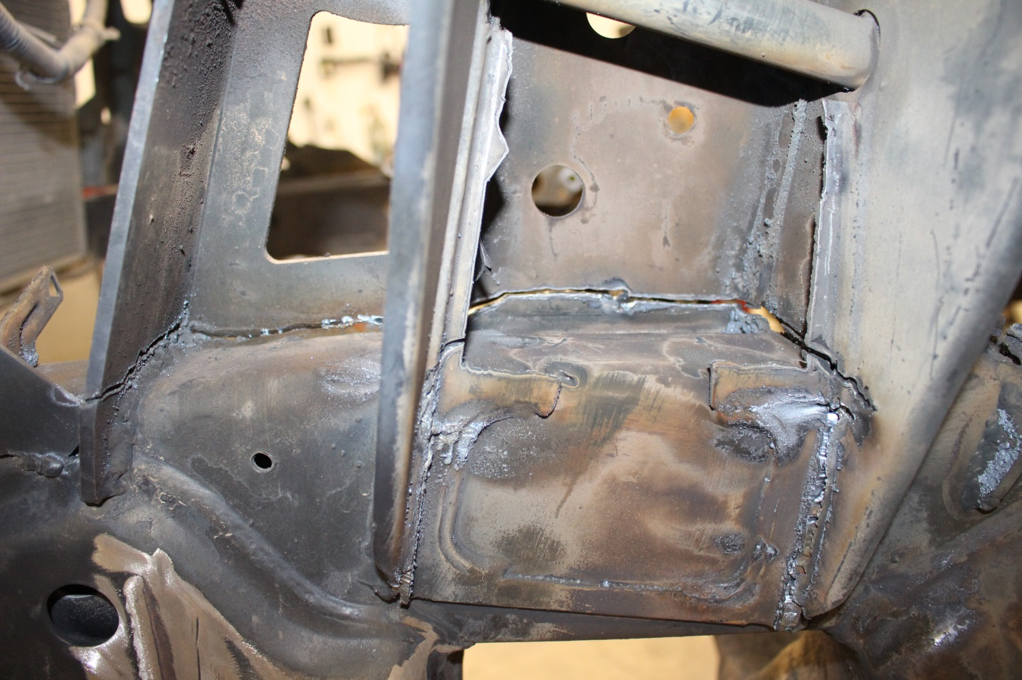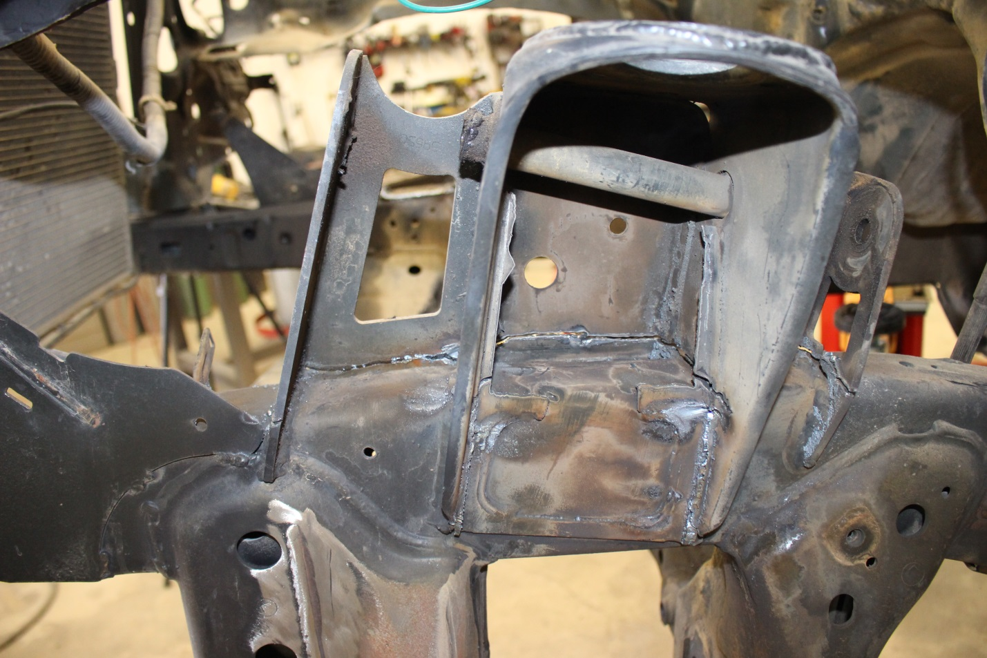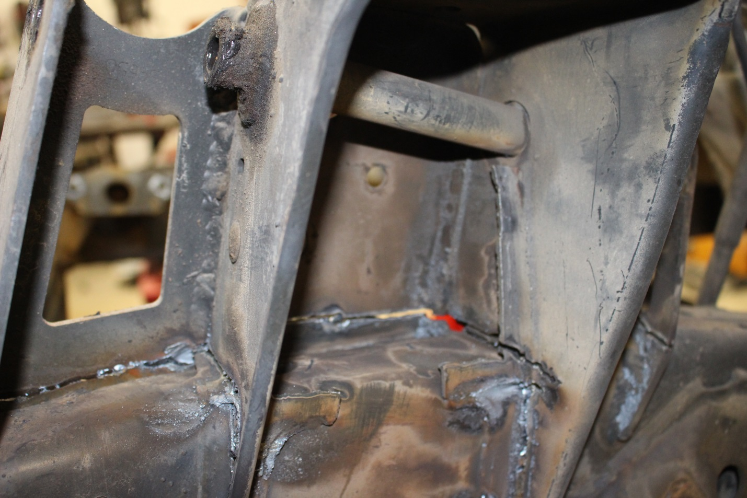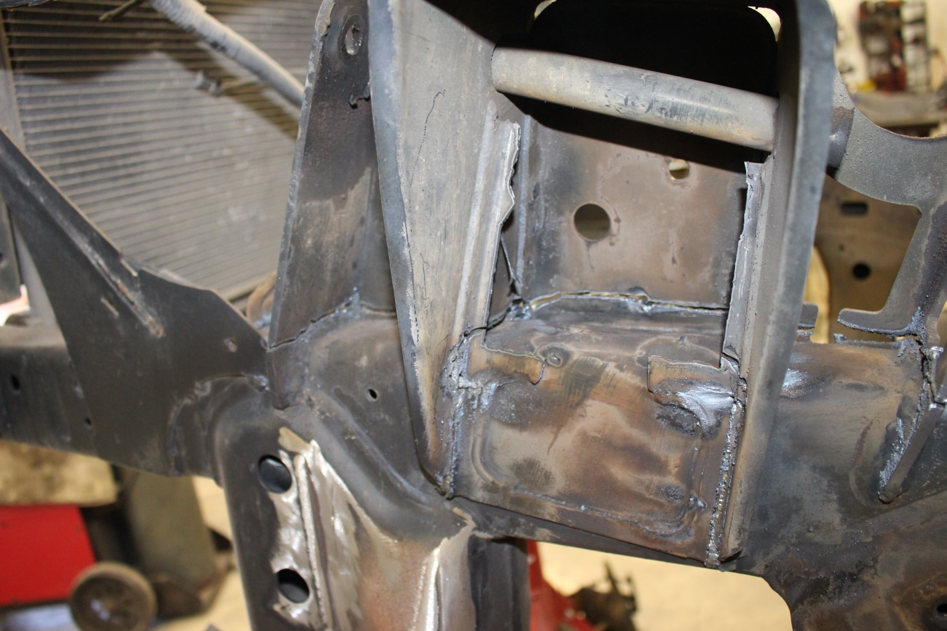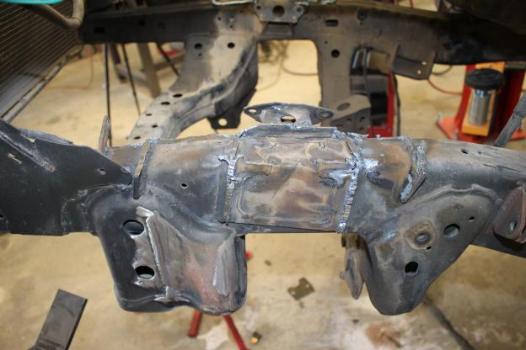

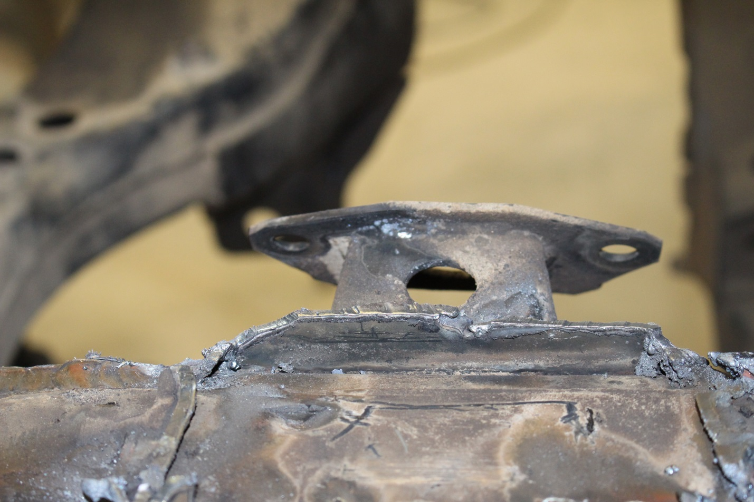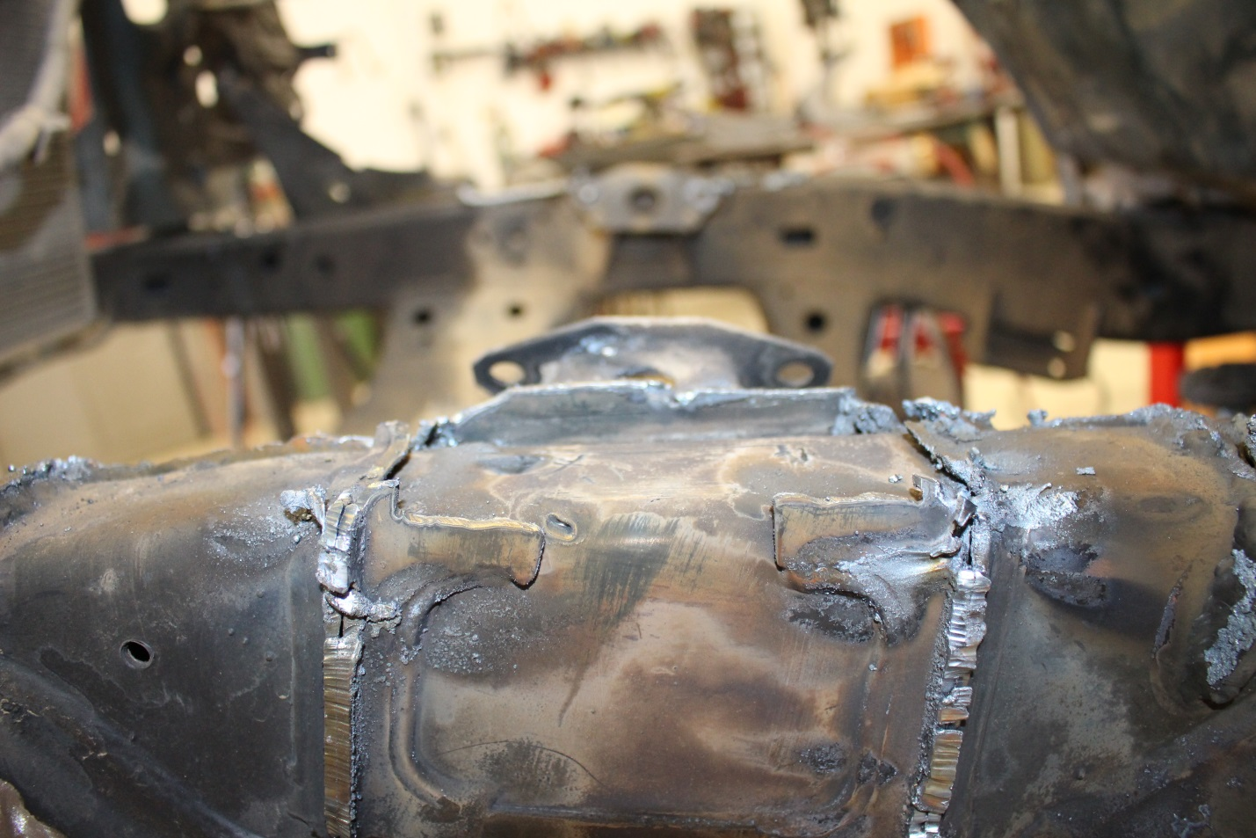

Step 6: Now that the tower is removed from the truck it’s time to clean up the frame to prepare for welding on the new UCA mounts and Shock Mounts. To do this I score the welds with a cutoff wheel Then I proceed to use my air hammer to get them off the frame. There will still be a small bit of weld on the frame but a grinder cleans that up easily and this way you don’t have any holes cut in the frame rails from removal that you would have to weld up.

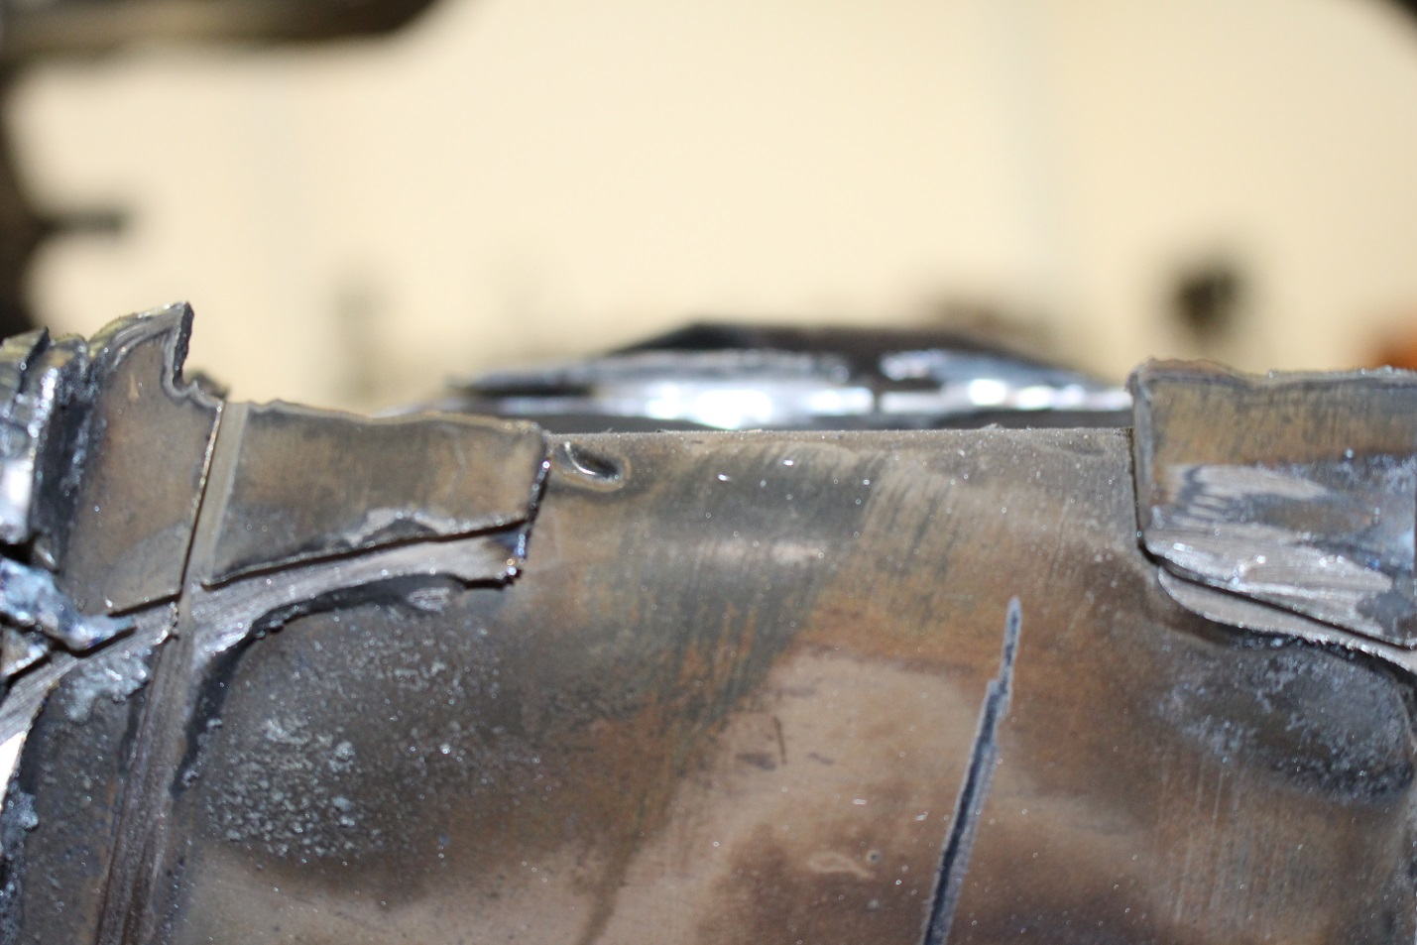
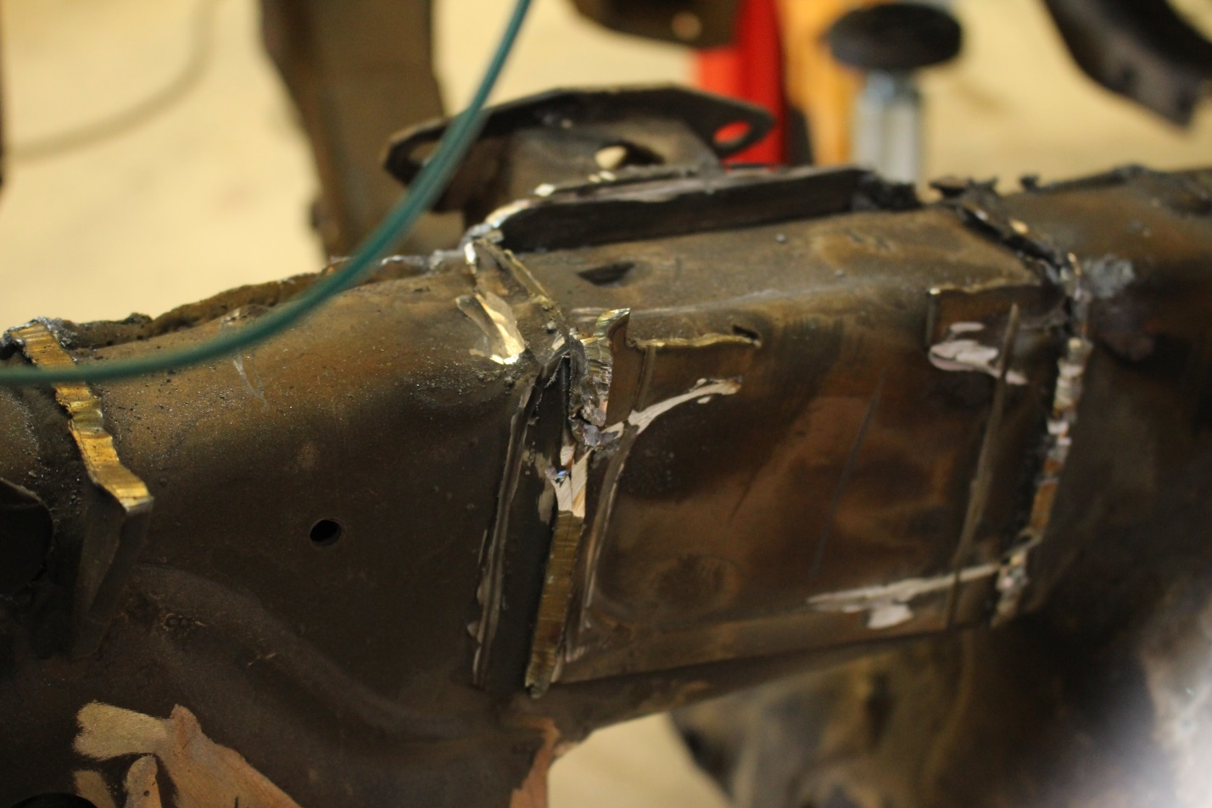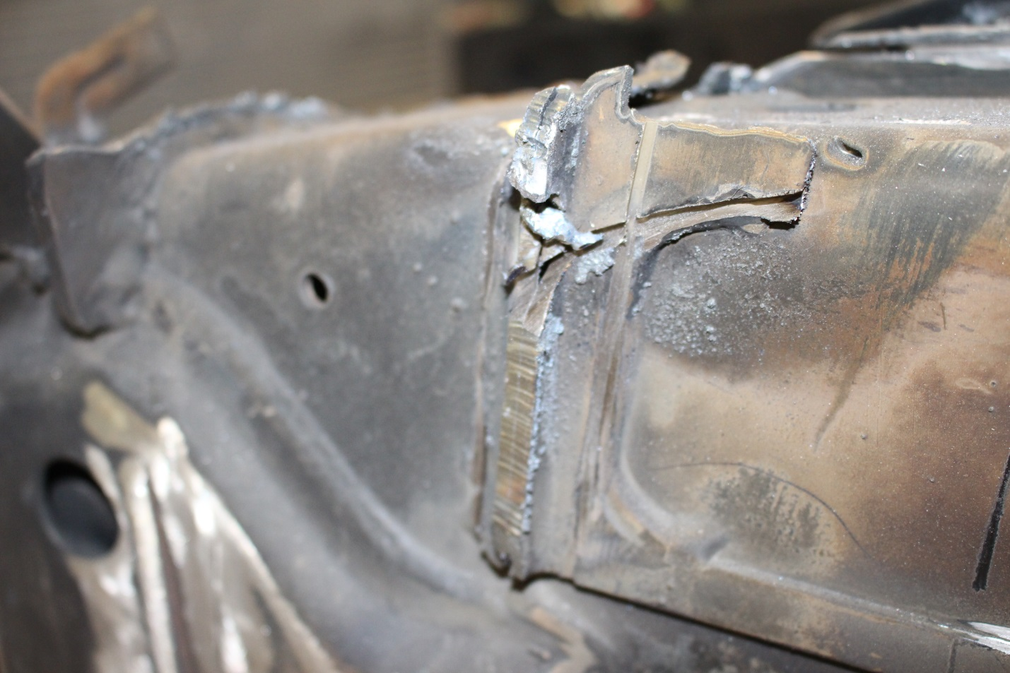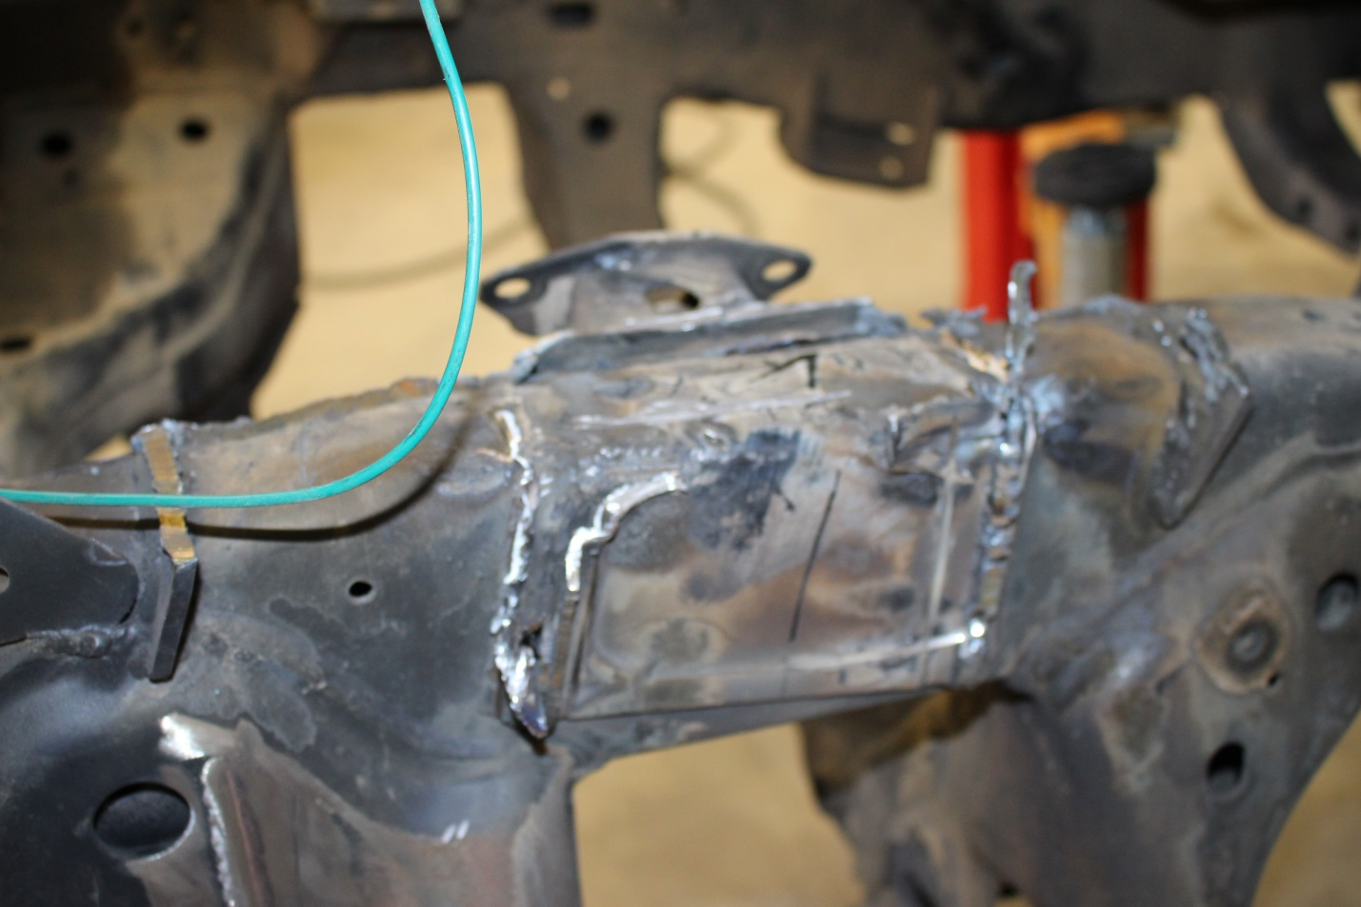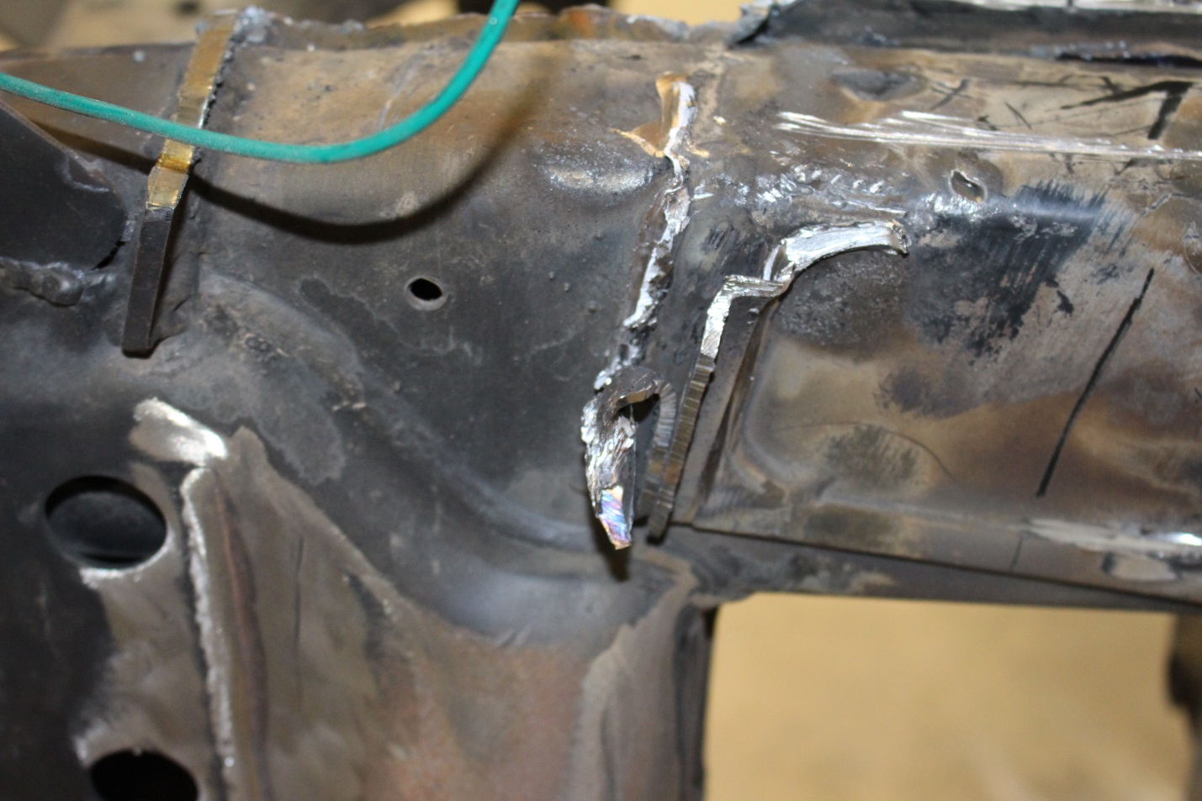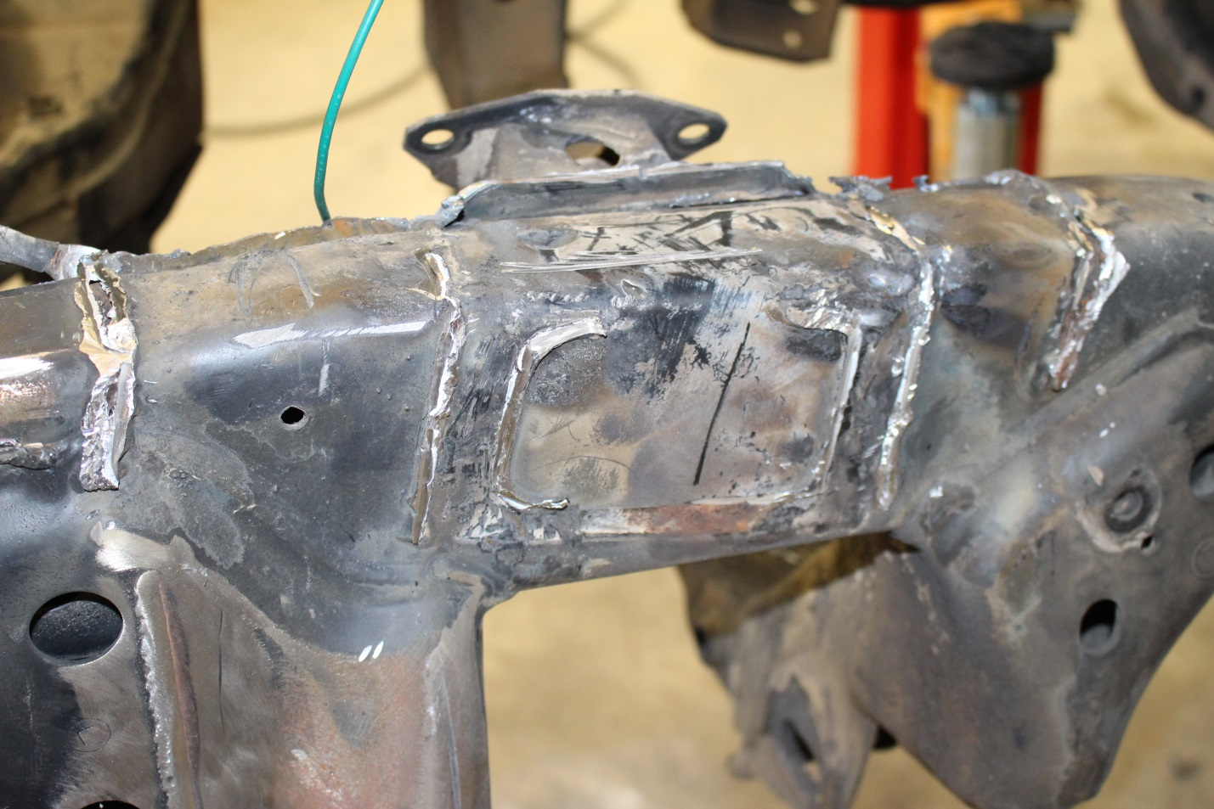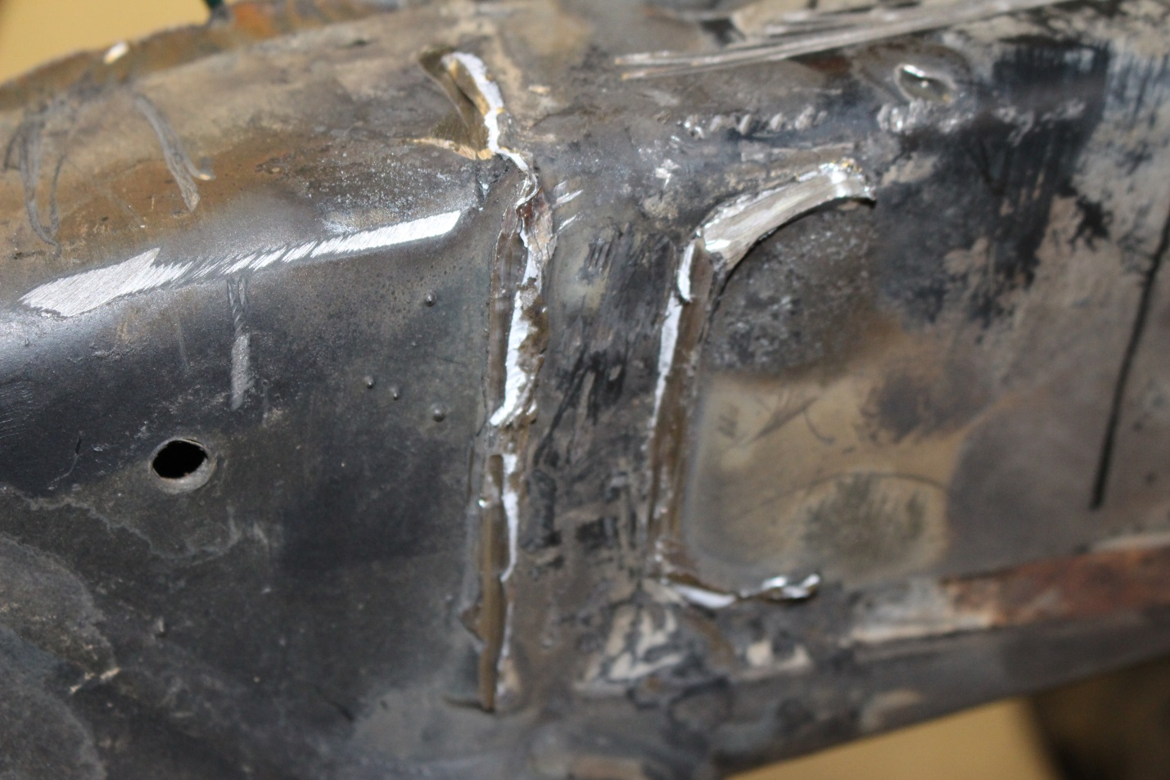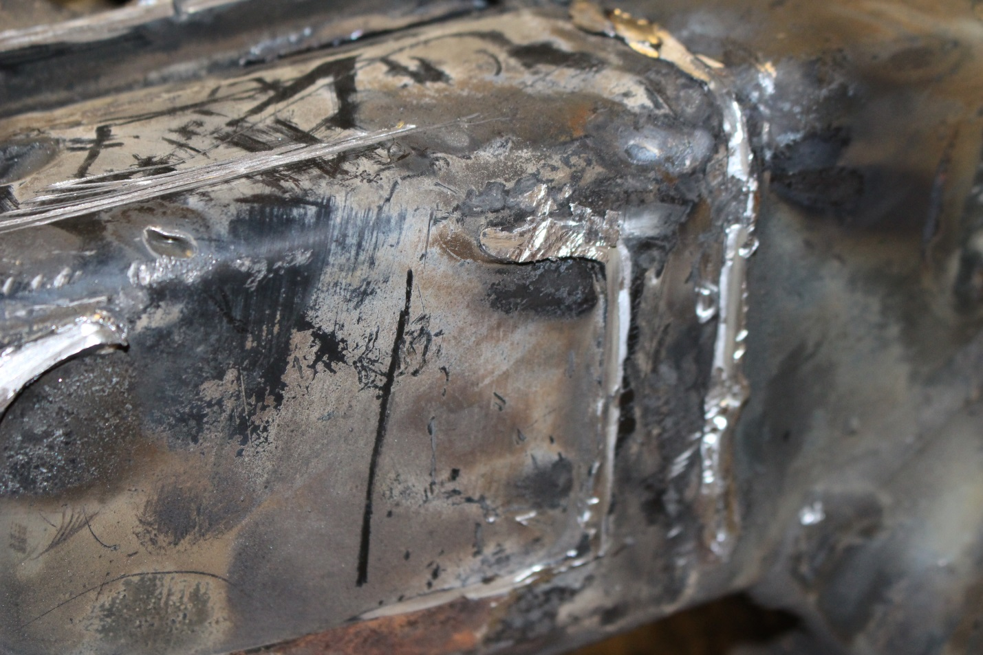

Step 7: Now that the last of the tower pieces are removed it’s time to grind the frame smooth. I use a flap disc to really put a nice smooth finish on the frame. I also clean the entire top of the frame AND the outside as much as I can so there is no paint to interfere with welding in the future.

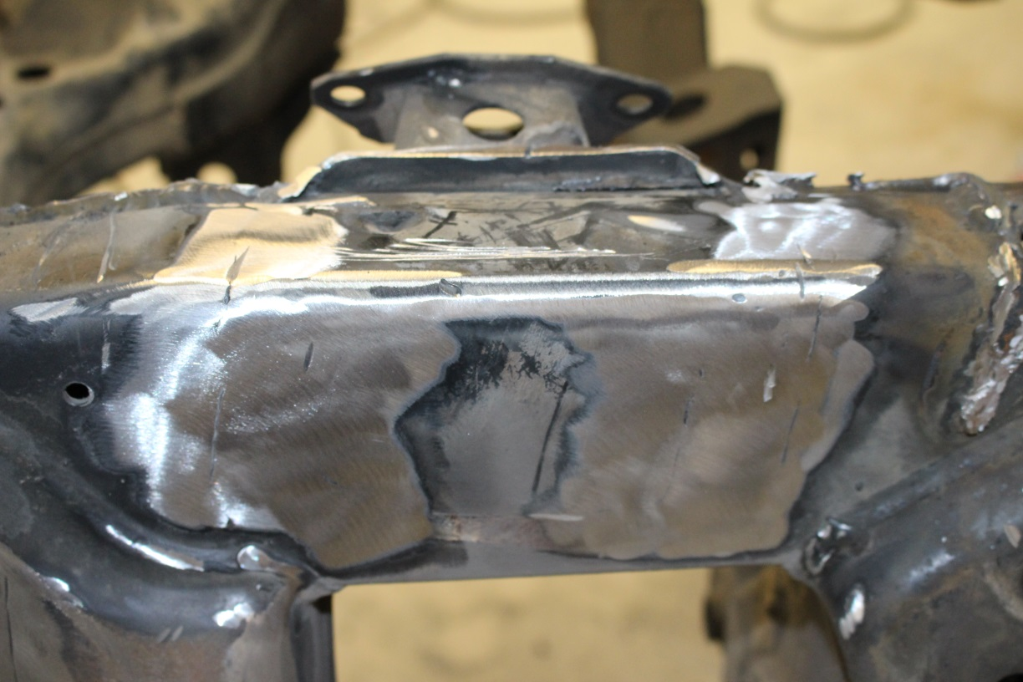
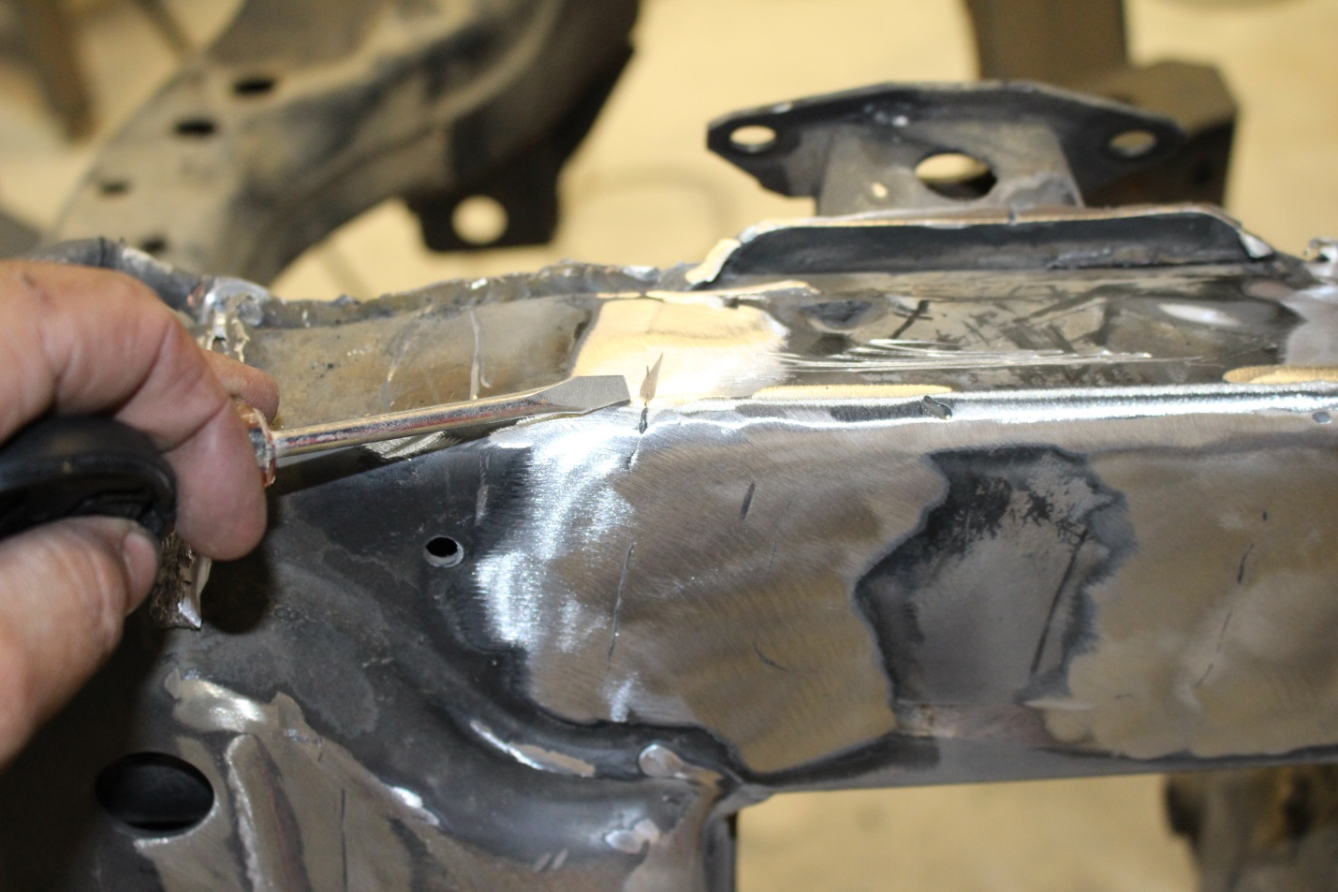
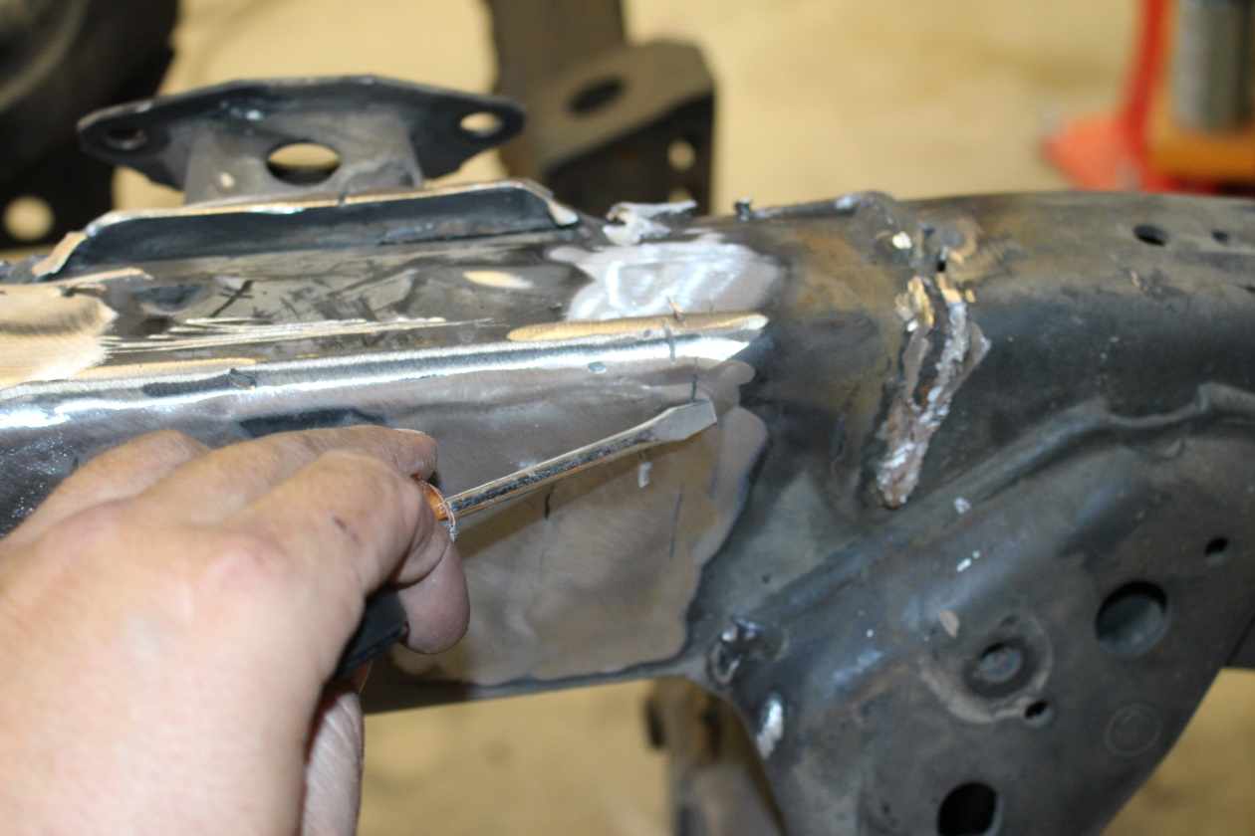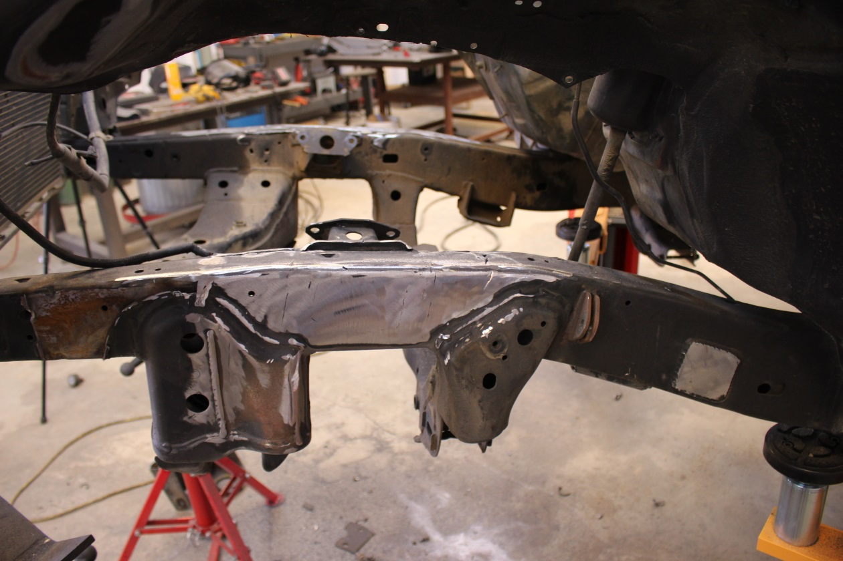

Step 8: Now that the truck is ready for the kit to be installed it’s time to focus on getting the towers tacked together, if you chose to purchase them, if Not skip ahead.

The Coilover goes towards the front of the vehicle and the bypass is behind it towards the rear of the vehicle. There is 2 flat tabs per tower. The tab that goes down the outside of the frame is for the bypass shock tab. The tower below is for the Passenger side of the truck since the bypass goes in back of the coilover and the tab that goes down side

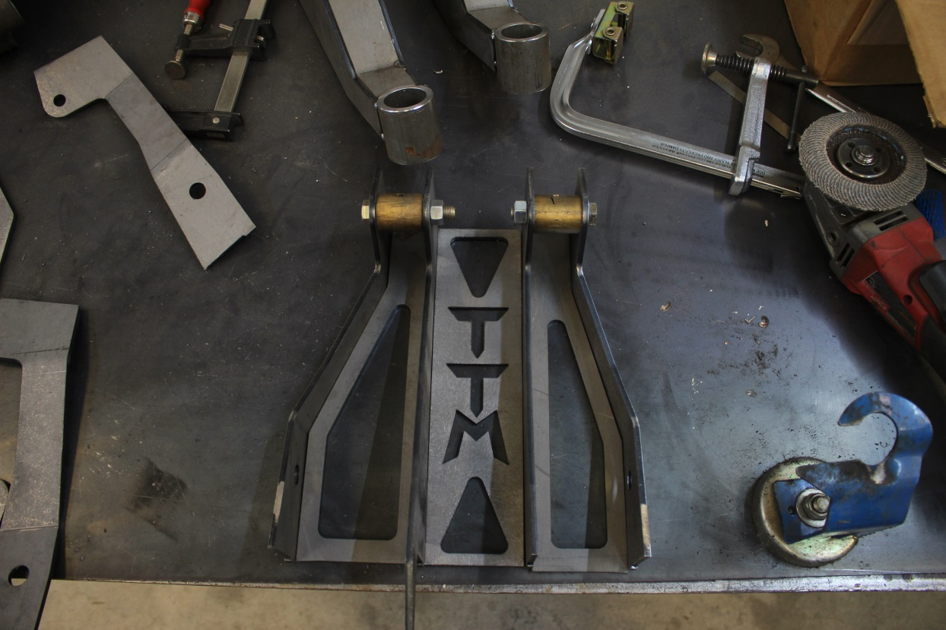
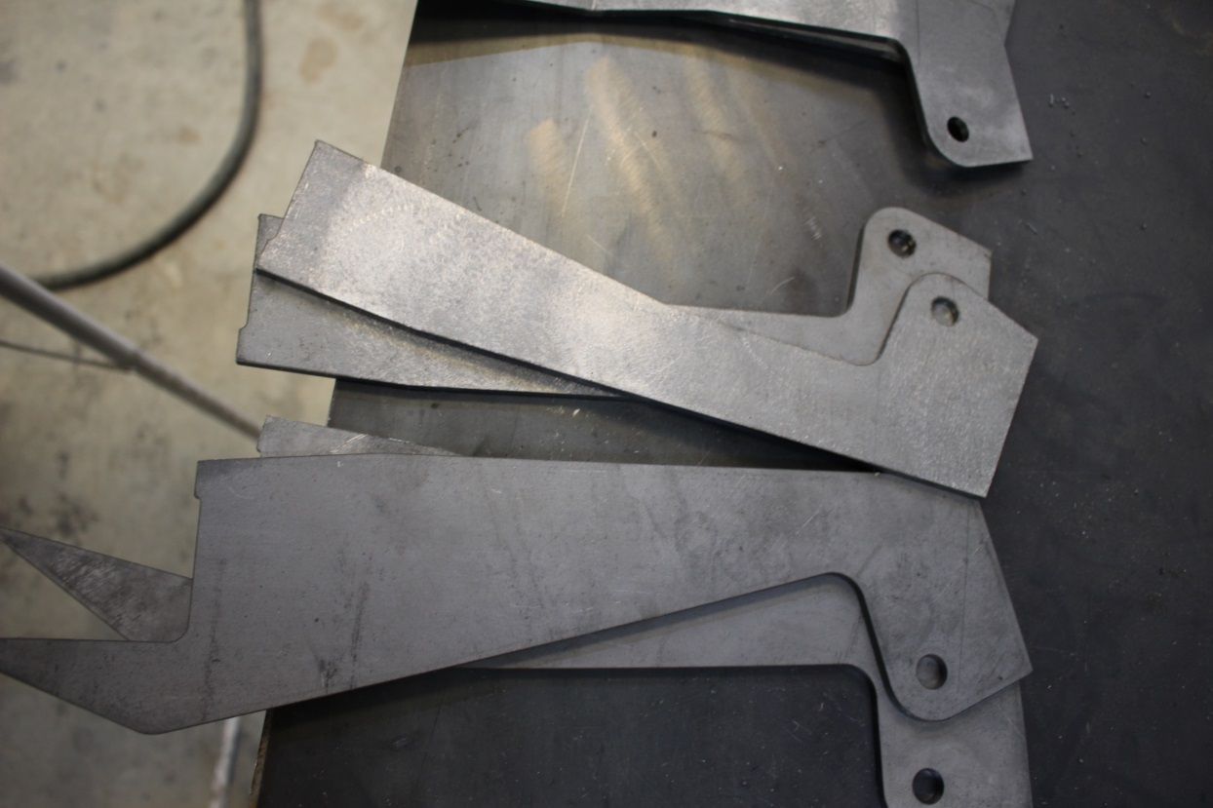

Step 9: Get all the components for the shock towers. You will have Left and Right Side towers. So some pieces will be the same but bent opposite

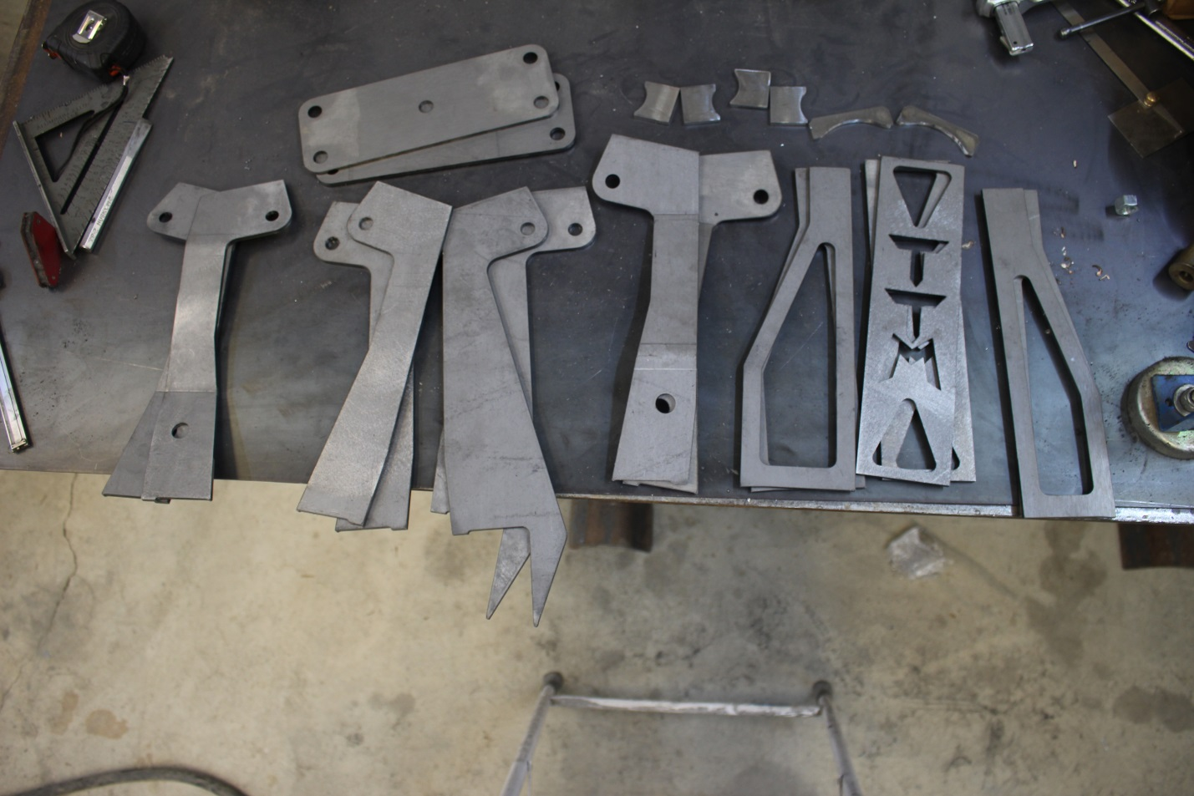
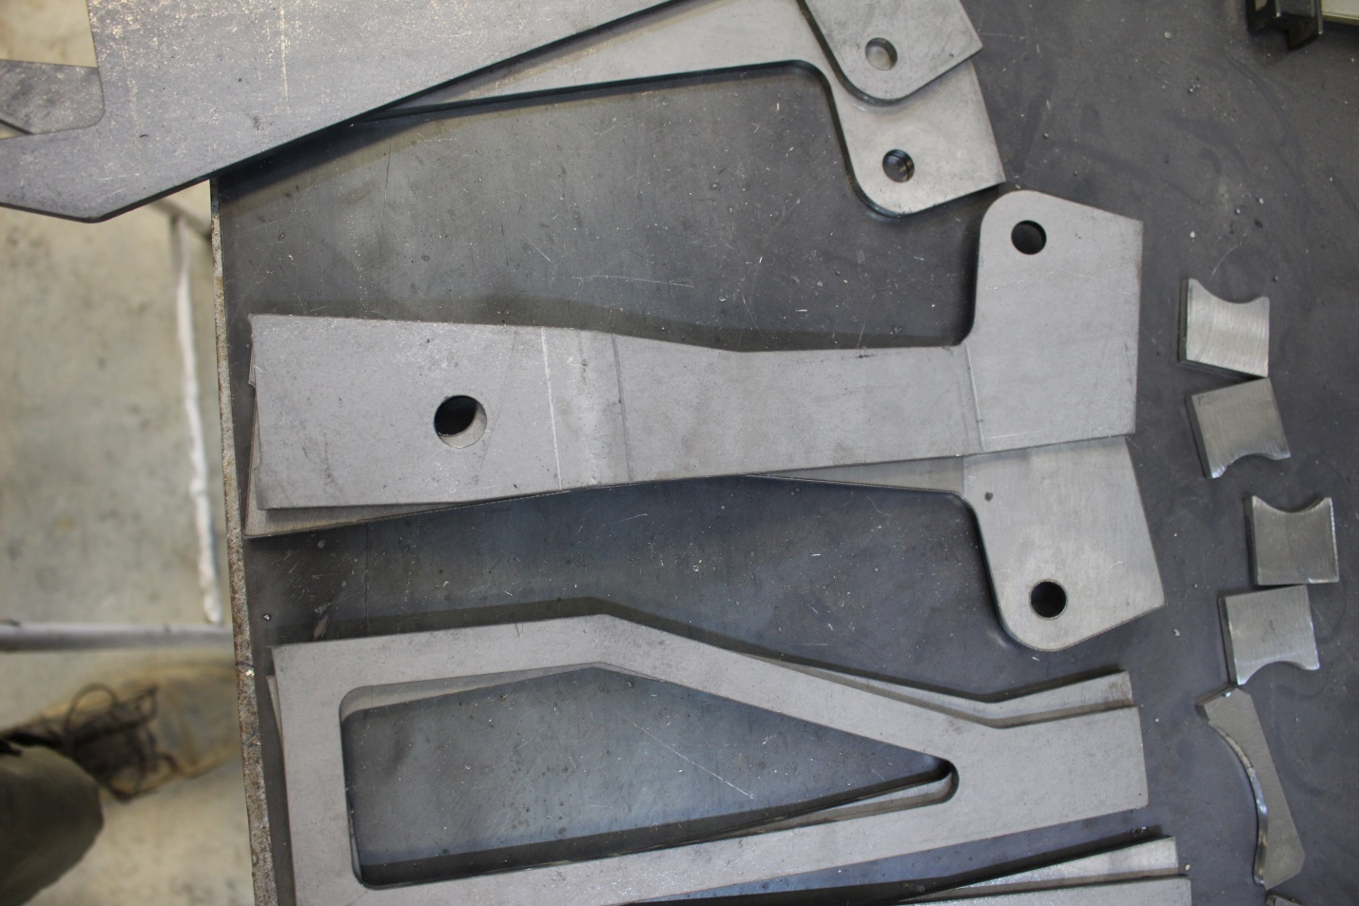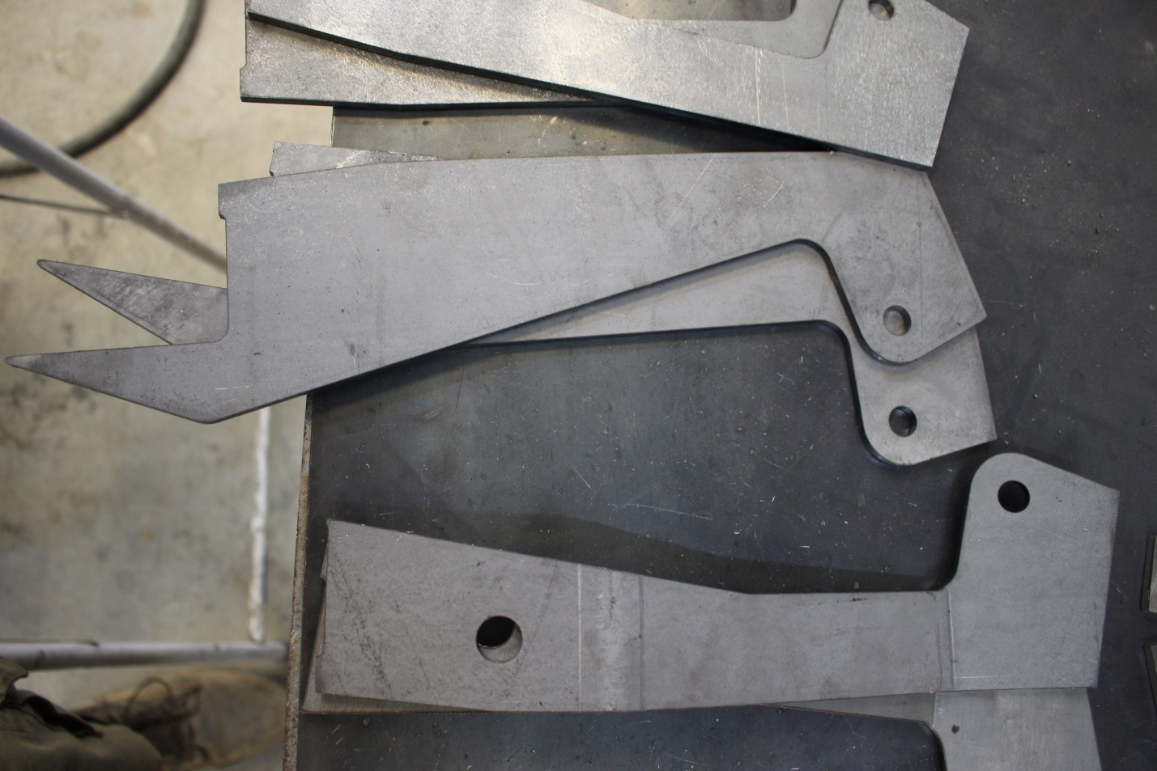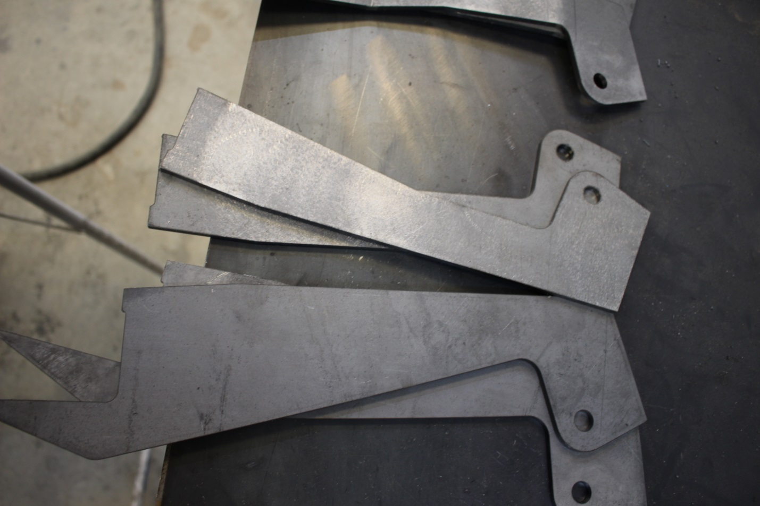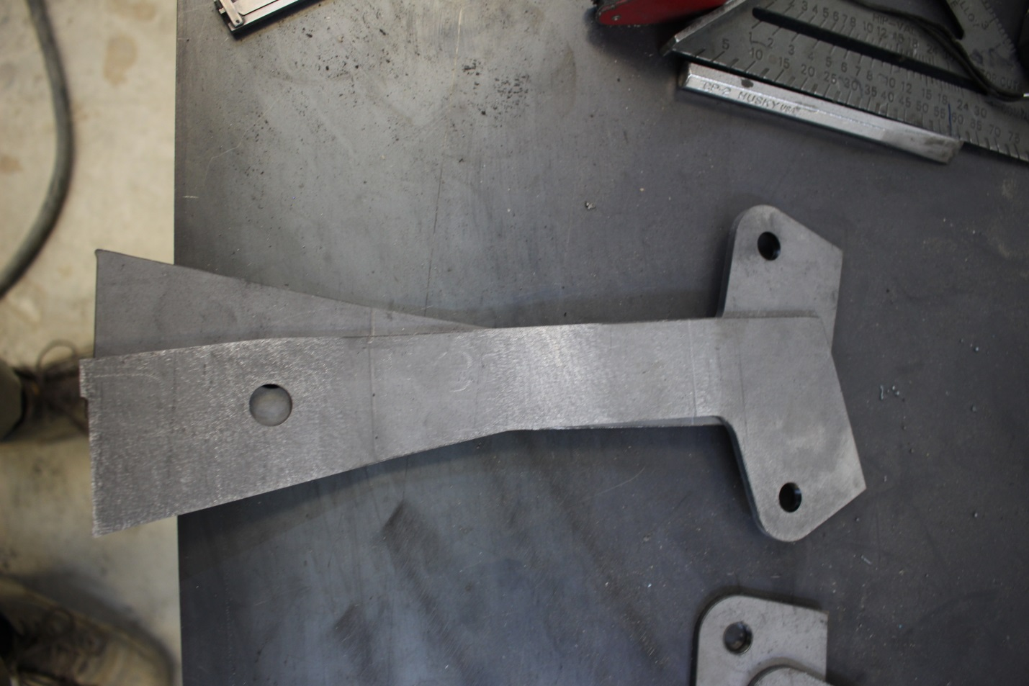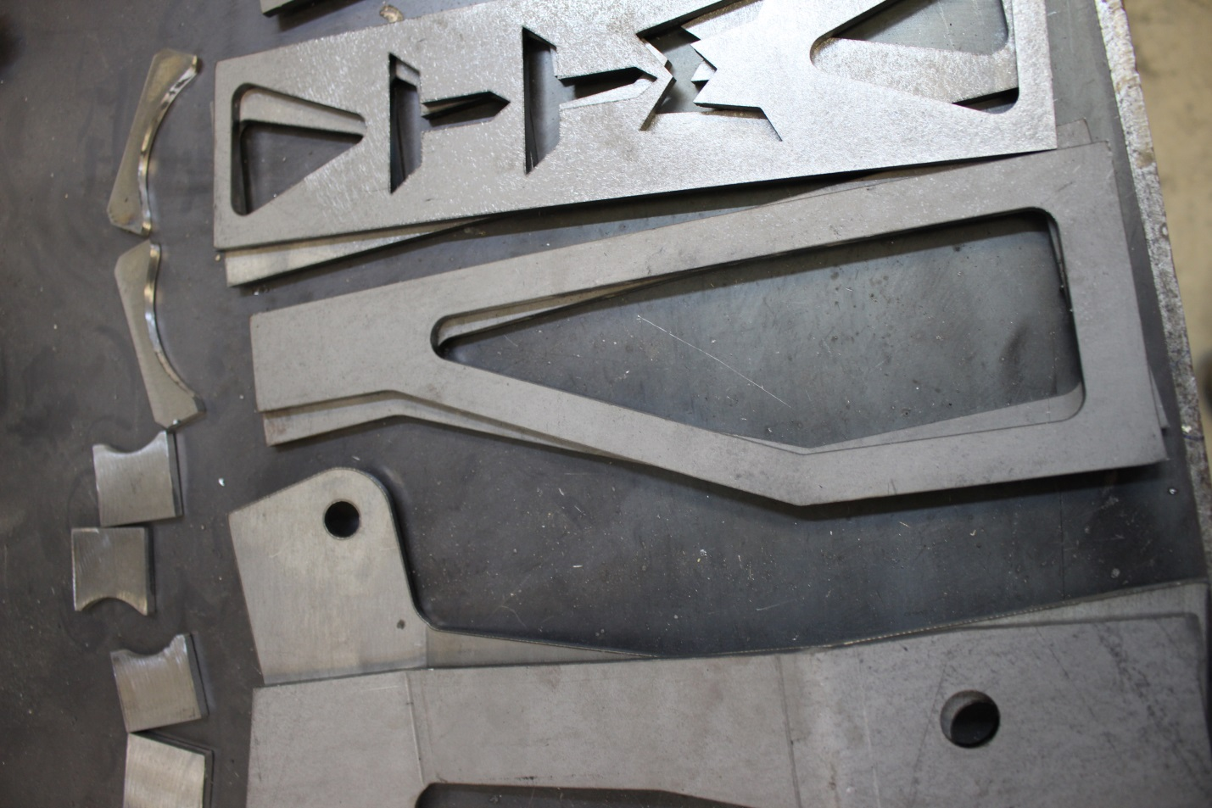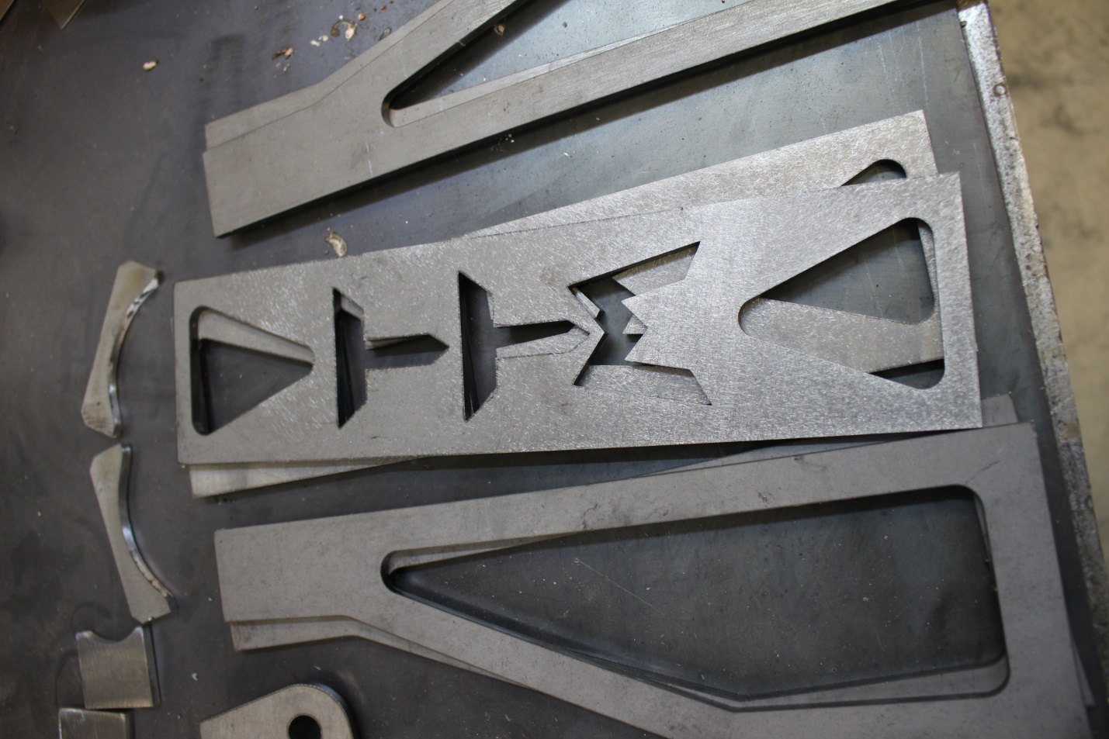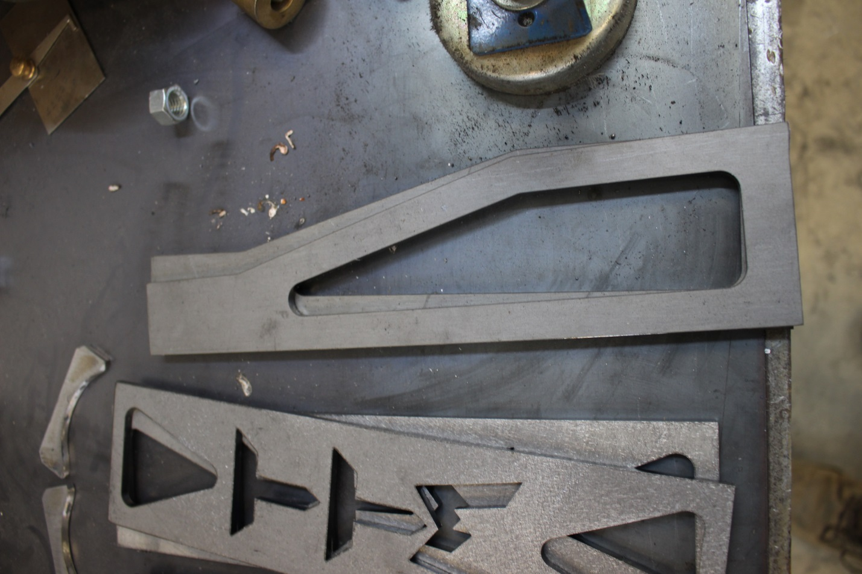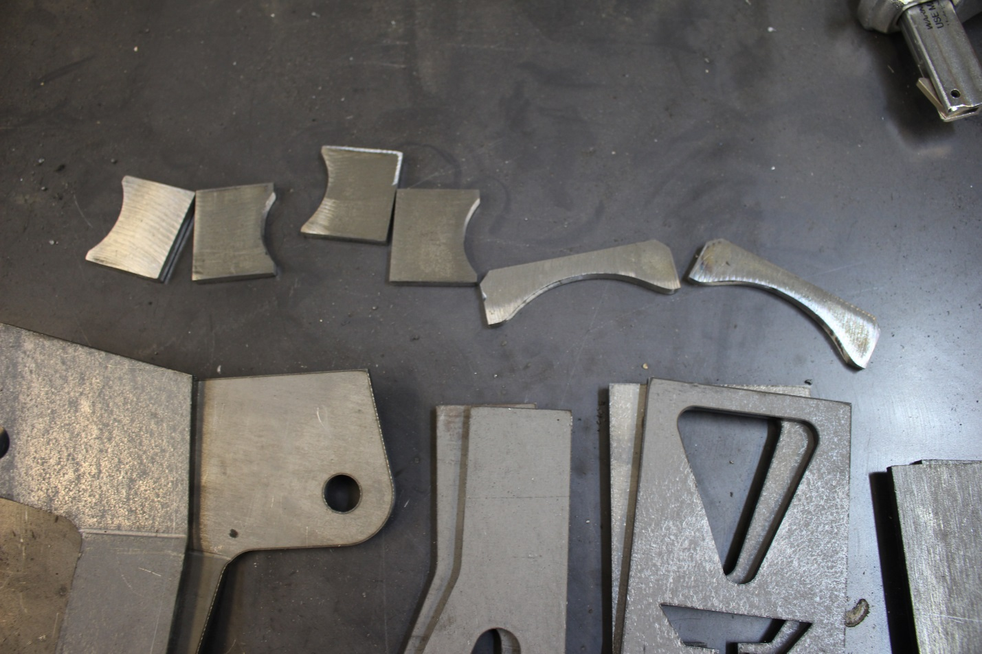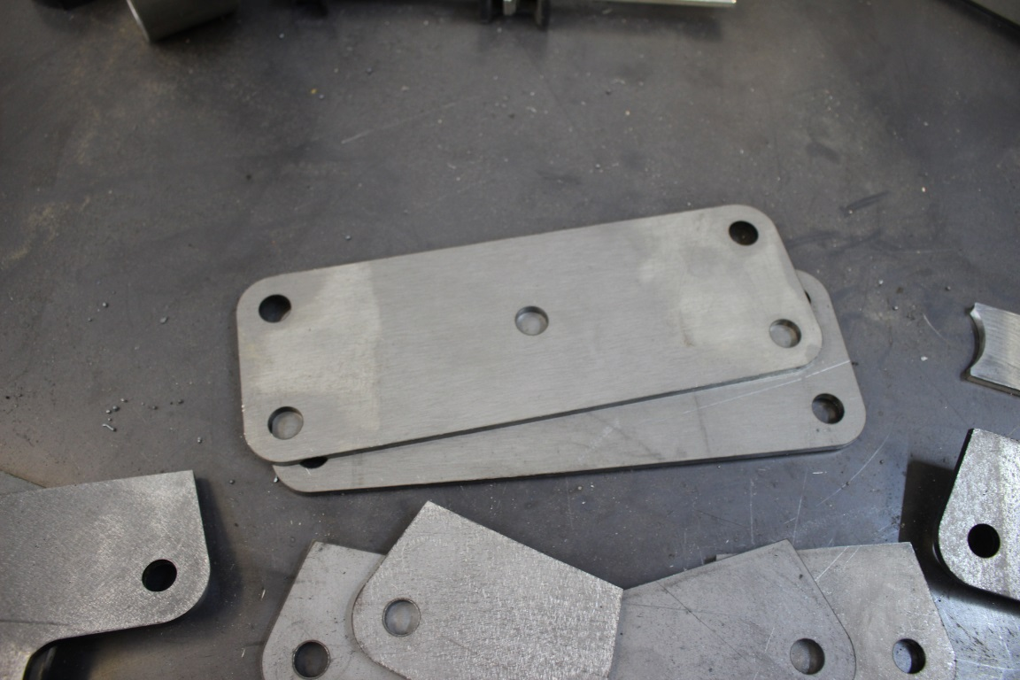

Step 10: Confirm you have the pieces in photos above. Then it’s time to start tacking it together. I use 1.5” width spacers to mock these up. Otherwise you will need to make some spacers with washers, shock spacers etc to be 1.5” so after it’s all tacked together shocks will be able to be installed and removed easily

Step 11: Now bolt together the coilover and the bypass mounts. The bent tabs with the holes closer to frame side index off the UCA bolts. The Tab that is bent more is for the bypass shock. So get the tab that has more bends AND the flat tab that goes down the outside of the frame and bolt those together with the 1.5” spacer. The rear of the towers all sit flat so lay them down and tighten the bolt up.

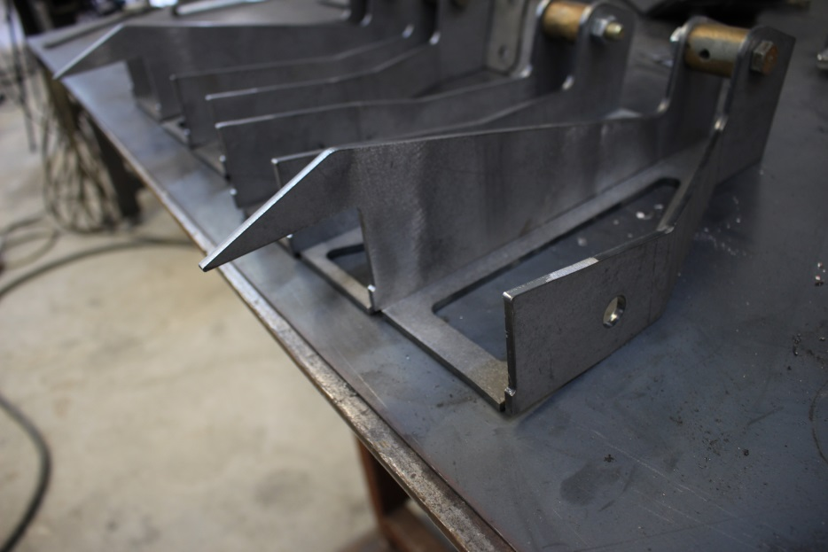
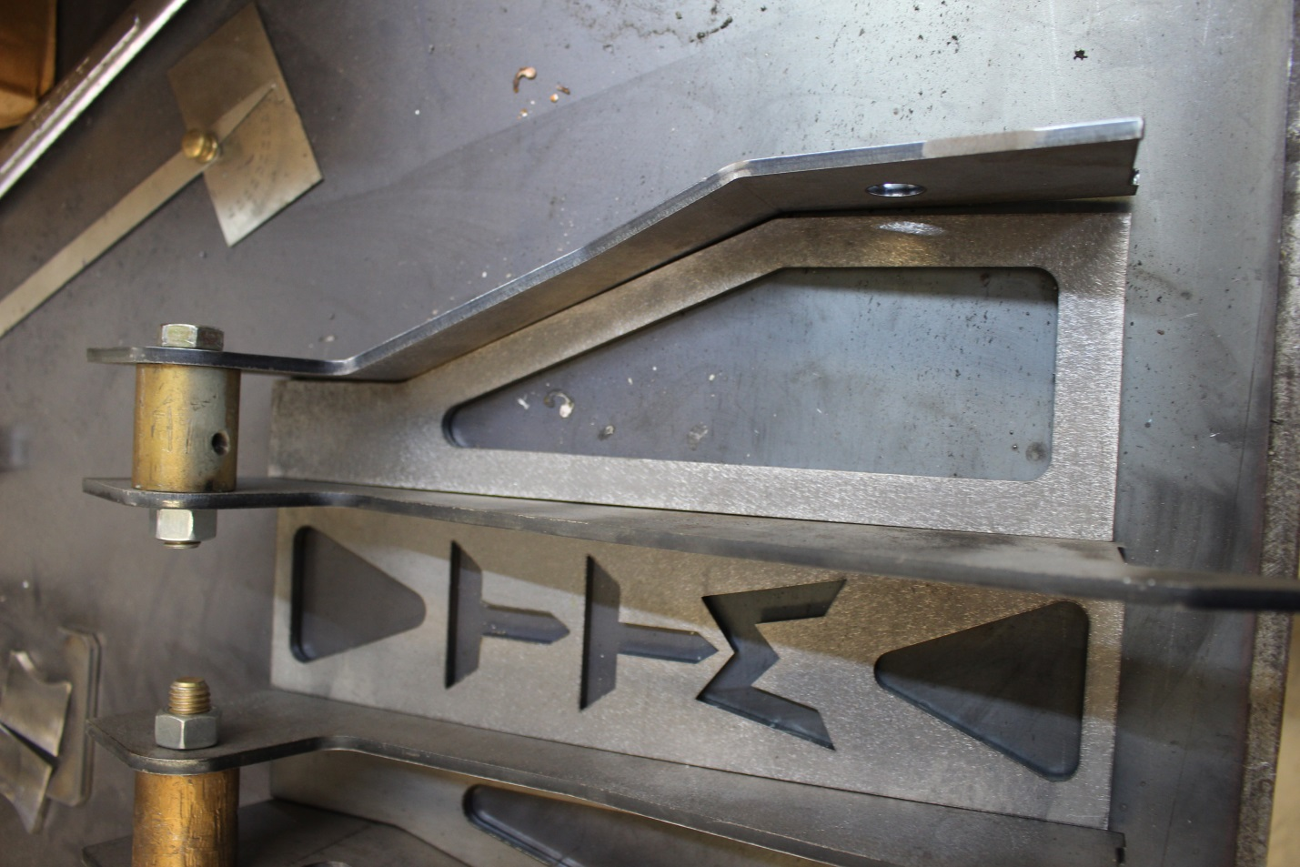

Step 12: Repeat the process with the coilover part of the tower

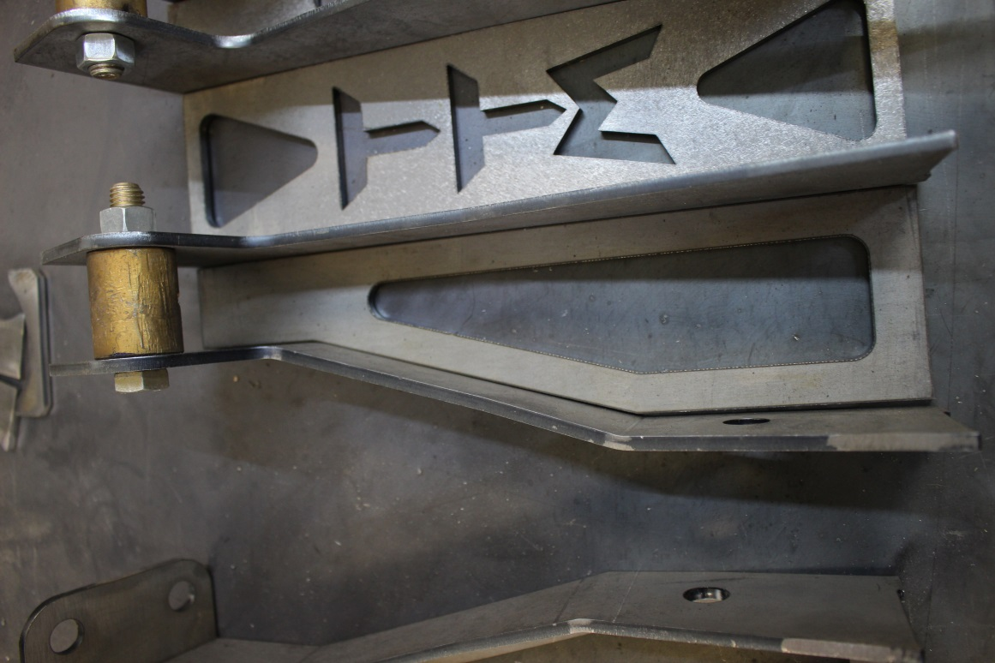

Step 13: Now that the coilover AND the bypass parts of the towers are tightened up and the back are lined up it’s time to tack together the bridge pieces of the towers.

Step 14: Take the coilover or bypass mounts and tack the rear bridge piece so they sit as an outside corner. Line up the Top of the bridge pieces and the shock tabs. Now you see the back bridge plates are flat but there is gap at bottom towards the frame.

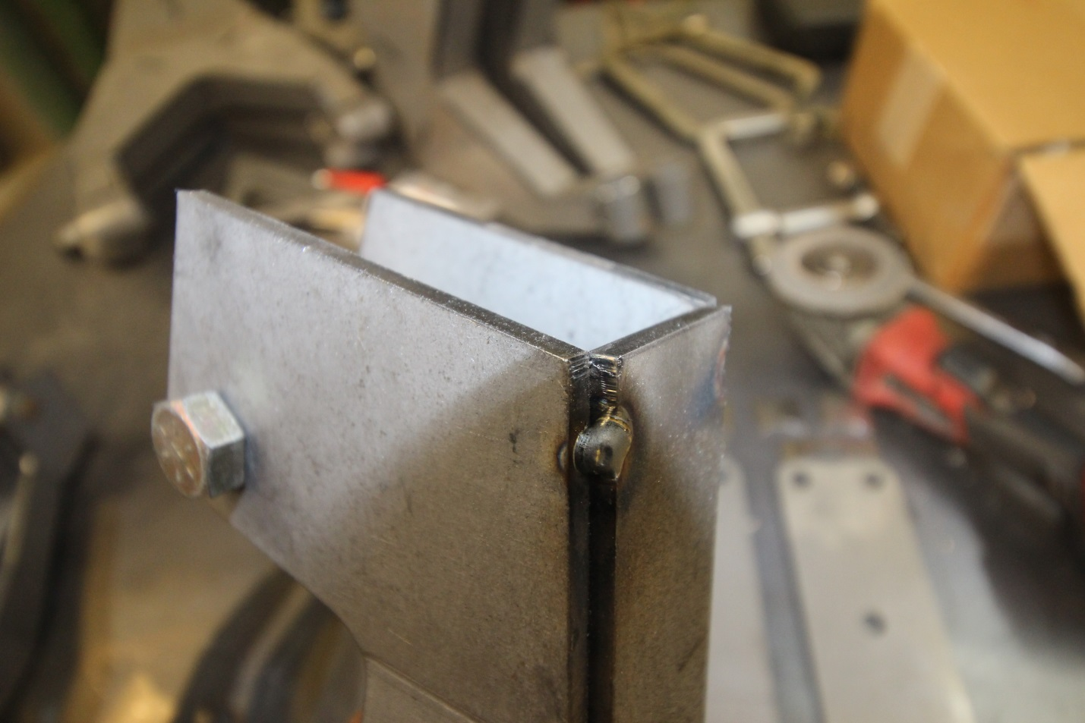
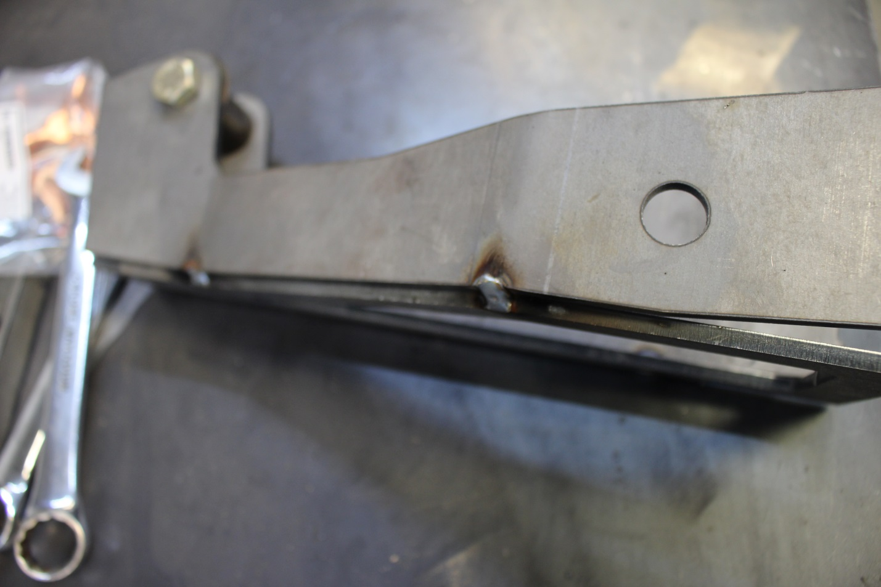

Step 15: Now to get rid of that gap you simply tack the bridge piece right where it starts to get a gap

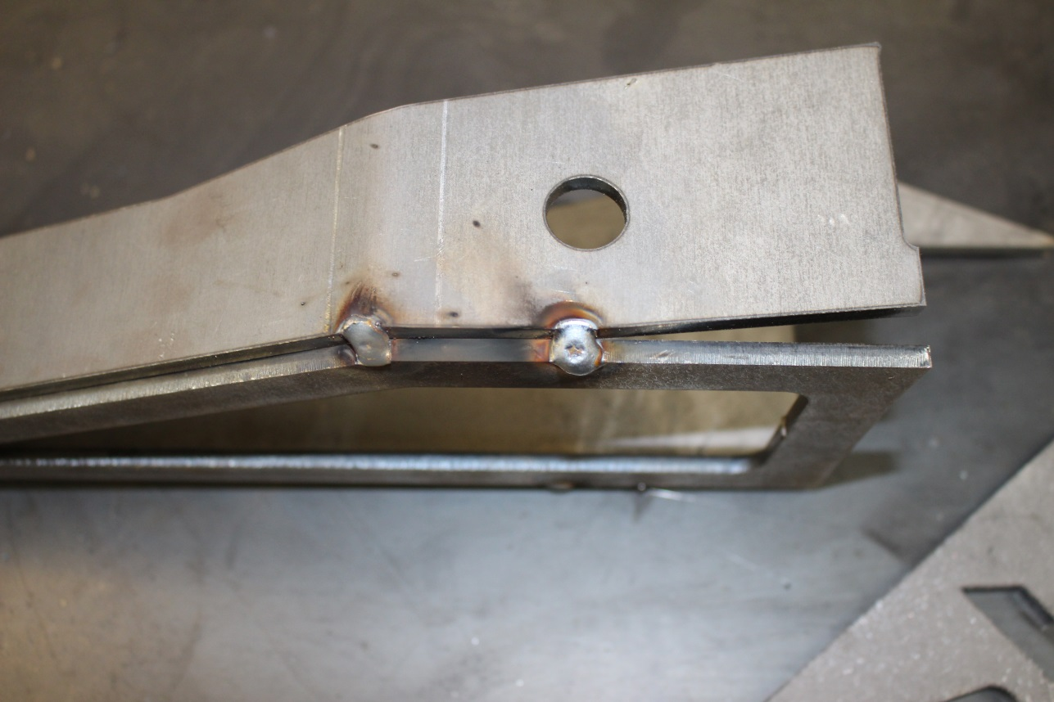

Step 16: Then you can lightly hit the bottom corner of the bridge piece to close the gap up, then tack that outside corner so it stays put

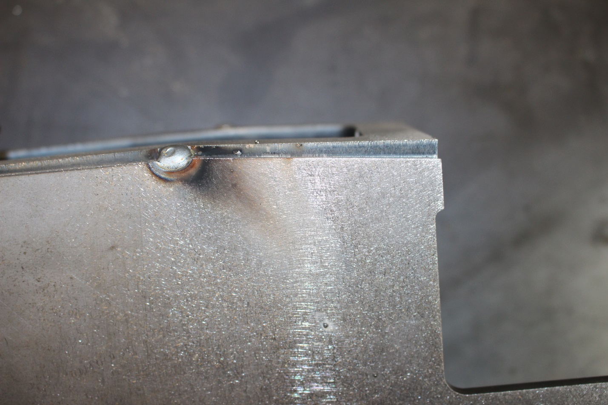

Step 17: Now repeat that process for both coilover and both bypass portions of the towers.

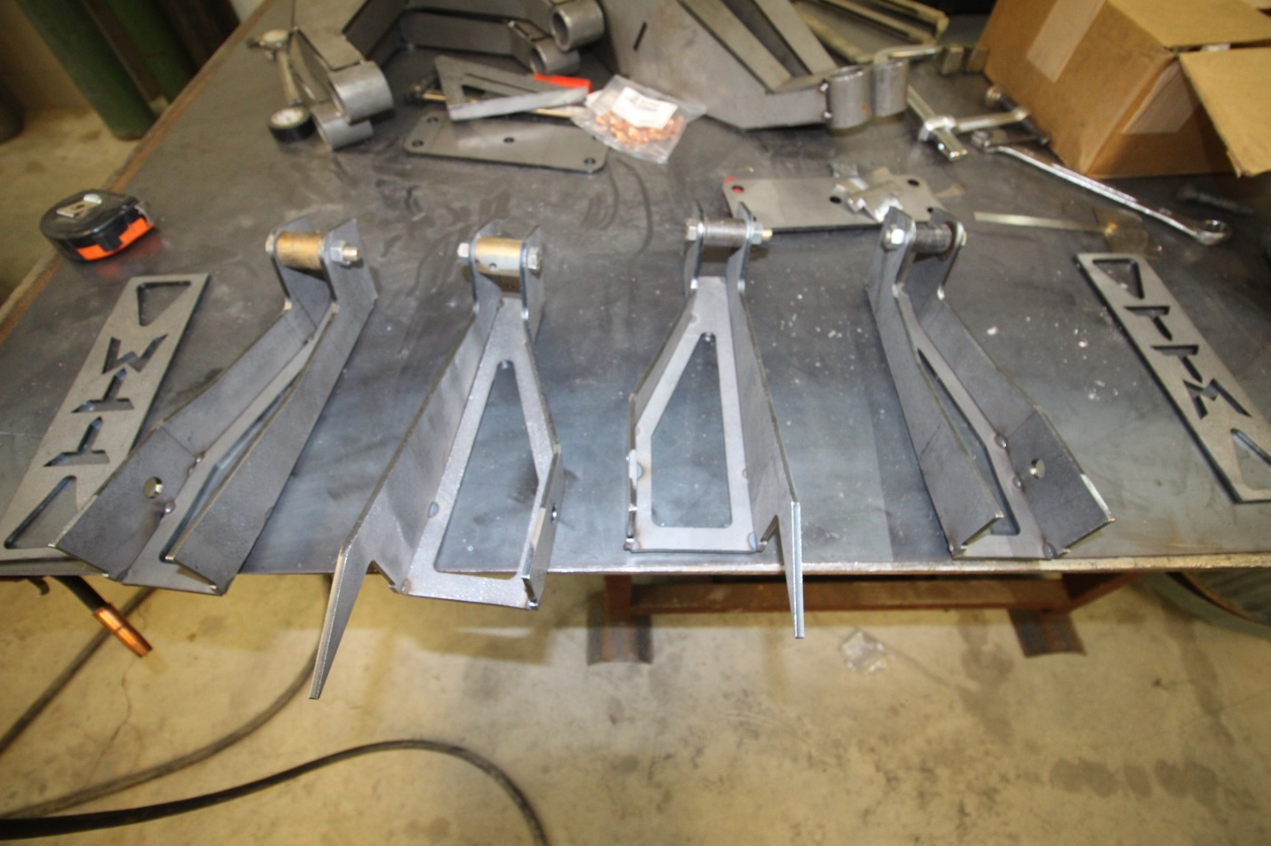
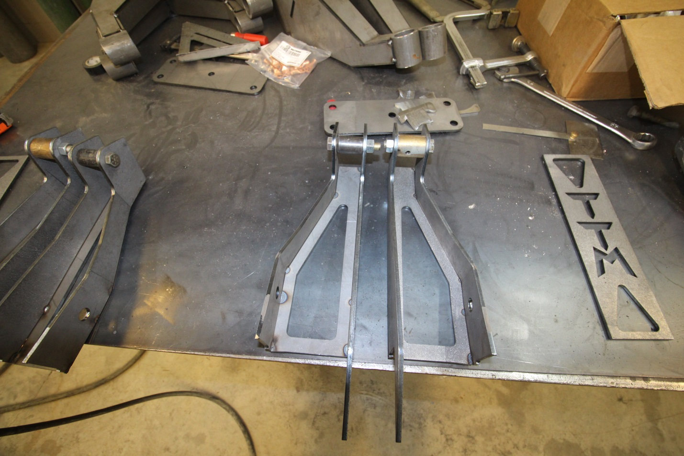
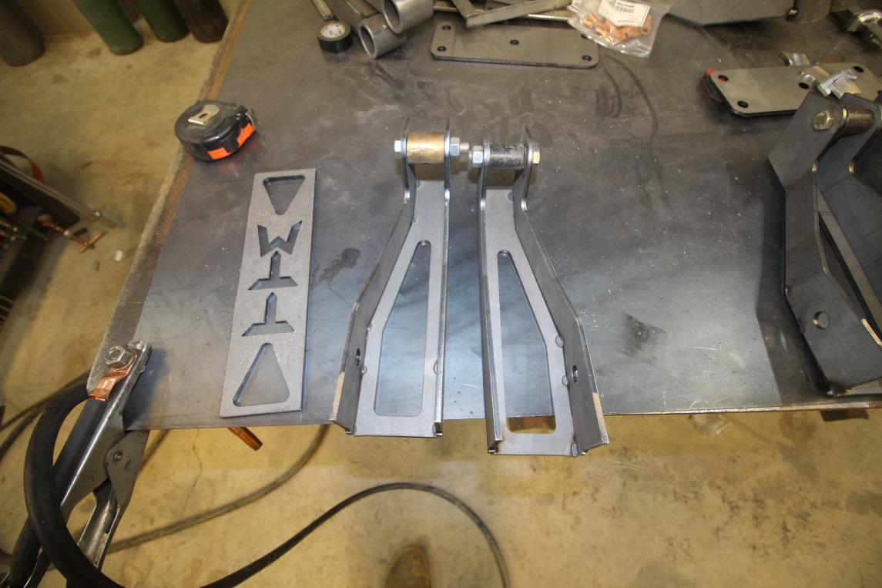

Step 18: So now you have 2 coilover and 2 bypass mounts for the towers. They should be mirror image of eachother to fit on both sides of the truck.

Step 19: Now to attach the coilover AND bypass mounts together to make it a complete shock tower.
The middle TTM bridge piece should be put so the TTM is the correct orientation so you can read it, not upside down. Now you need to make sure the edges of the flat pieces of the mounts are ground smooth so no tacks interfere with fit up.

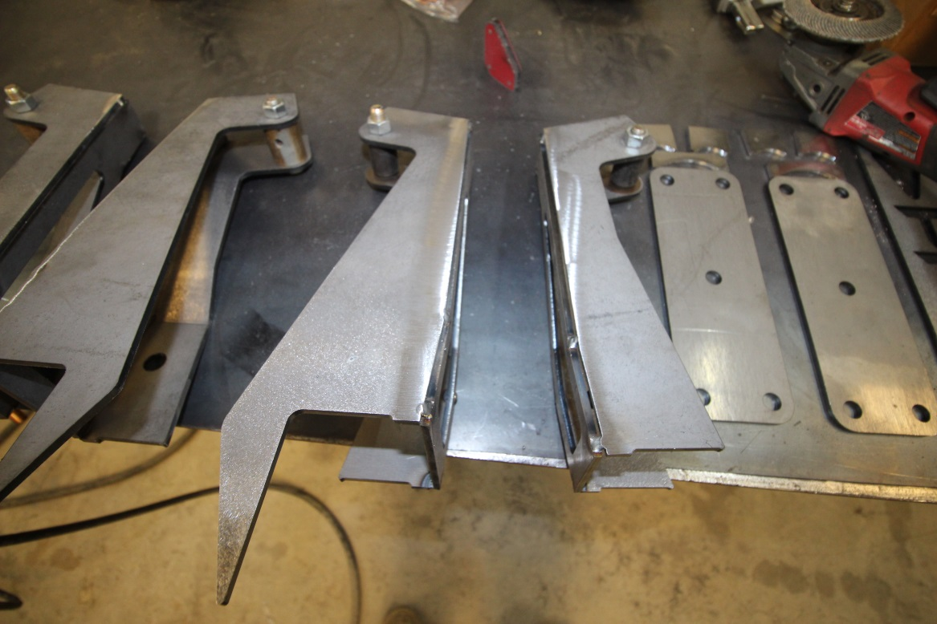
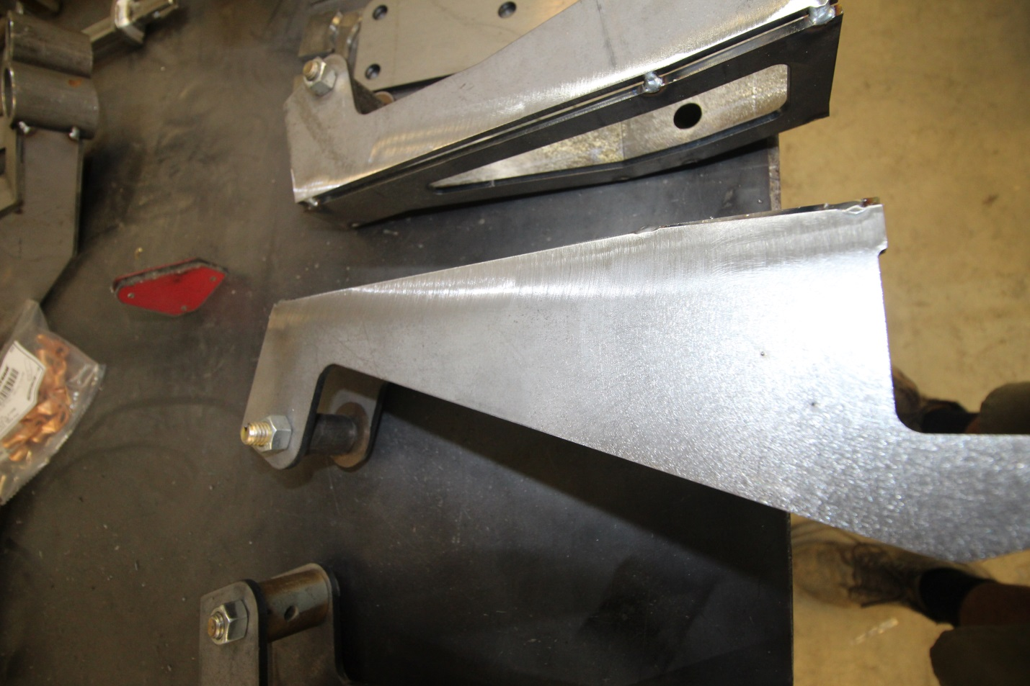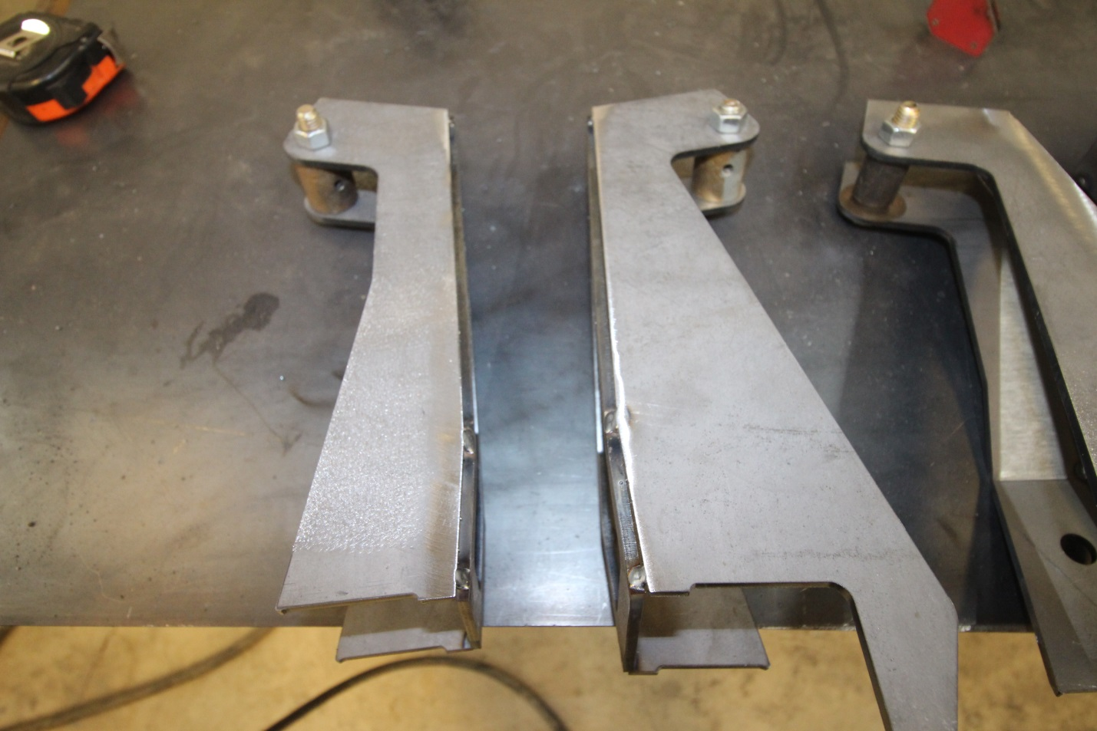

Step 20: Now the Inner Bridge piece fits together as an outside corner with the top/bottom matching up perfectly with the shock parts of the towers. Once you get a few tacks you should push it flat against the table to make sure nothing is misaligned. Now I always tack the top of it together first and sometimes there will be a slight gap at the bottom because the heat warps it out. So push them tight so the shock mounts are flat against the middle bridge piece.

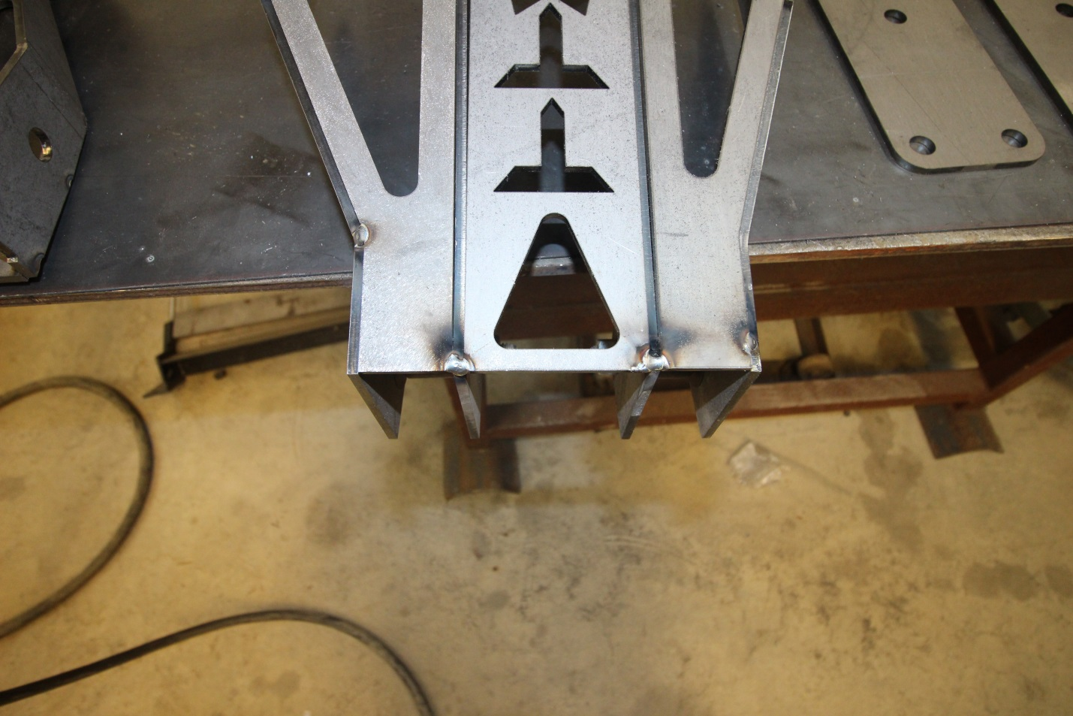
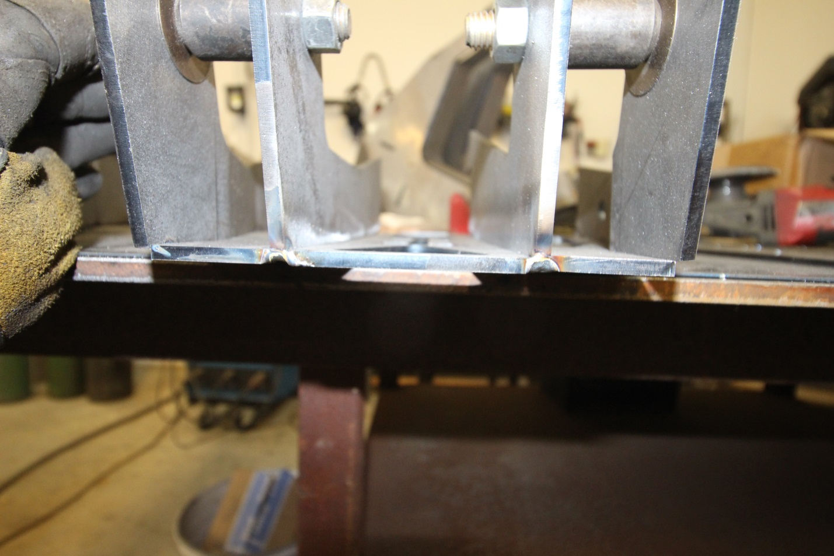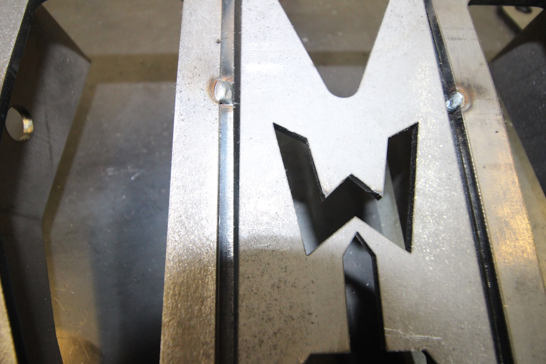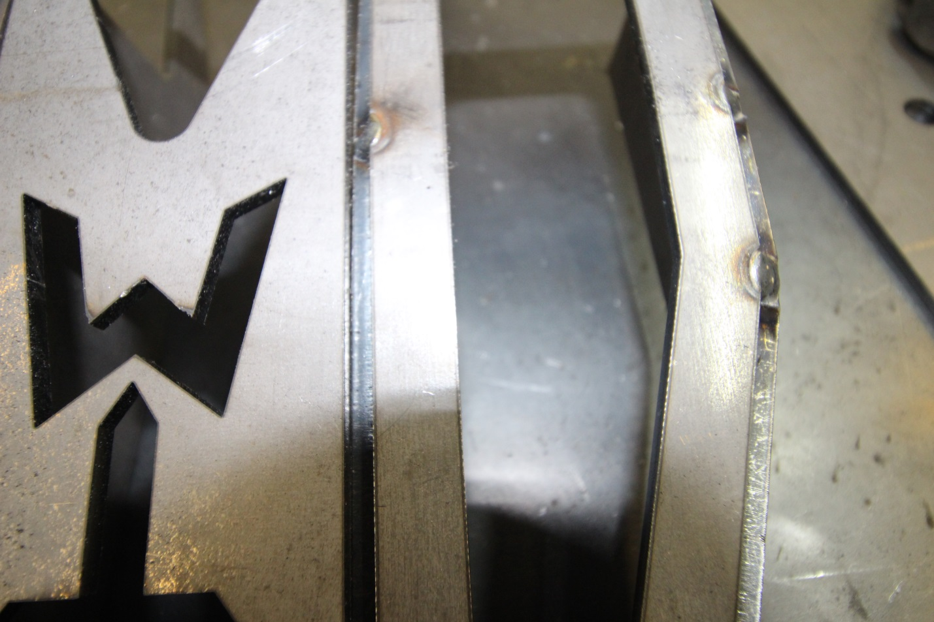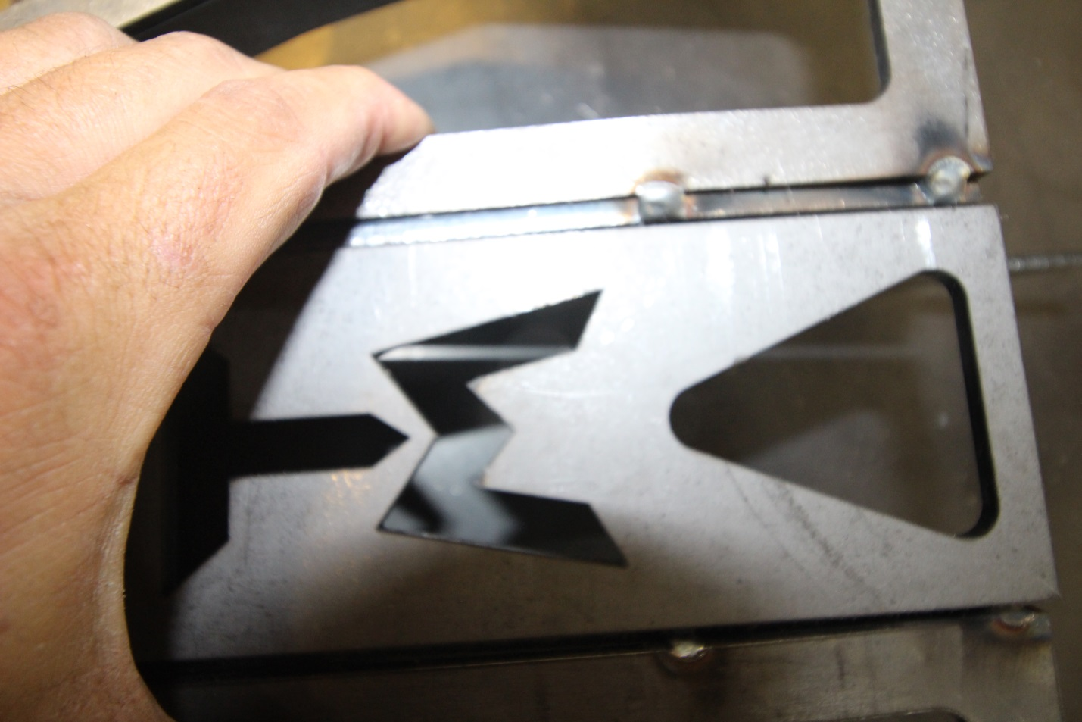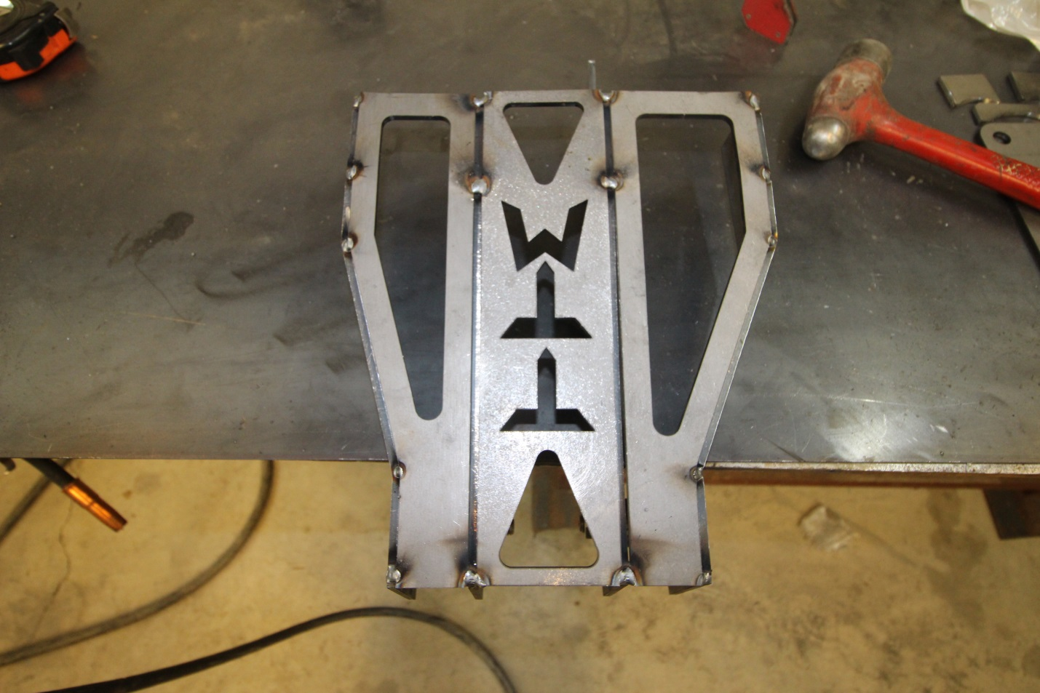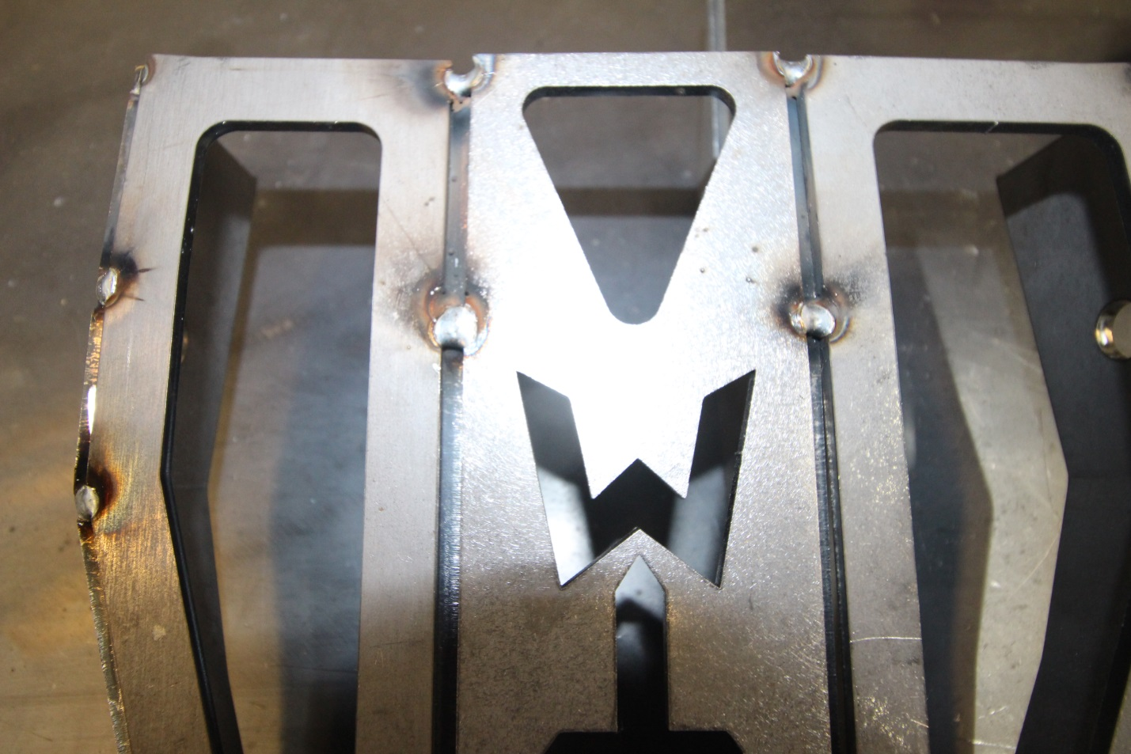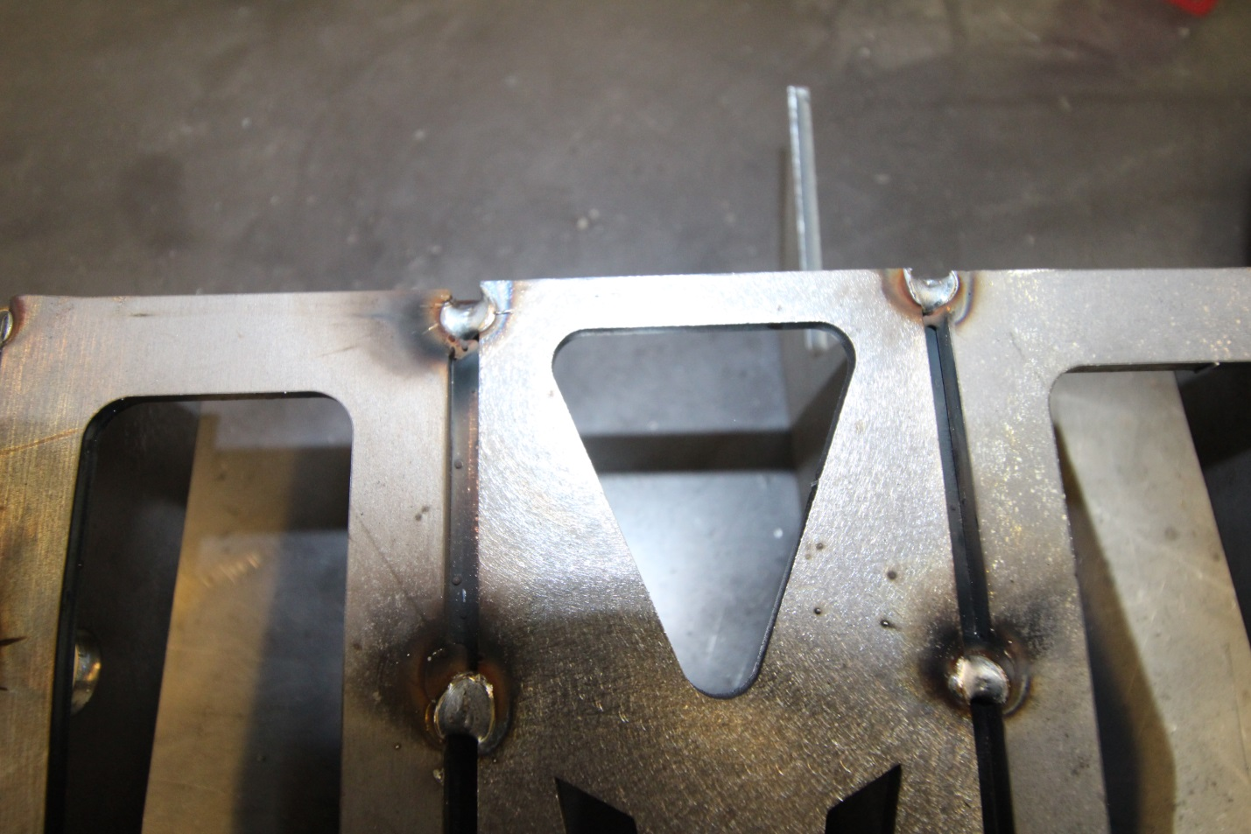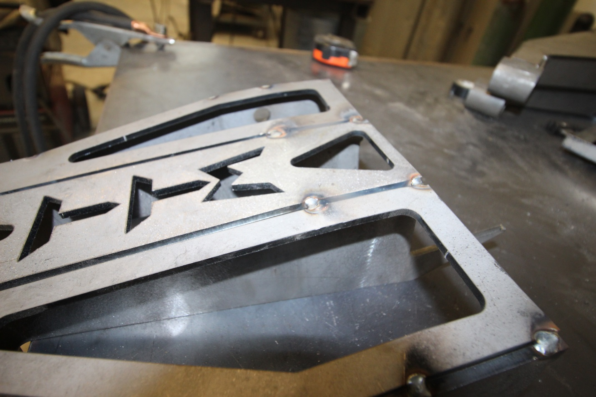

Step 21: As you can see in photos above the outside corner construction allows for a nice single weld to tie both bridge pieces AND the shock tabs together.

Step 22: Now that the tower is tacked together it is time to install the top plate. It has 5 ½” bolt holes in it so you can run a removable engine crossmember OR tie into it with a engine cage like on a race truck.

Step 23: Getting the top plate centered and squared up with the towers. Measure to find center length ways and width ways. Then measure the tower width outside And mark the top plate accordingly so you can line those marks/lines up with the towers. I used a speed square for the lines. Lining up the square lines with the shock mounts AND the rear of the tower confirms everything is square .

DO NOT WELD THESE UNTIL TEST FITTING ONTO TRUCK

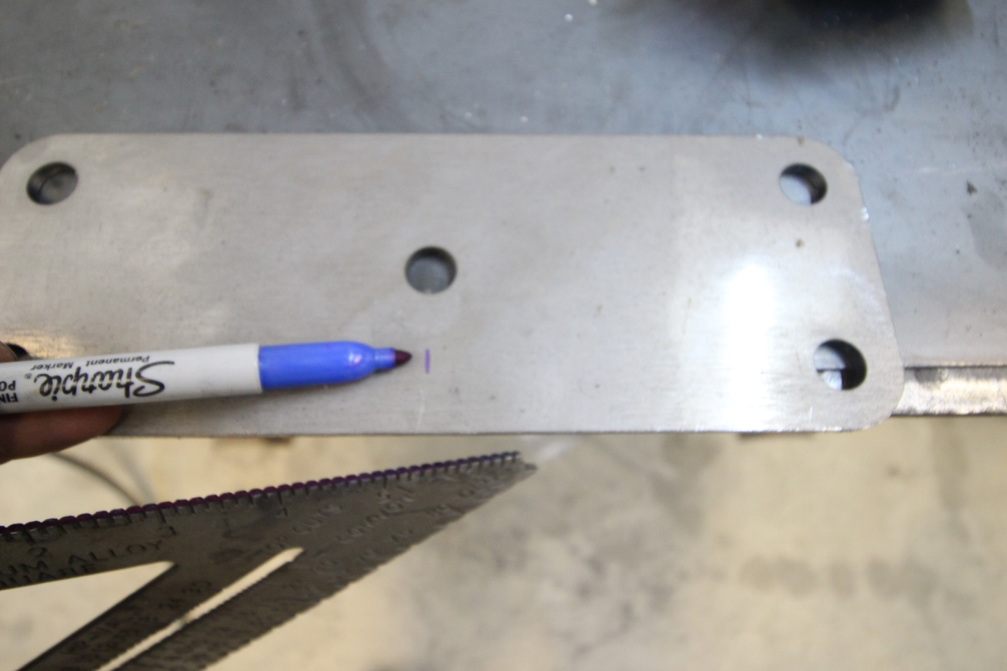
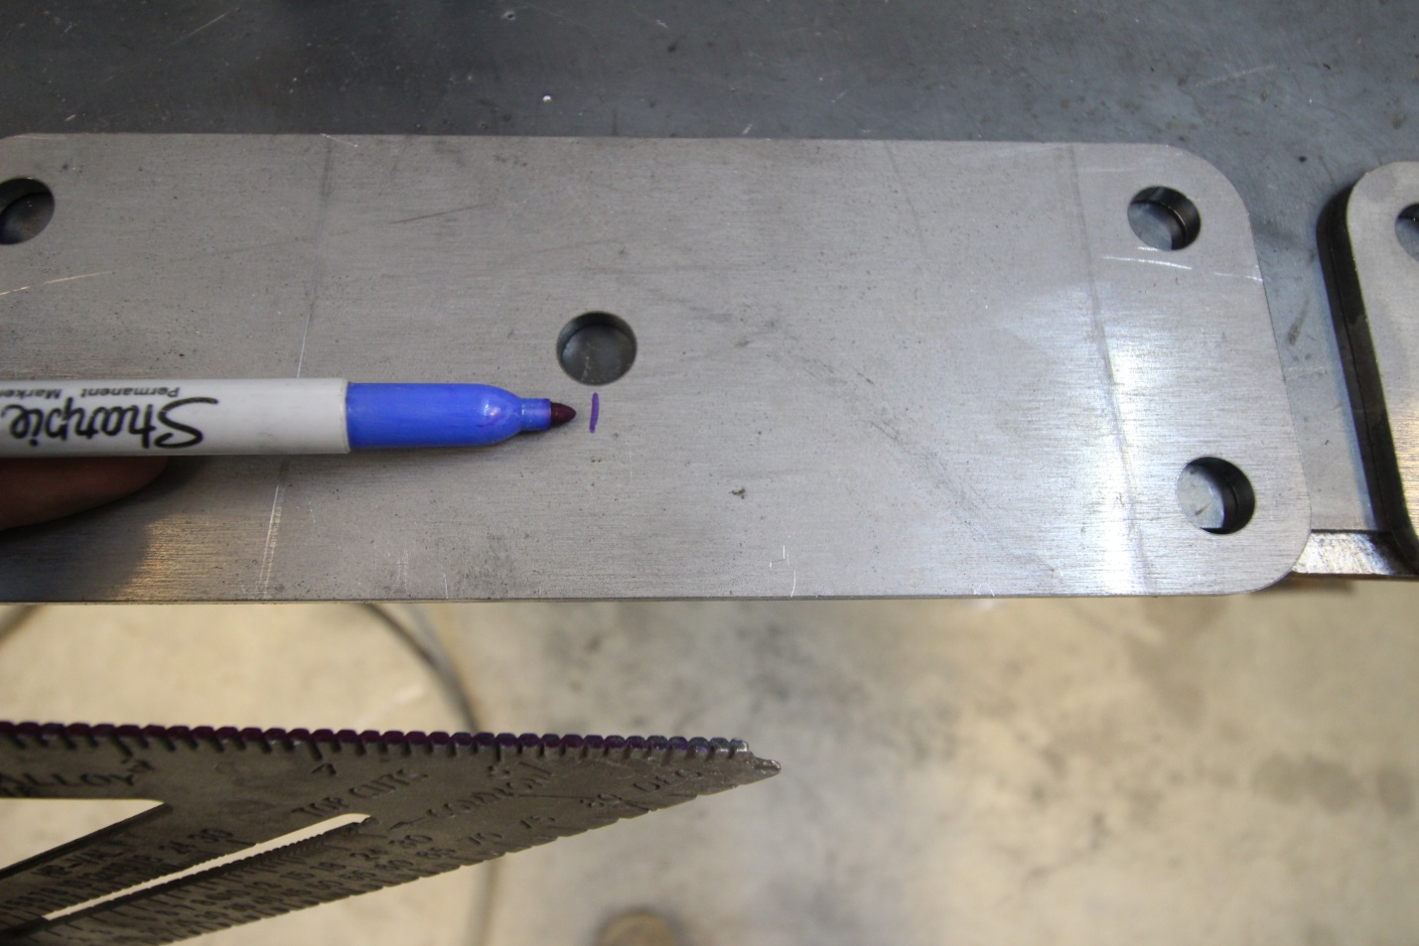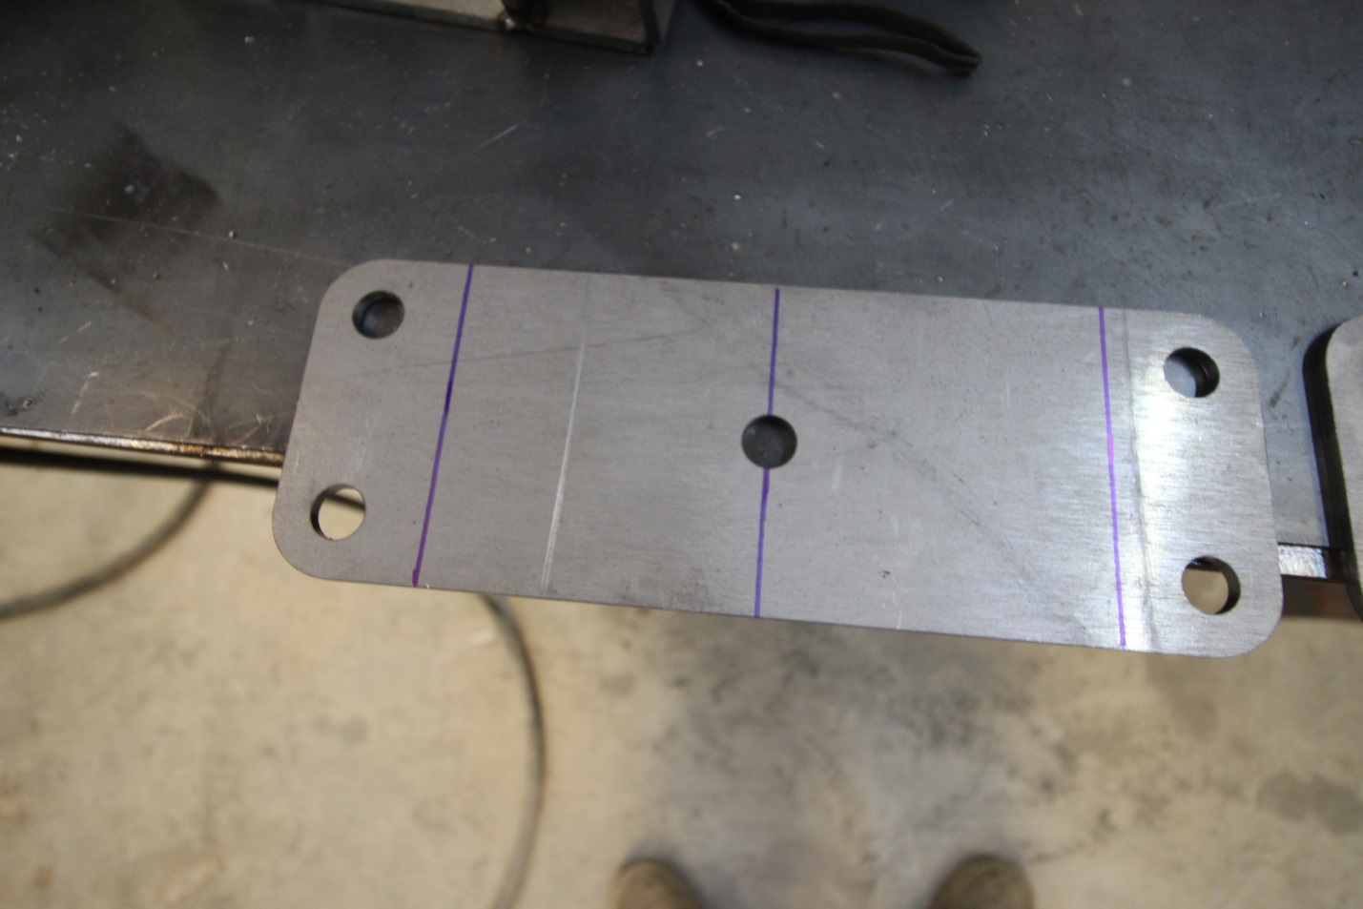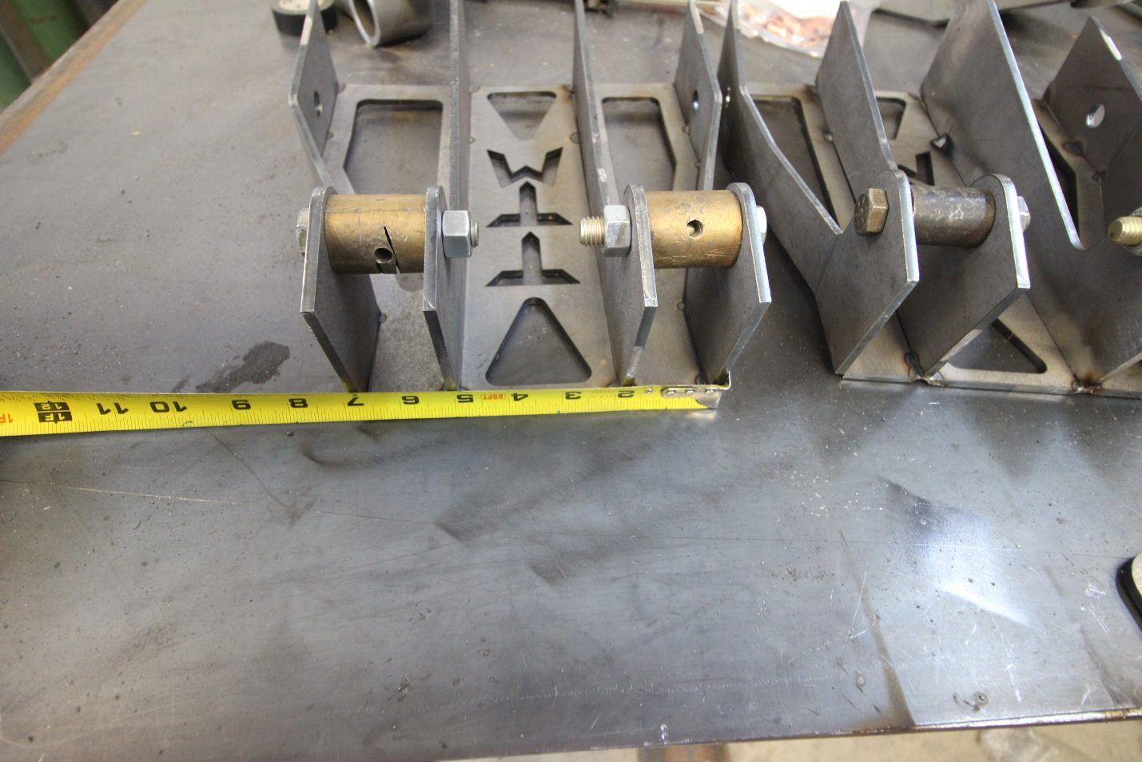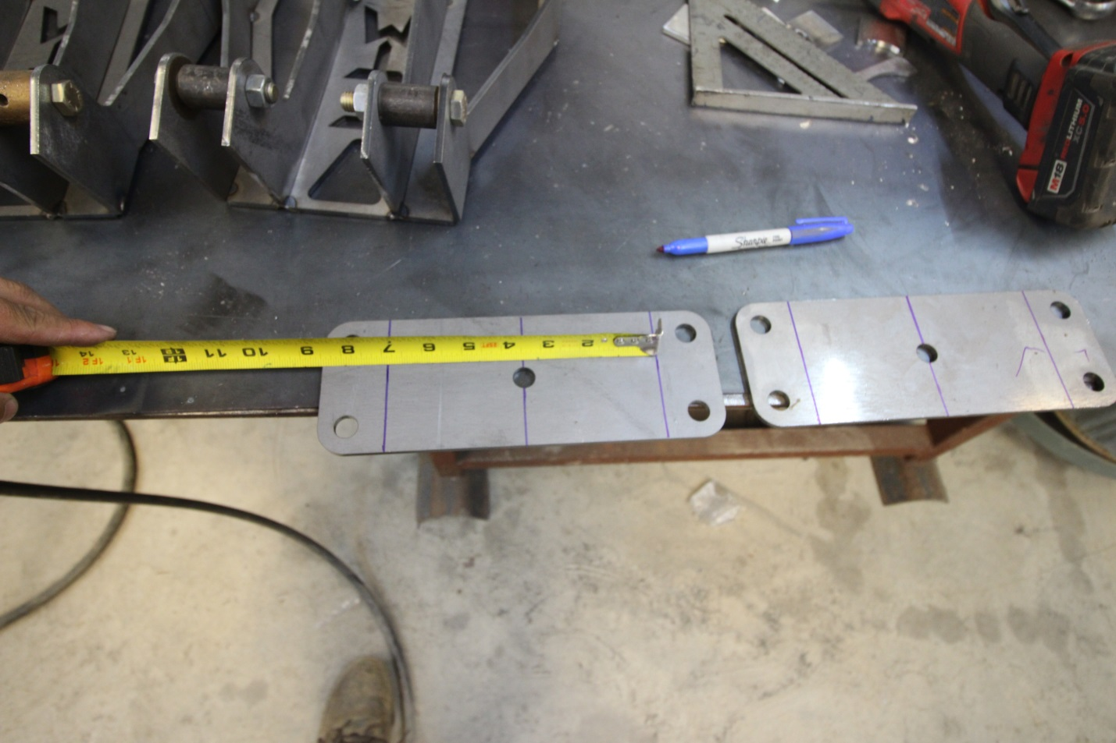

Step 24: Now that the towers are tacked together it’s time to get back to installation on the truck. Test fit LCA inner sleeve’s into the factory LCA mounts. If they are bent inward at all a couple hits with a hammer will spread the factory tabs to make installation easier.

Step 25: Towers are ready for the upper shock mounts, now to position the lower mounts. The Lower shock tabs are offset slightly so there is a direction on them. Bolt them together in same orientation so that all 4 shocks, both sides, will be positioned the same way. The longer leg I put towards the lower uniball end of control arm. When bolting these together with the 1.5” spacer, make sure that the bolts go in from the outside of control arm, if you don’t do this you cannot remove the bolt and will need to break the tacks OR cut the bolt.

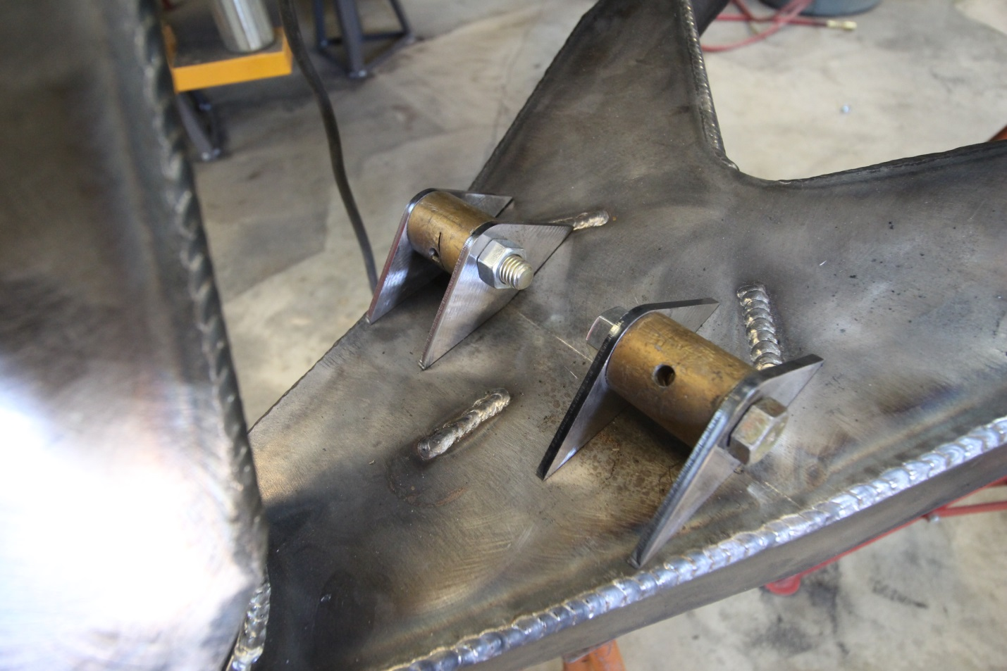
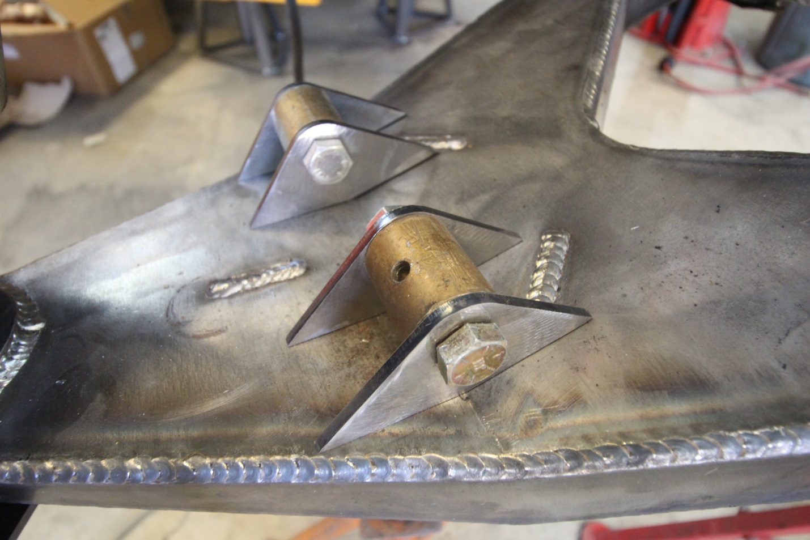

Step 26: With both sets of LCA shock tabs bolted together and positioned on the LCA. Measure the outside width of the tower. Make the LCA shock tabs the same measurement AND even on the LCA. The tips of the outer tabs should be just over the edge of the weld on both sides. When evenly spaced on LCA and correct width to match the tower tack them in place.

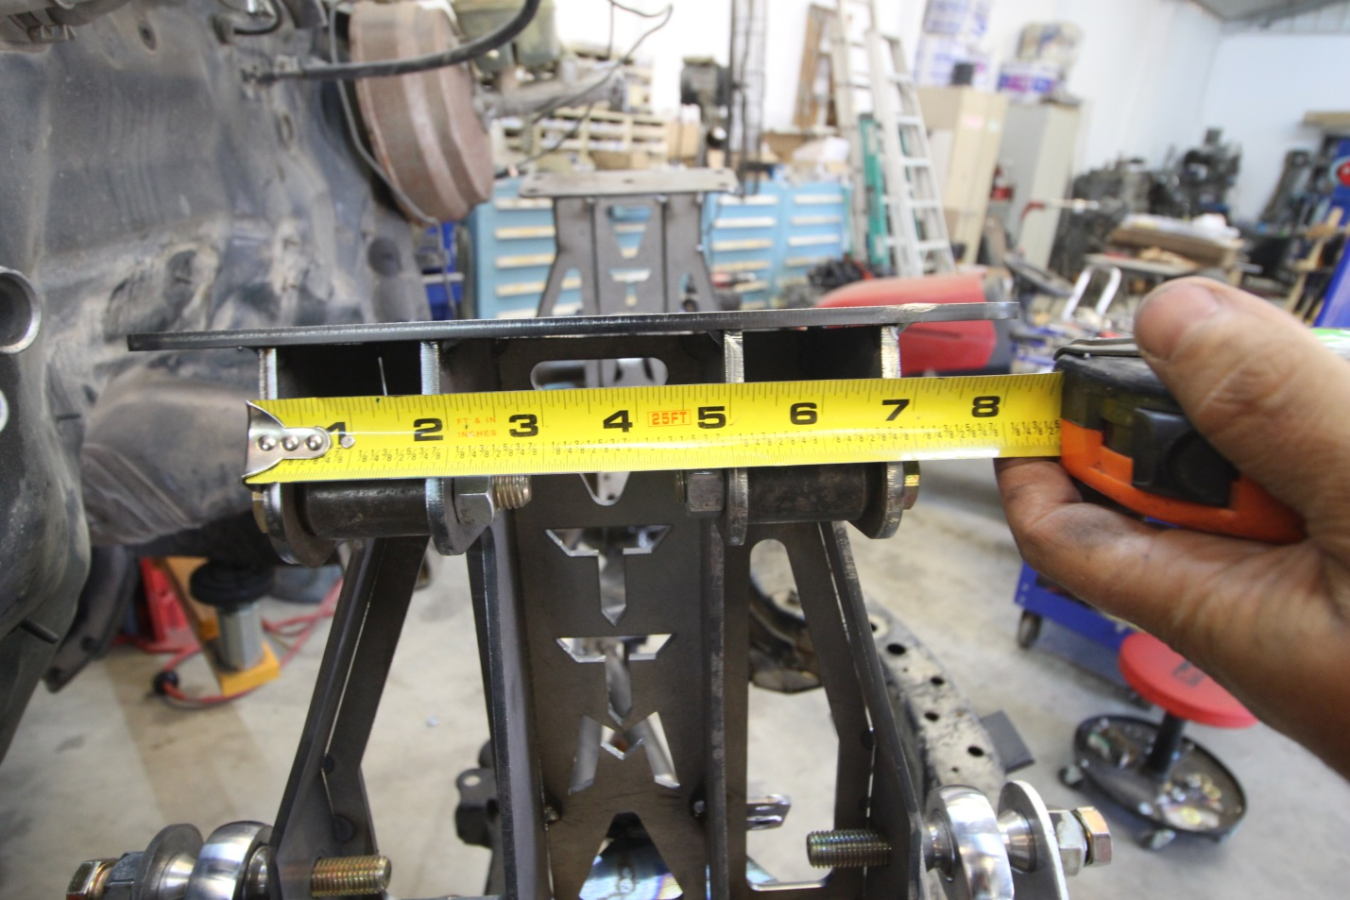
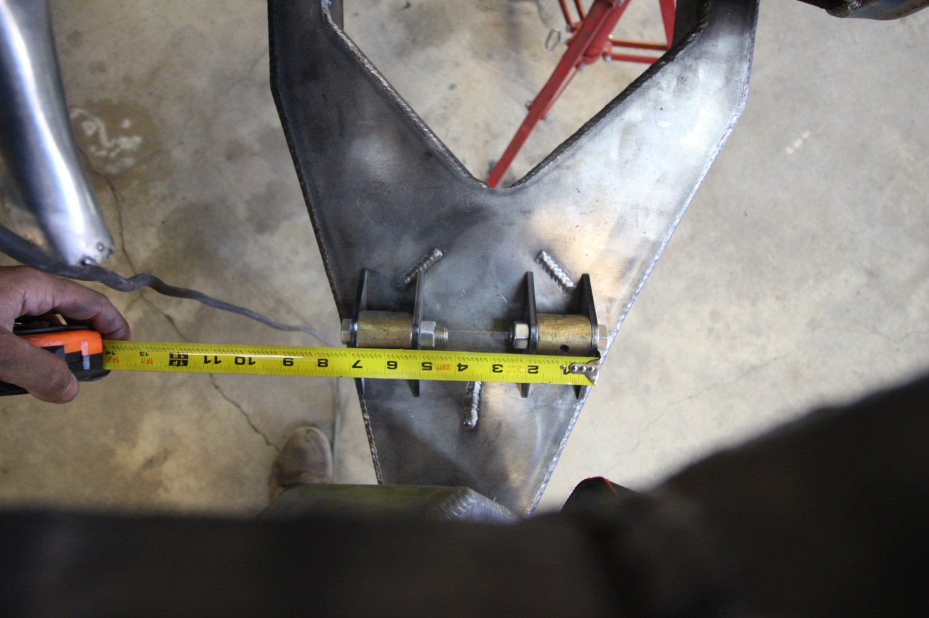
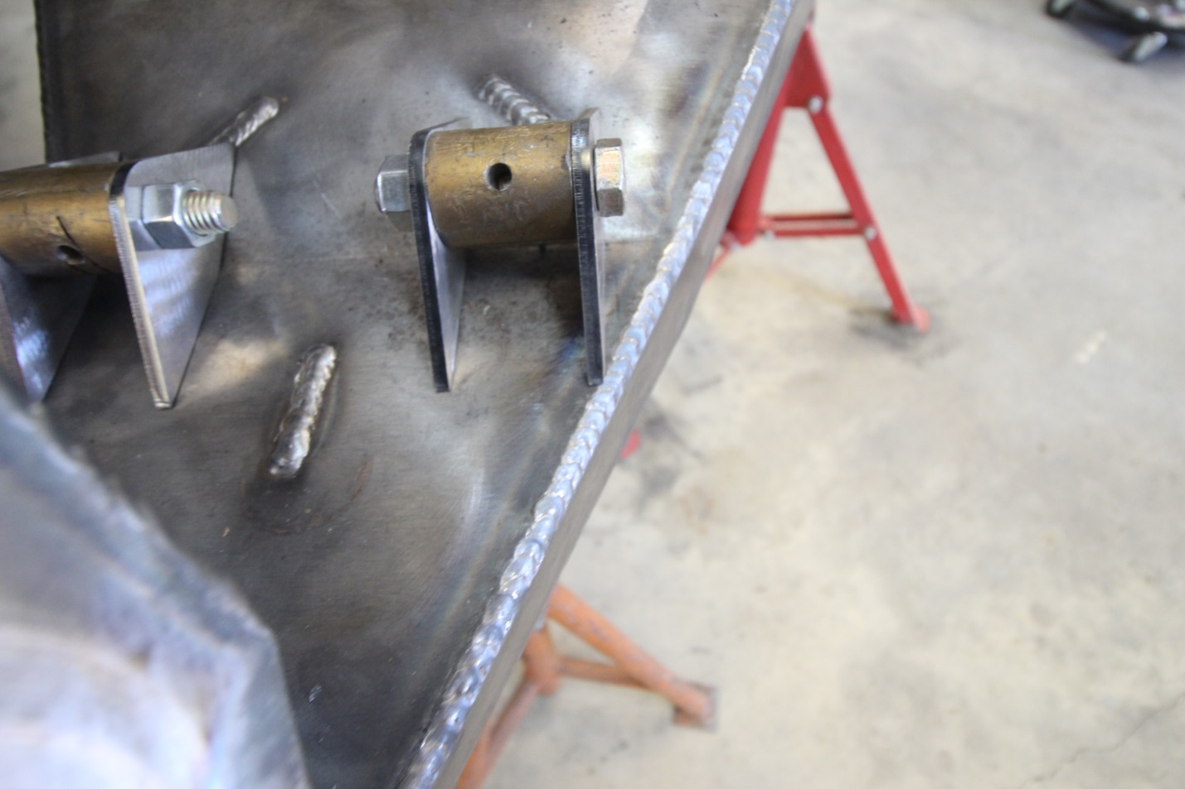
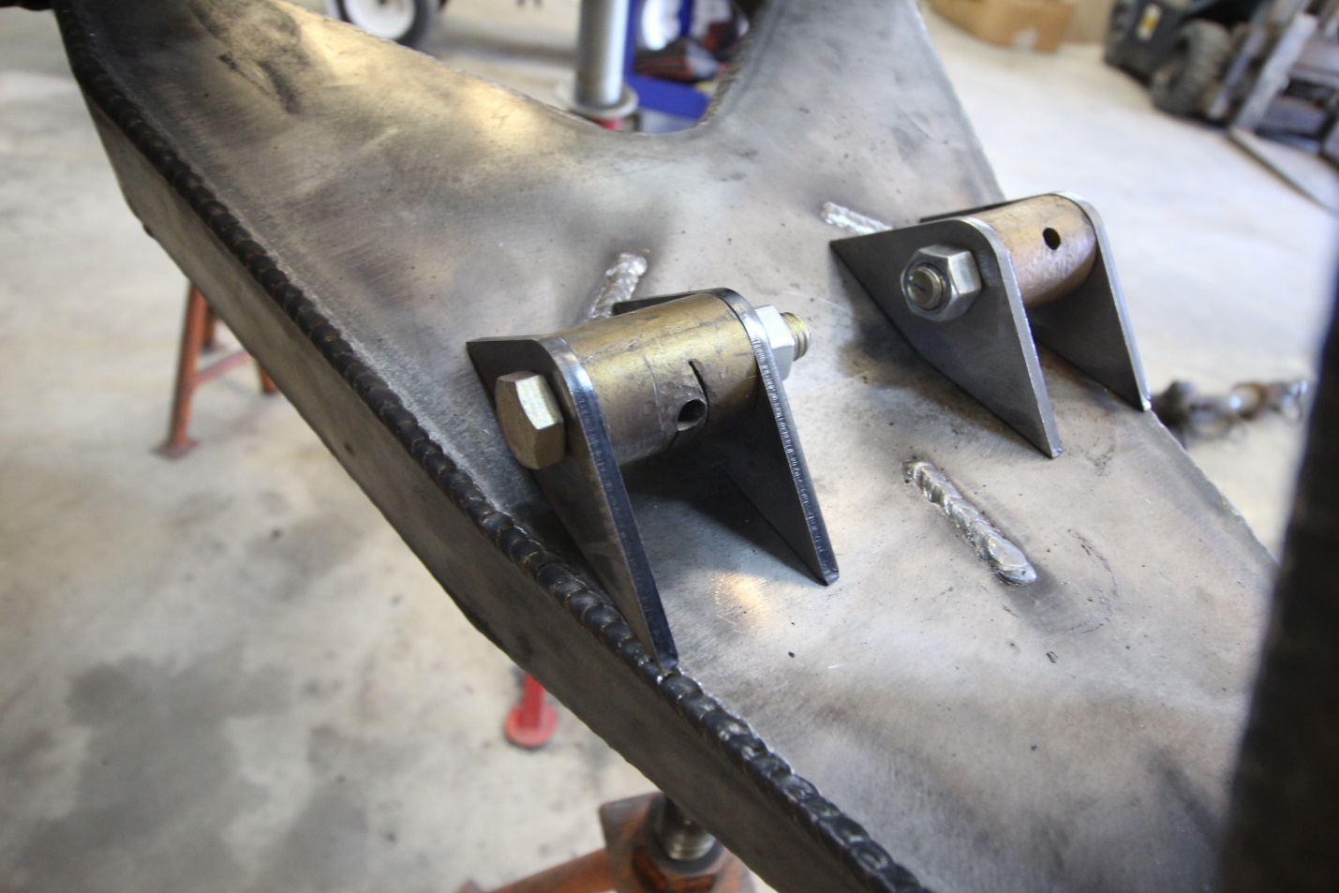

Step 27: Install bushing assembly into LCA. Hammer in 1 of the bushing half on each LCA. Then I apply silicone grease in between where the bushings will go. When both bushings are installed there is a slight void between them that I make sure has plenty of grease to extend the life of the bushings and keep them quiet. Hammer in the second bushing half into each outer tube.

Step 28: Once each pivot has both urethane bushings installed in them now it is time to install the inner sleeves. There should be some grease squished out between the halfs. Smear it around AND if necessary put more grease to fill the grease sleeve’s fully before installing inner sleeves. Once that is done I use a shorter ¾” Bolt with washer, slide that into the inner sleeve and then line it up on bushings and tap it in with the hammer. You will need to push the lower bushing against the table when hammering it through the second half otherwise the bushing half could get pushed out of the arm.

Step 29: Now all bushings are assembled and you confirmed that the urethane bushing is tight against the .250 inner pivot bushing tube it is time to install the lower A-arms onto the truck. The lower A-arm front and rear plates of the arms have 1 bend in each of them. The side with MORE bend and the TTM logo tacked on goes towards the front of the vehicle. Install the A-arms with the provided ¾” bolts, washers and LCA cam eliminators. I put under the head of the bolt AND under the washer the provided flat washer and then under washer against the frame the Cam Eliminator Washers.

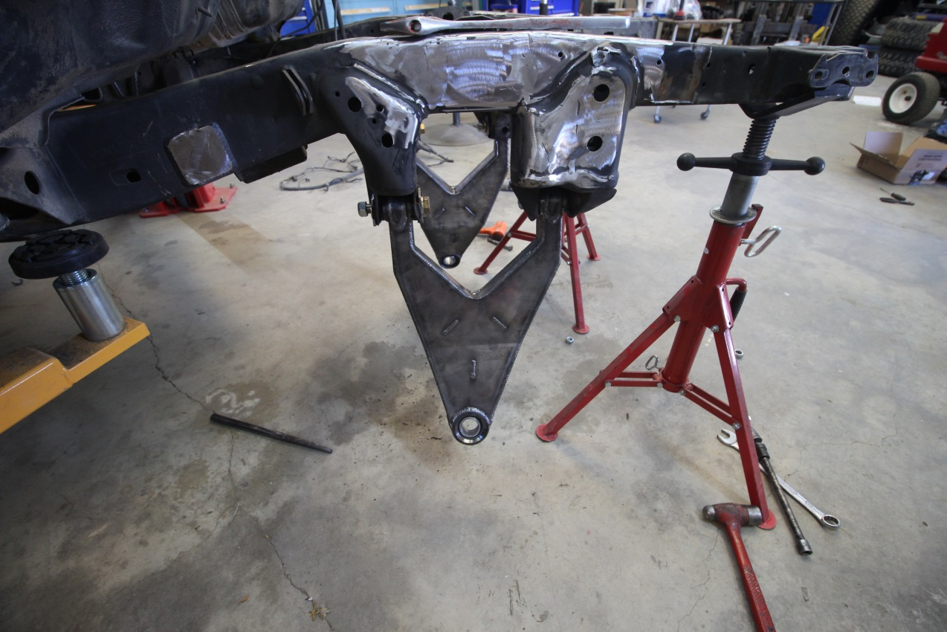
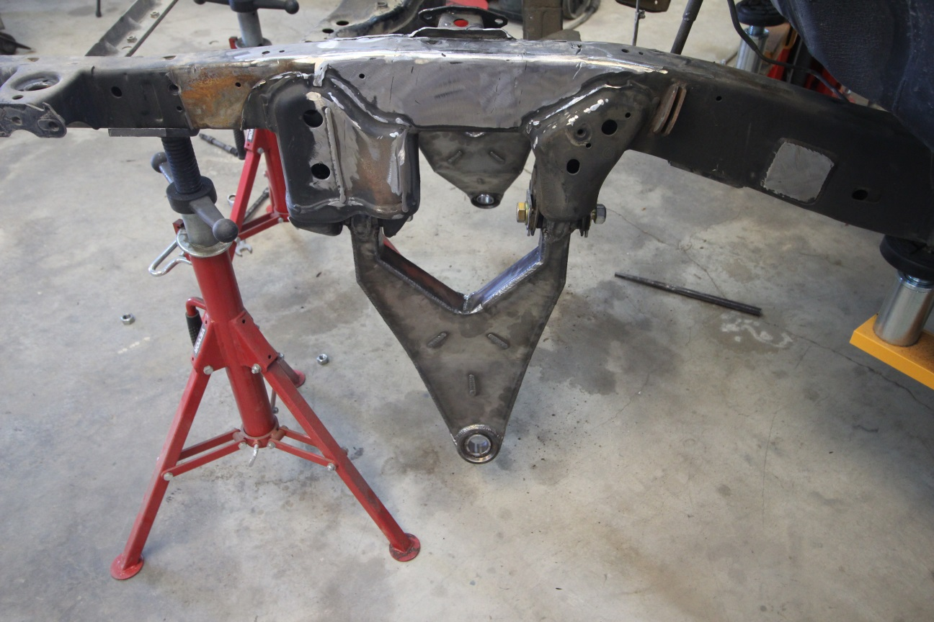
The Large Jack stands are at the front of the vehicle the arm should appear as above.
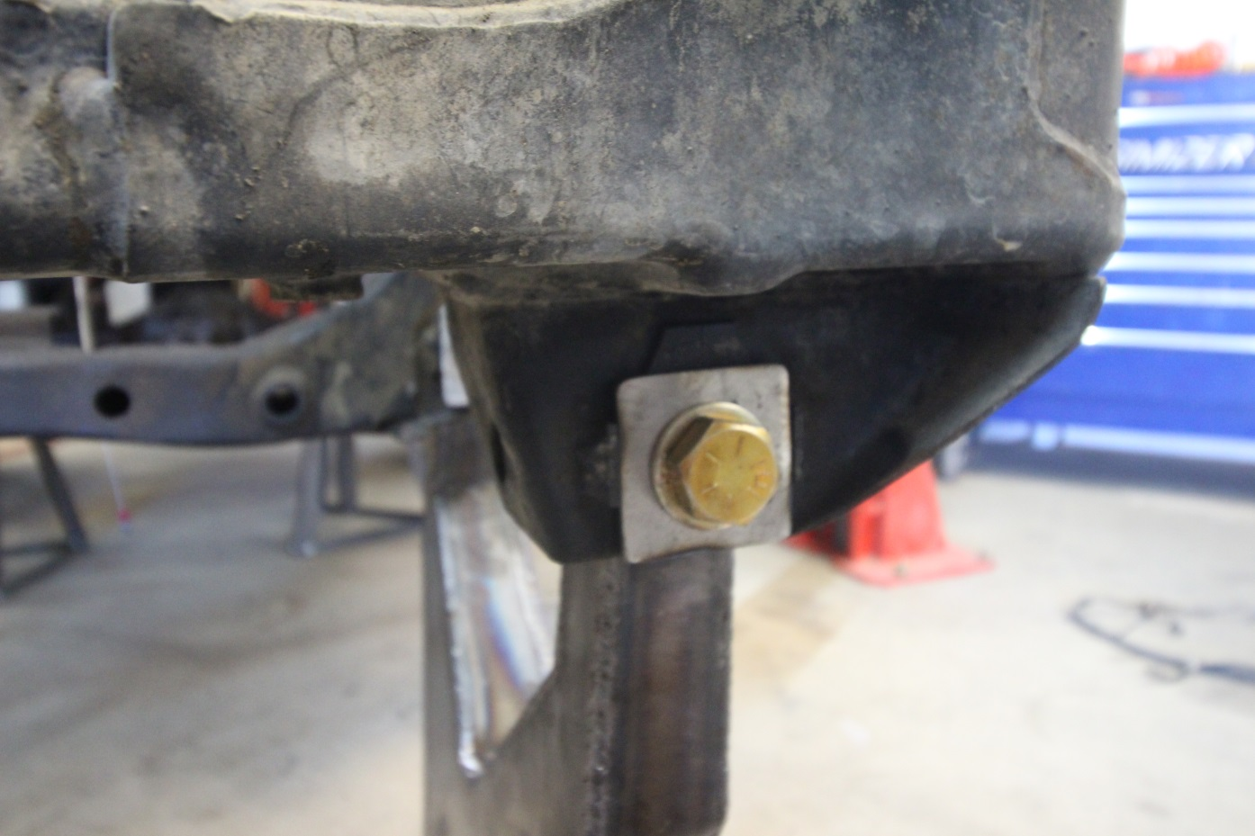

Step 30: Put the LCA on a jack stand so the lower uniball is fairly level with the ground side to side. Next is to Install the upright spindle assemble.
Step 31: Get the ¾” Bolts that are correct length with supplied washer and Nut to attach the Spindle to the LCA Uniball. Get the 2 pairs of 1.5” Uniball Misalignments Spacers. I always put antiseize on the misalignments before installing them into uniball so they will be easy to remove in the future. I use Revlock Copper Antiseize but any antiseize will work upon removal in future.
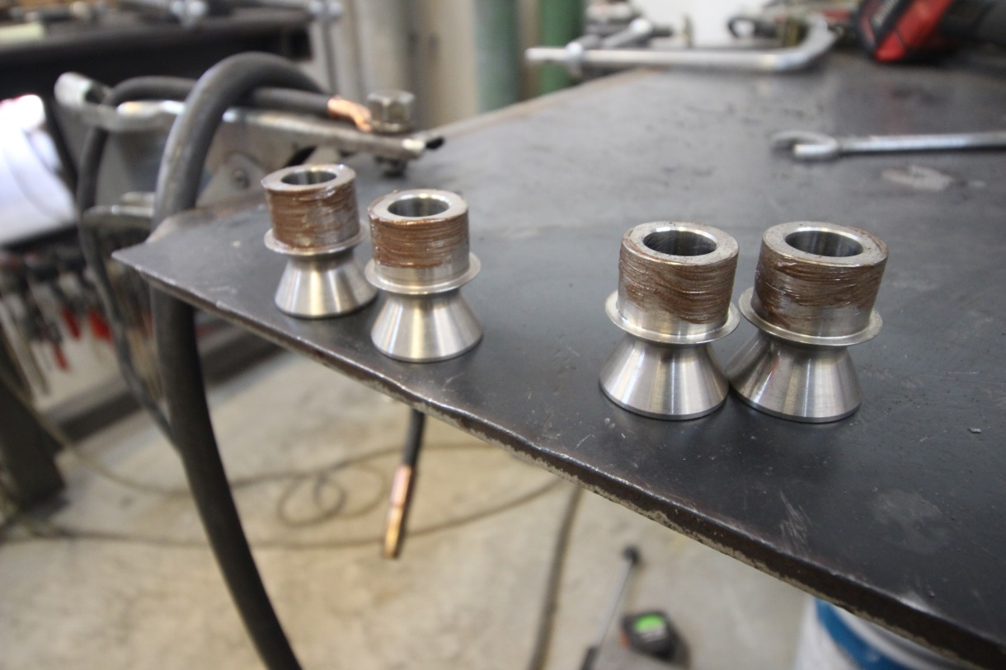

Step 32: Install the Spindles onto the LCA with the steering tabs towards rear of truck so the tie rod will be able to connect. Also you will notice the side of the spindle with steering arms attach to it is flat, and front of the spindle is bent towards rear of the truck.
Step 33: Next step is to install the UCA onto the spindles. Before doing that you need to install the 7/8” heims into the UCA. You need to fully thread the jam nuts onto the heims until it won’t screw on anymore. Then thread them into the UCA until it bottoms out. Once they bottom out. Unscrew the UCA heims 4 full turns so they are all out the same amount for next step. Hand tighten jam nut against the UCA bung to keep them all oriented correctly

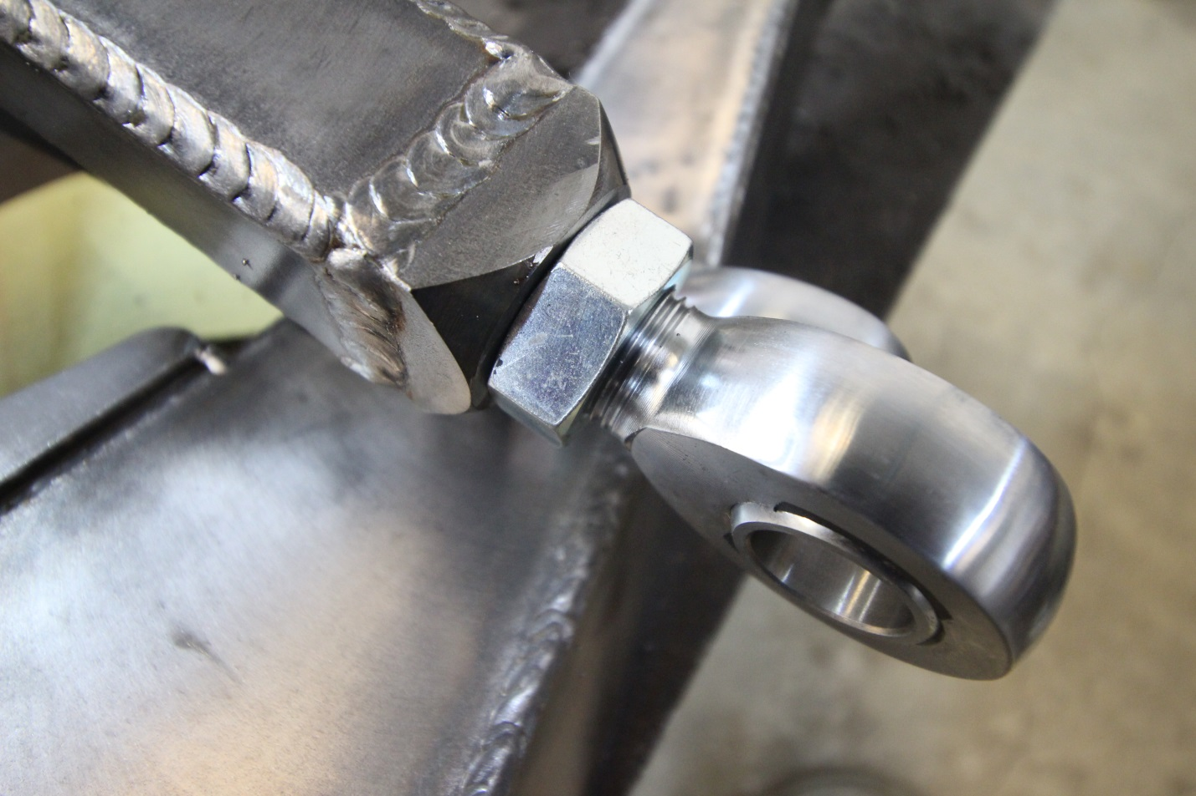

Step 34: Now that Spindles are installed onto LCA. You can install the 16-10 High Misalignment Spacers into the upper uniball. Then bolt on the UCA onto the spindle with the supplied 5/8” bolts, flat washers and nuts.
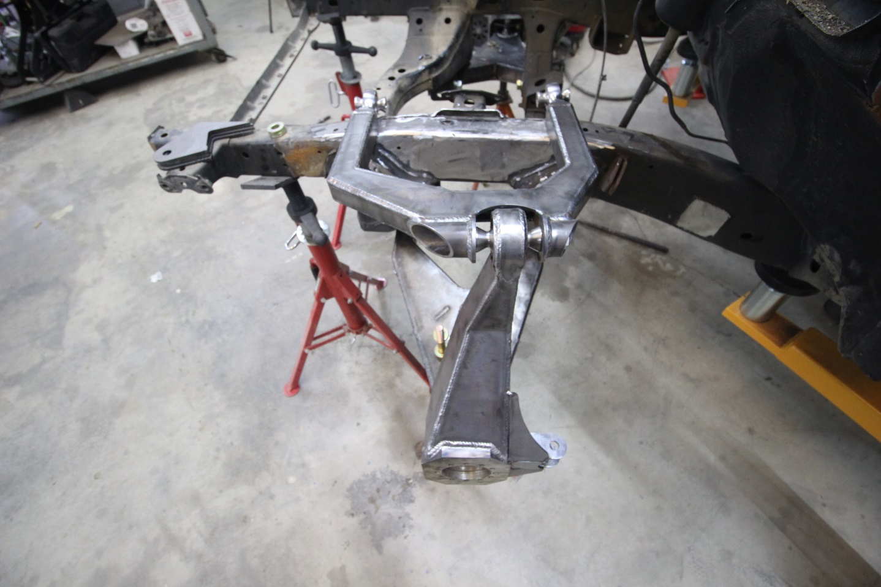
Step 35: Once UCA is installed onto spindle on truck it is time to install the 14-10 misalignment spacers into the UCA heims. Again apply some antiseize and install them into the heims.
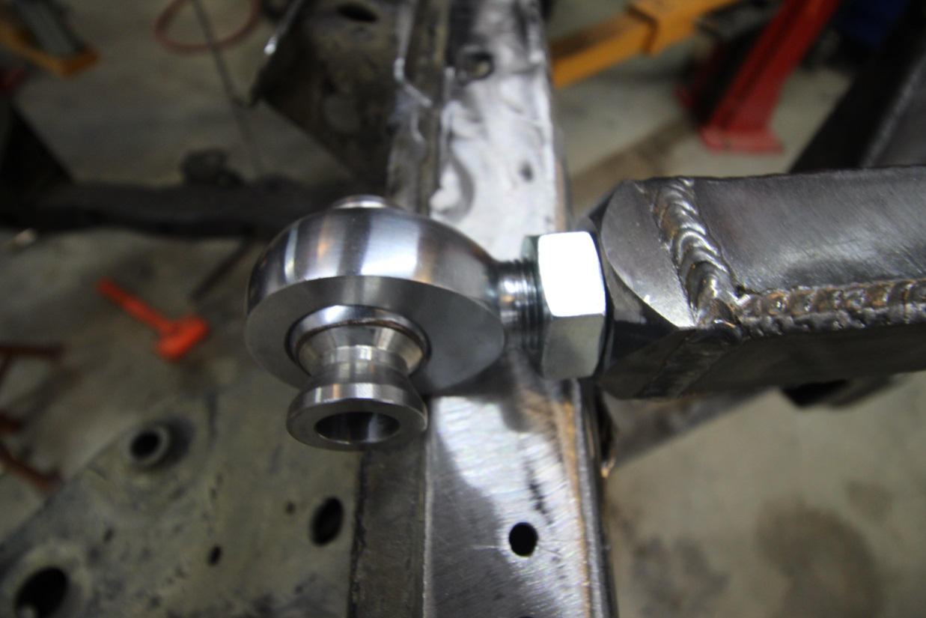
Step 36: Next install the UCA tabs that weld onto the frame. There is 8 tabs provided with the kit. 2 of each tab. You will notice on the back side of the tabs there is 1, 2, 3 or 4 notches. This signifies where they go onto the truck. The tab with 1 notch goes in very front, Then 2 behind that, 3 on front side on rear heim and 4 at very end. 1,2,3,4 in that order from front to back. Install these with a long piece of 5/8” all thread, available at local hardware store, to assure they are all square and correct spacing.
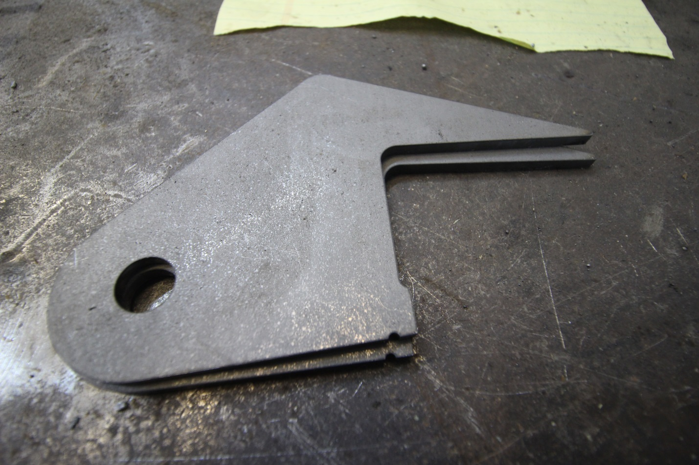
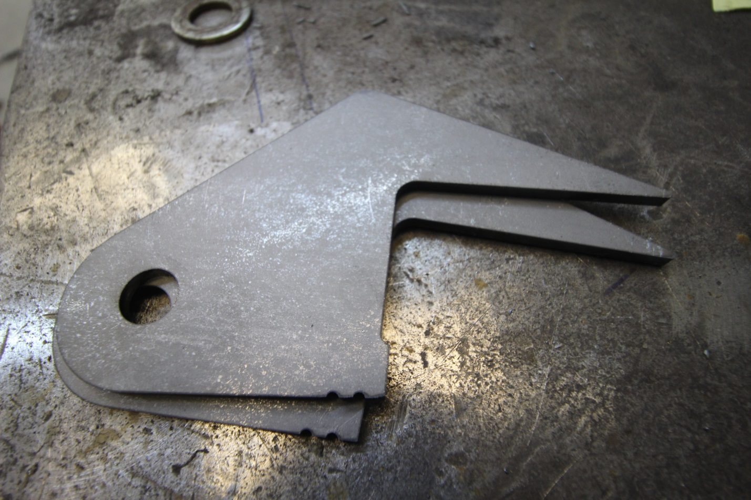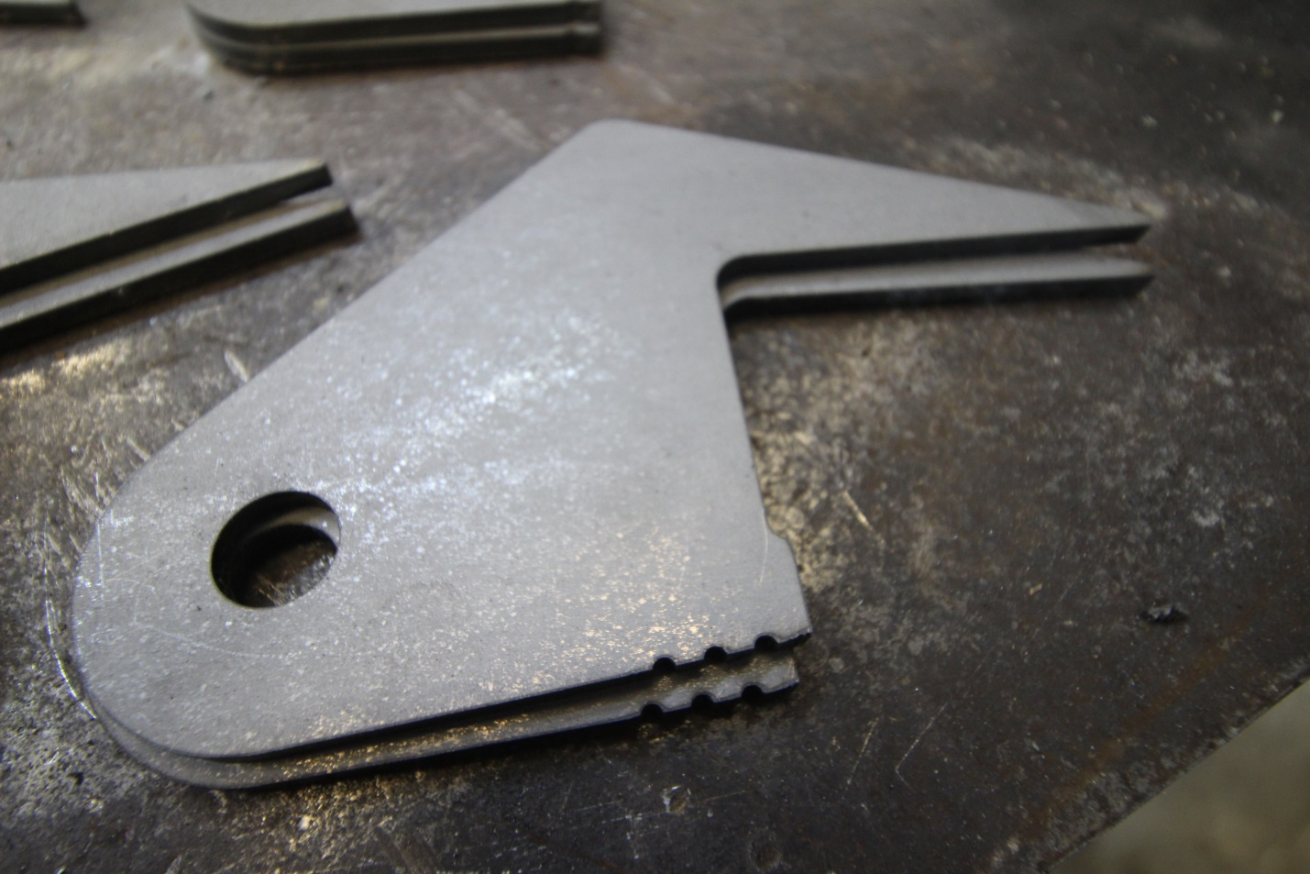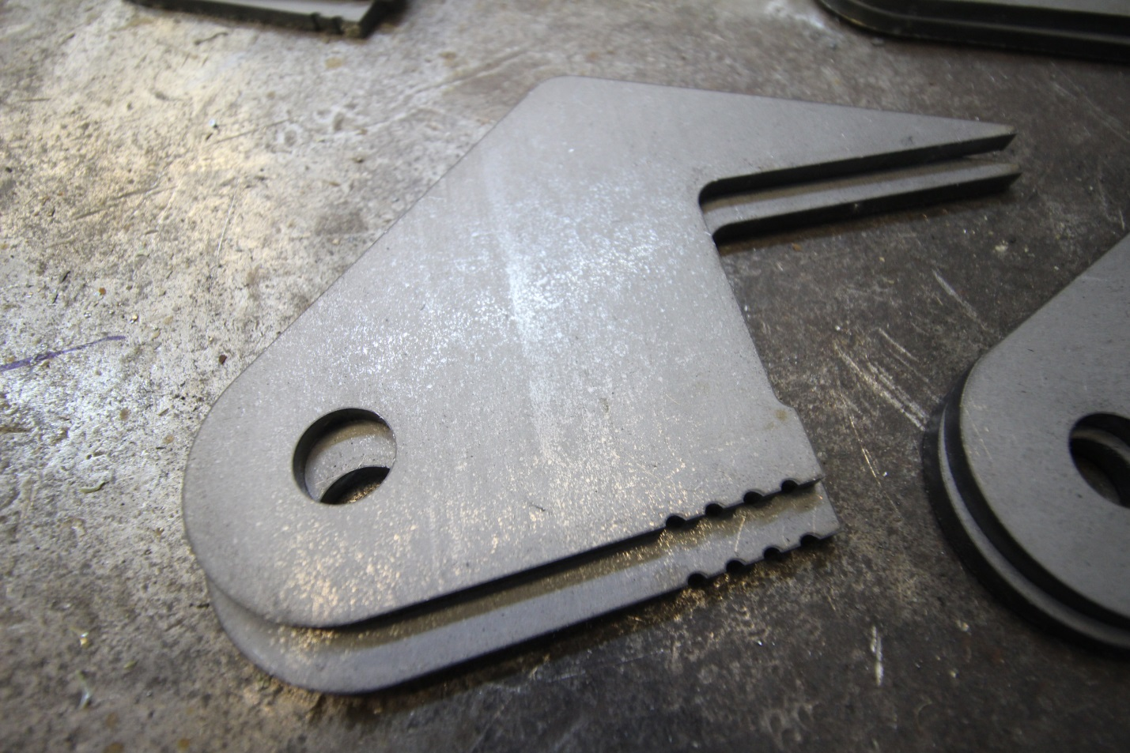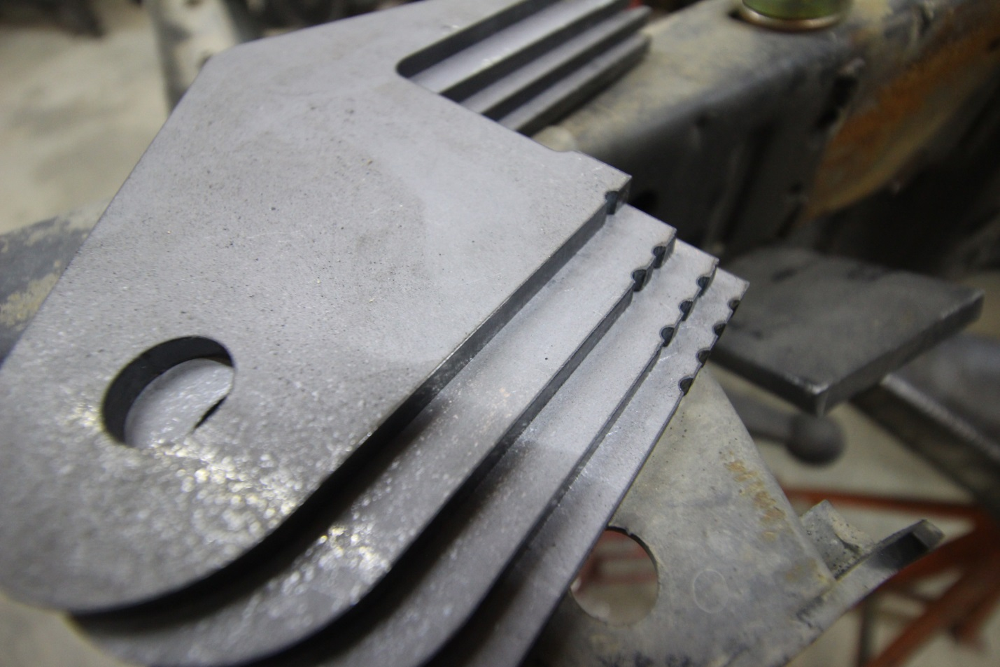
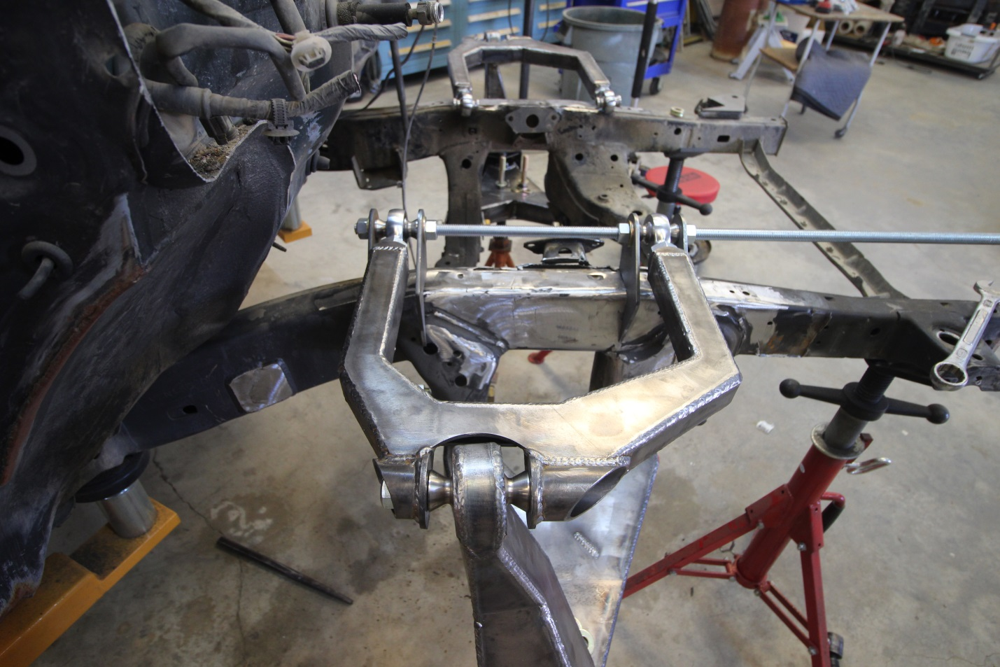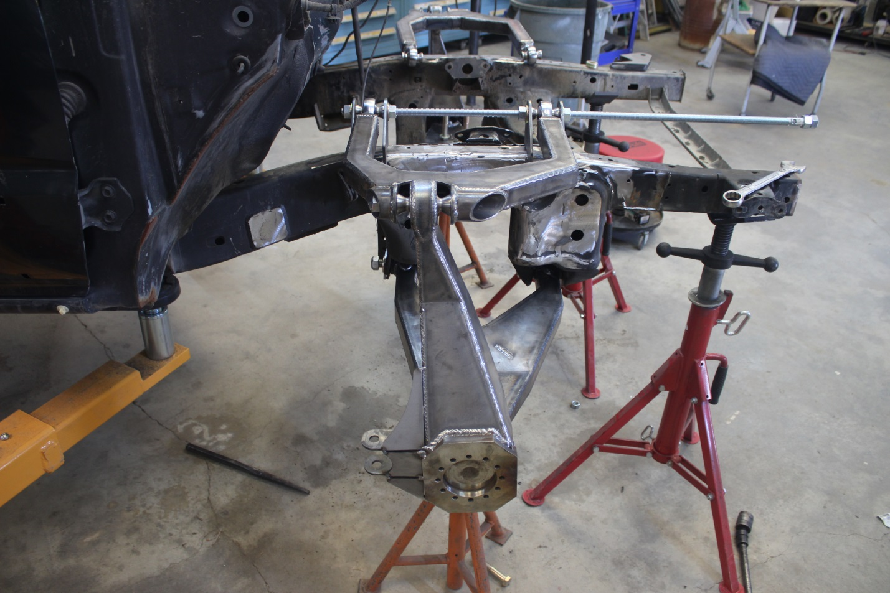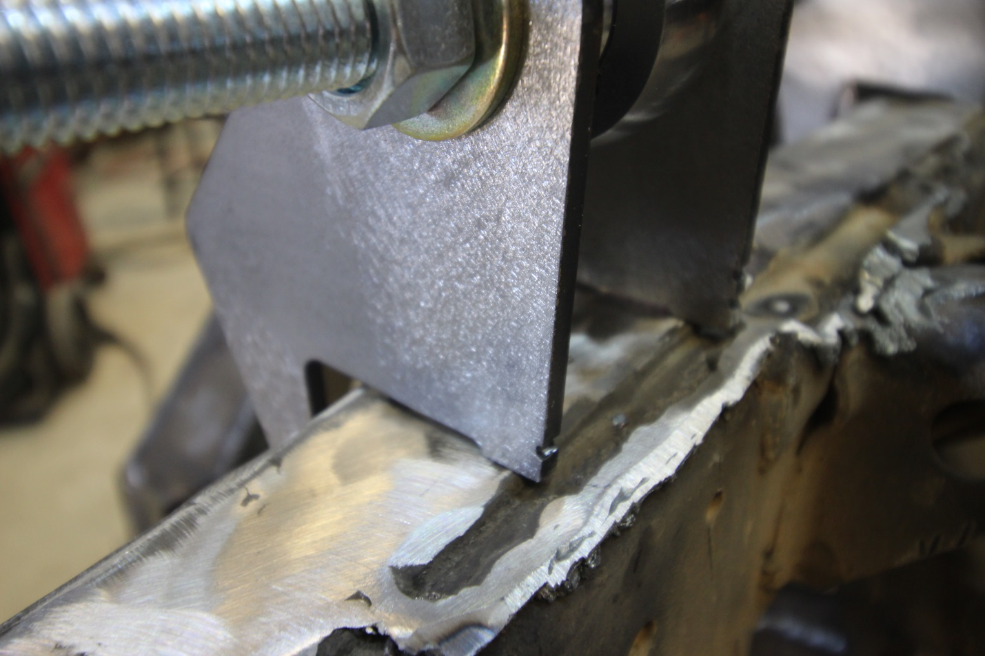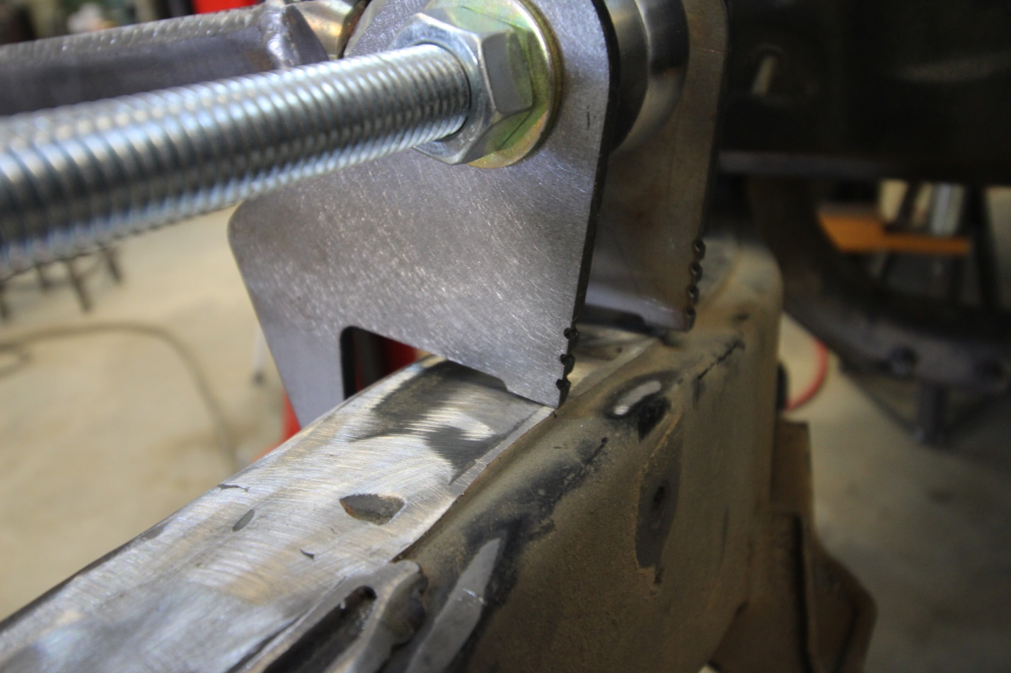
Step 37: Now to get UCA placement on the frame it is done as easy as possible. You need a digital angle finder and a piece of square tubing or a level. Put level against the bottom of the frame under the cab. Extend the level so the end sticks out past the frame for you to put the digital angle finder ontop of it. 0 it out.
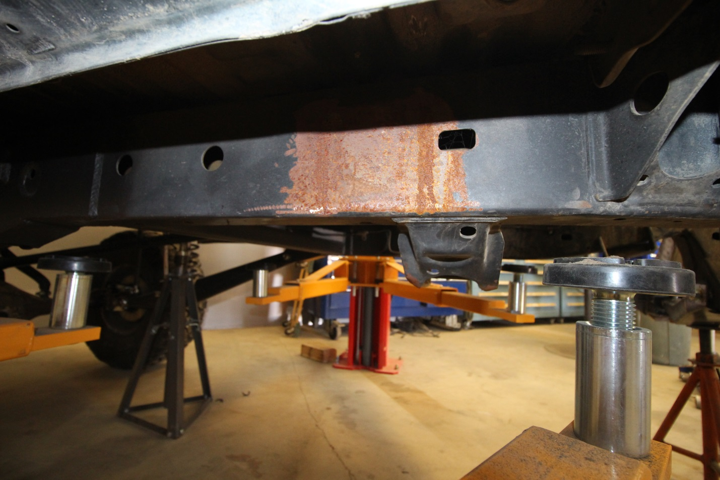
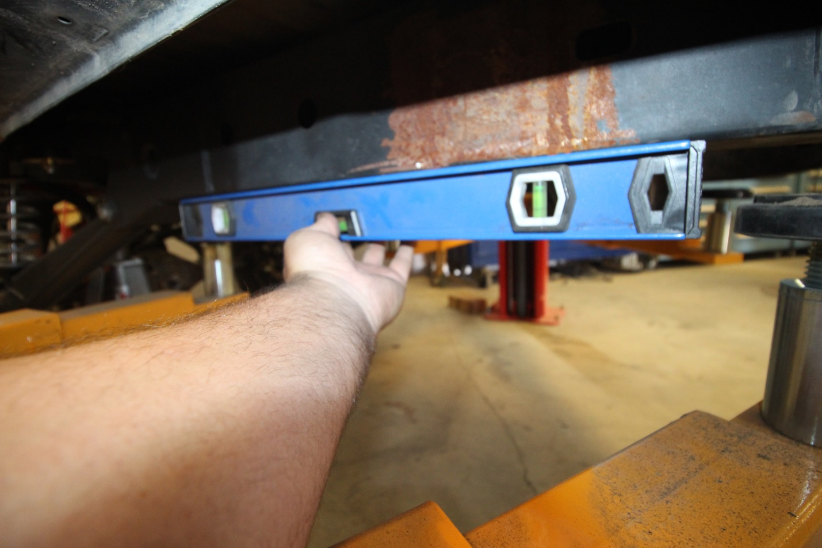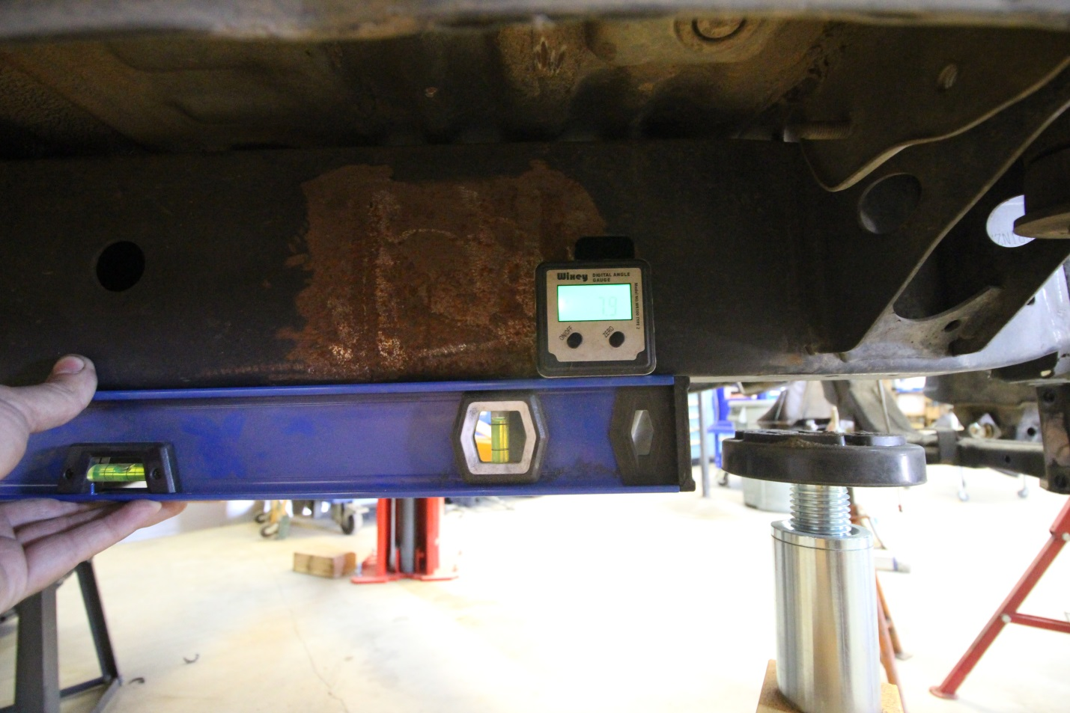
Step 38: Now that the angle finder is 9 off the bottom of the frame you need to put that angle finder on the backside, flat part of the spindle. Than adjust the angle the spindle is sitting to be 90 degree from bottom of the frame. I use a c-clamp onto spindle to get more leverage to angle it easier.
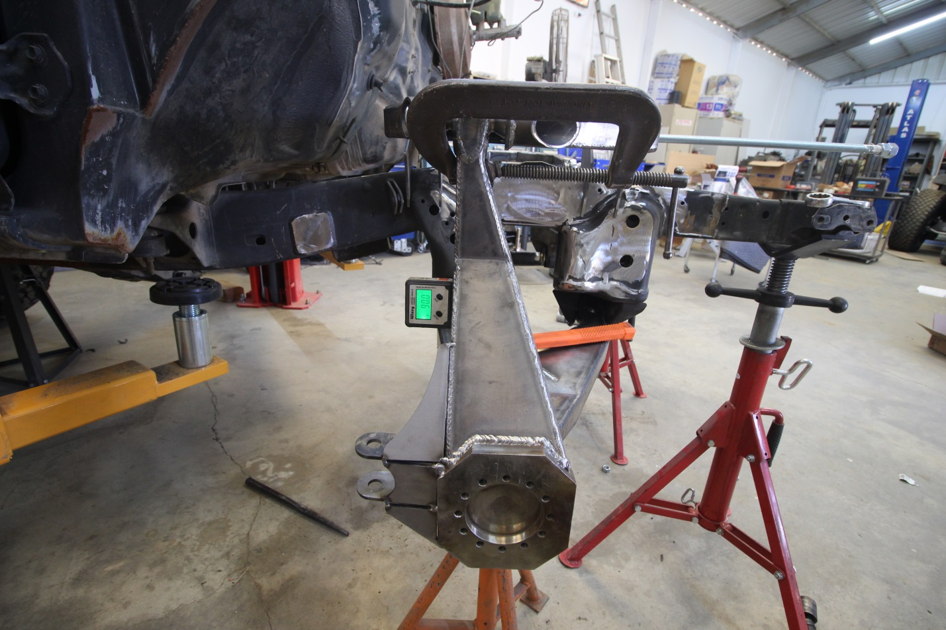
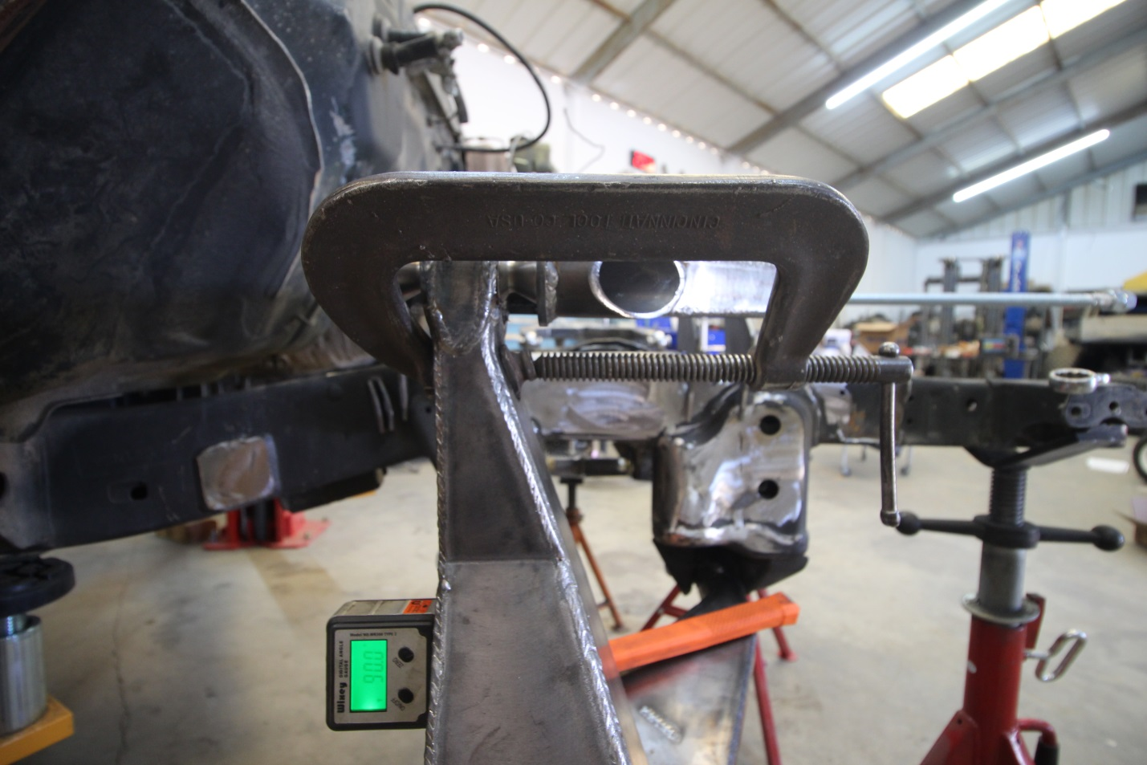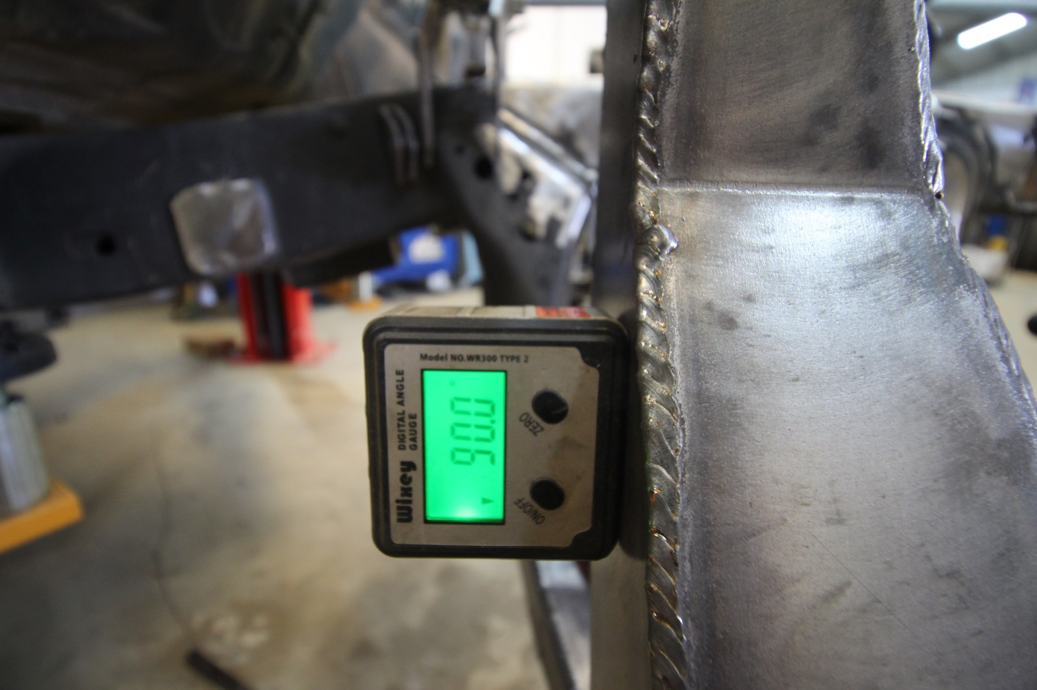
Step 39: Now that you got the spindle 90deg to bottom of the frame, tilt the UCA in/out as necessary to get the uca tabs to sit down flat ontop of the frame. The UCA tabs will not sit perfectly onto the frame since the legs that wrap down the side will hit the factory pivot gussets.
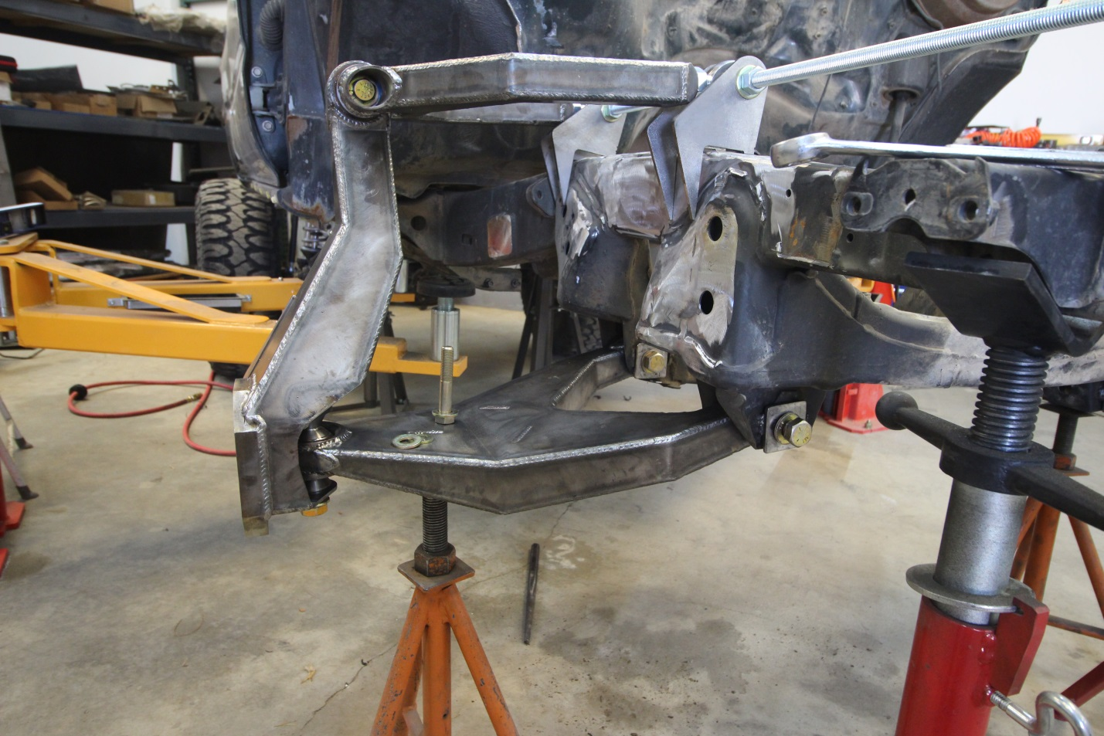
Step 40: Now the UCA tabs are sitting roughly ontop of the frame and down the side. The legs that wrap the frame hit the factory metal on side of frame. You will need to mark and cut those tabs to fit the factory frame. To get correct notching necessary you need to ensure the spindle is straight with side of truck, not turned any noticeable amount. I put a straight edge on snout block face of spindle and turn to adjust where it looks to be in line with door/rocker
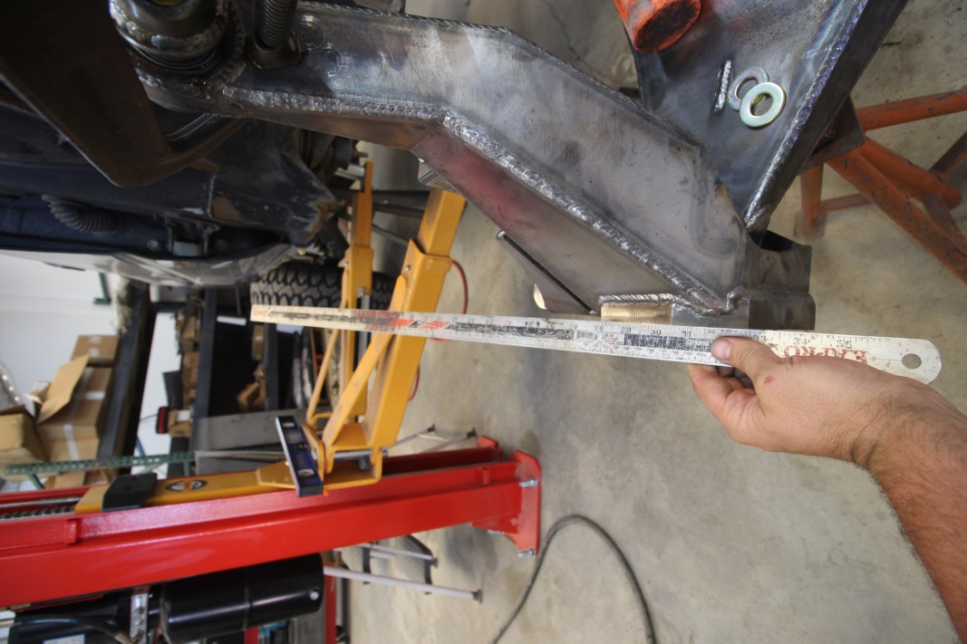
Step 41: Now that spindle is oriented correctly in relation to turning, you need to ensure the UCA is square with that. To do this I measure the front edge of uniball cup to inside of UCA tabs on each side and adjust until even.
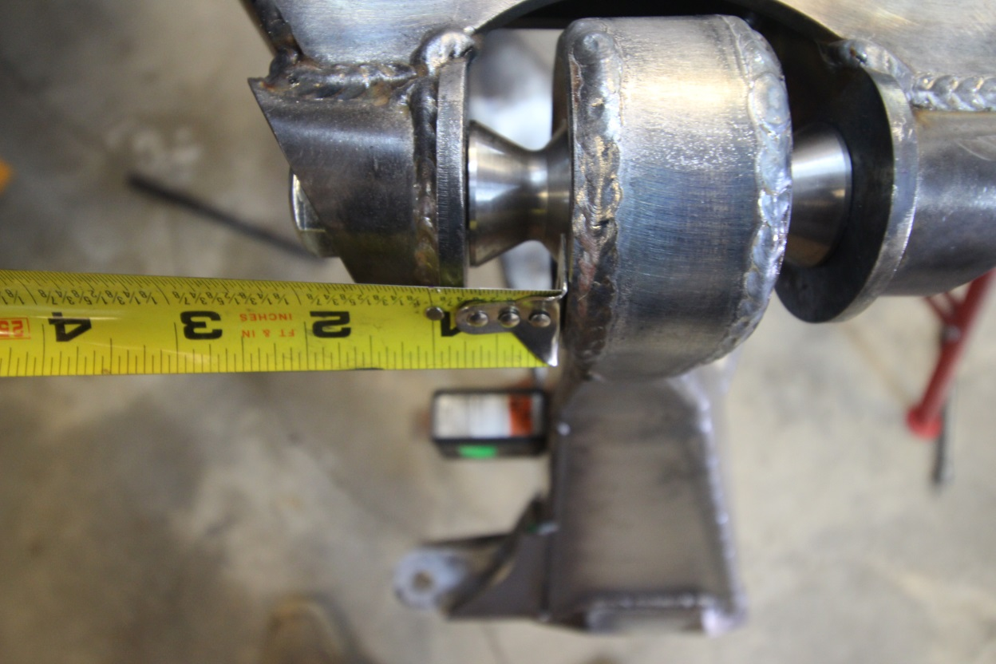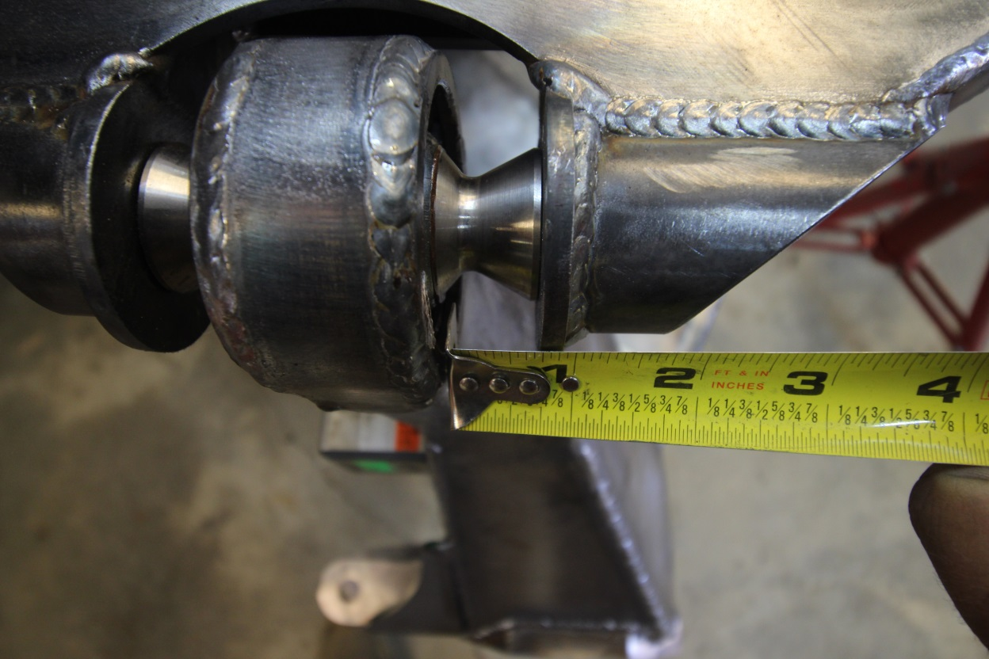

Step 42: Now that the UC and spindle are correct. Double check that steps 40 and 41 are good. Sometimes when adjusting step 40 it will change step 41 or vise versa
Step 43: Everything is correct now mark the UCA tabs for the notch to allow both sides to sit flat against the frame.
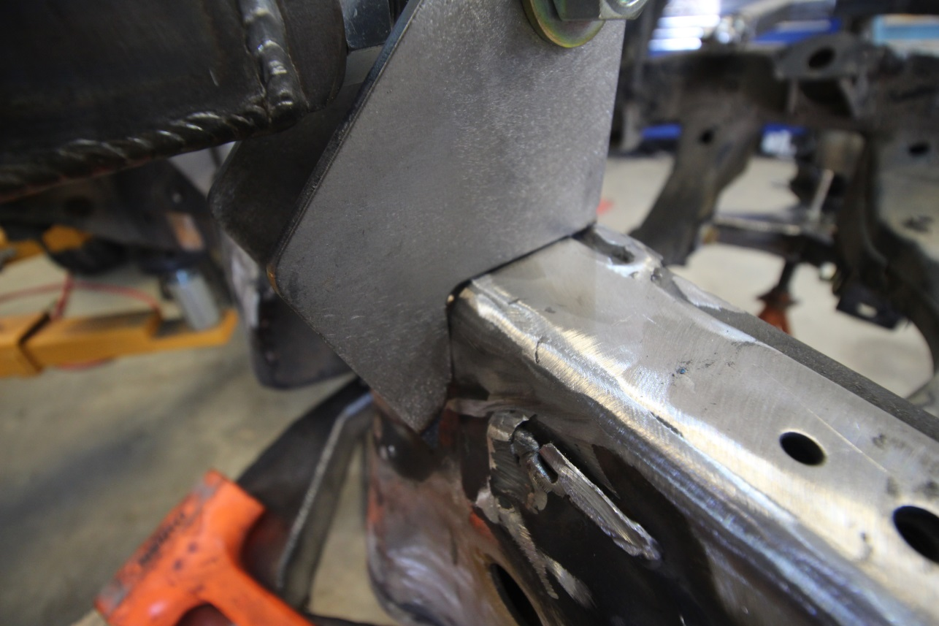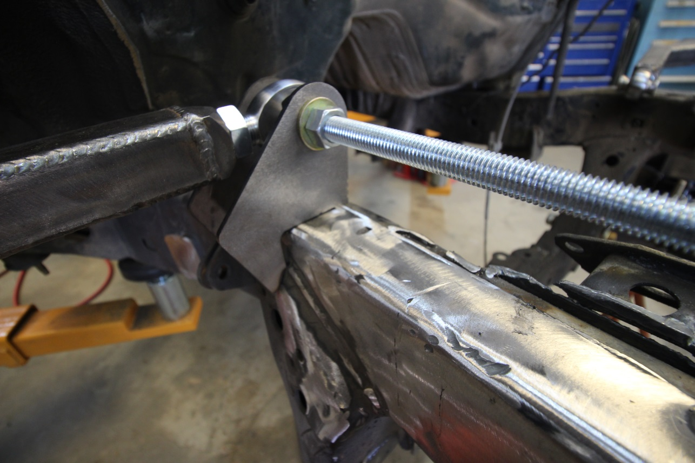
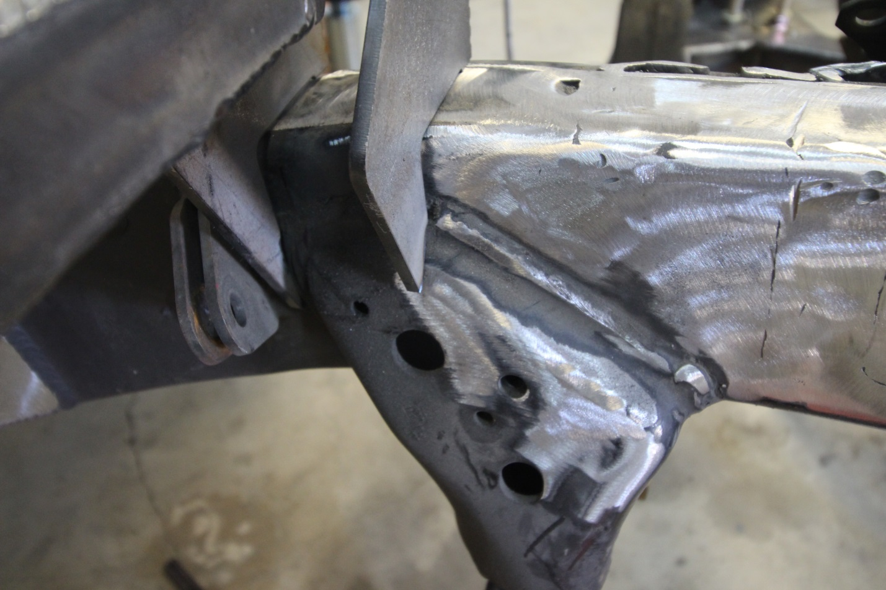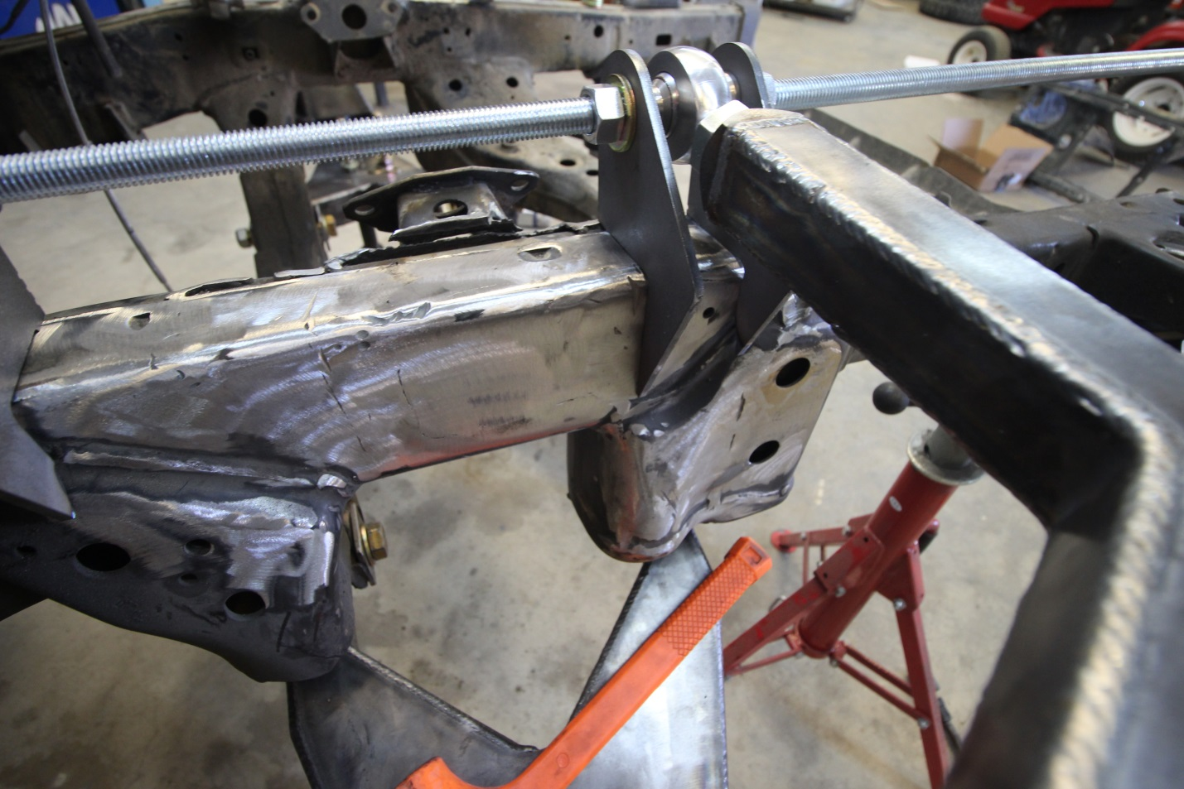
Step 44: Once UCA tabs are notched and if necessary grind the notch on bottom of the tab closer to bolt to ensure that they sit flat against the top AND sides of the frame.
Step 45: Repeat Step 42: Now that the UC and spindle are correct. Double check that steps 40 and 41 are good. Sometimes when adjusting step 40 it will change step 41 or vise versa
Step 46: Now tack weld the rear UCA tabs in place
Step 47: Test fit the tower between the UCA tabs since that is where it goes and the UCA bolts index the tower in correct position
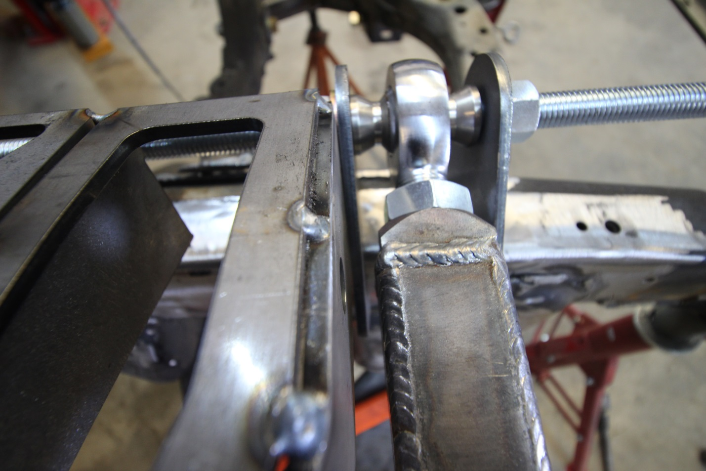
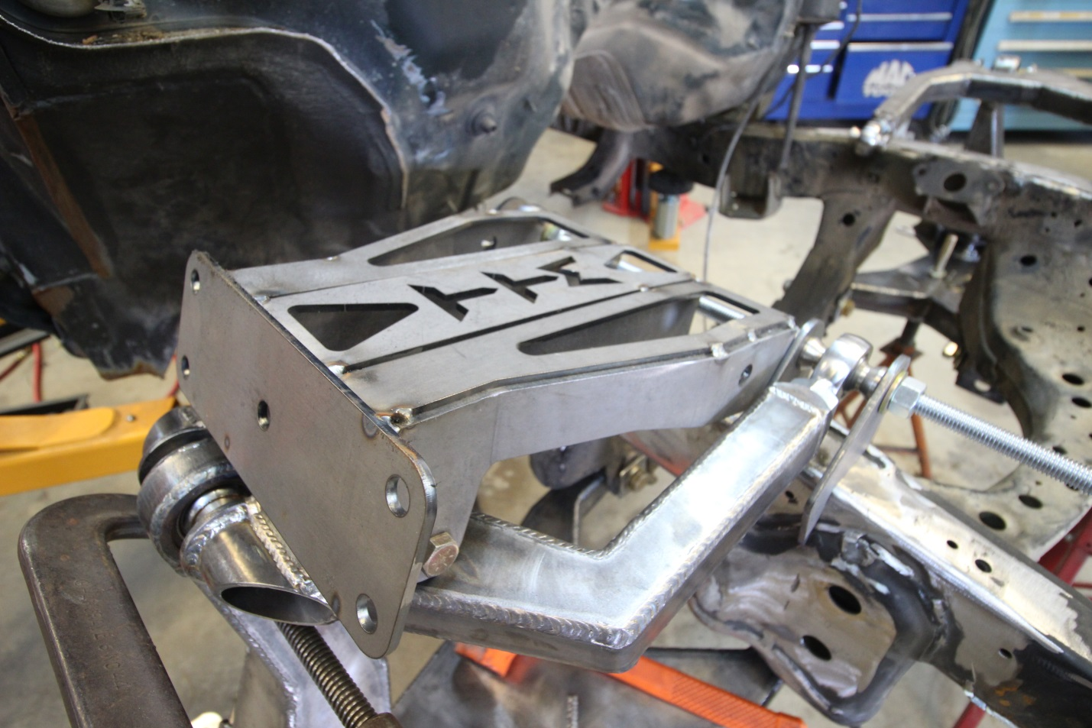
Step 48: If the Tower doesn’t fit between the UCA tabs, loosen the front nut holding the front UCA tabs tight to the heim. Then using 2 wrenches turn the inner nut on the front UCA heim so that the UCA will spread in width. It usually doesn’t have to spread much since they are welded in a fixture BUT they sometimes shrink ¼” or so closer together. Once spread correct amount tighten front tab against the heim again. Then tack the front UCA heim tabs in place
Step 49: Before removing the piece of all thread from the UCA mounts. You need to put something between the UCA to keep it from spreading back in and bending the tabs you just tacked in place. I use a bottle jack from a stock vehicle to keep it in place.
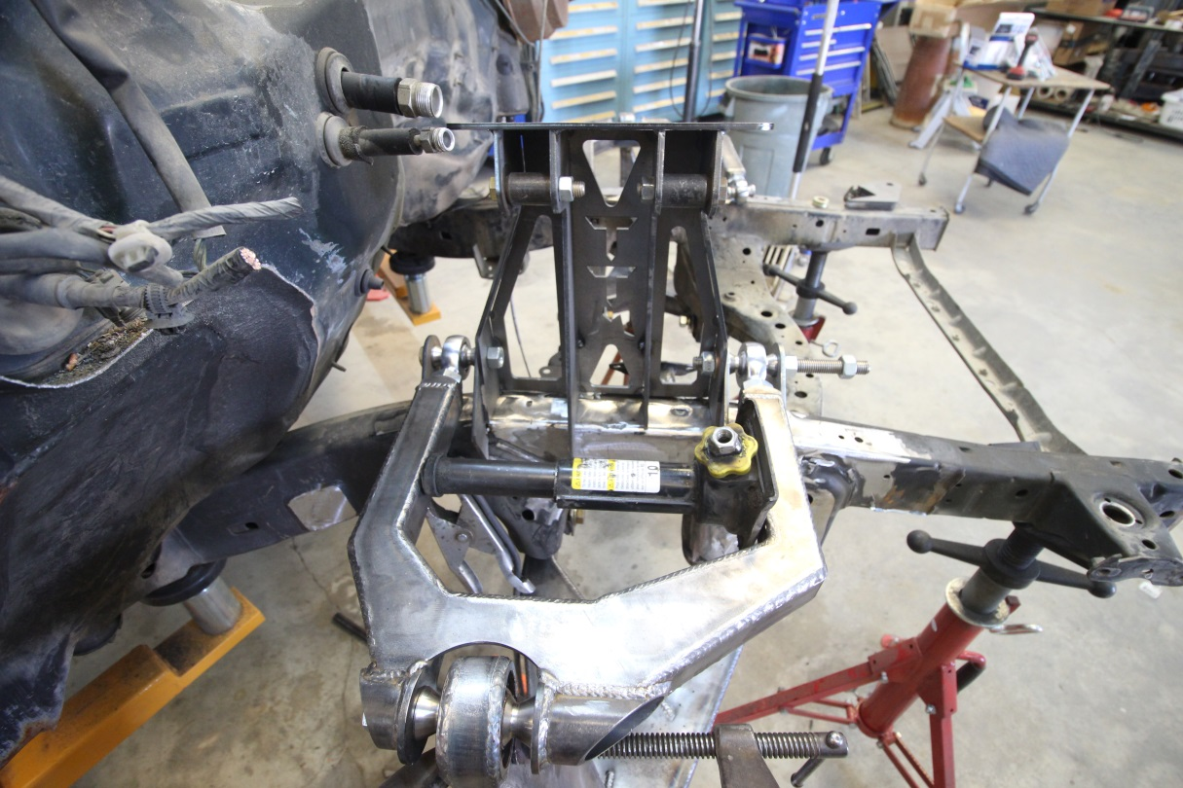
Step 50: Once bottle jack is in place to keep UCA spread at correct width it is time to remove the piece of all thread.
Step 51: Once all thread is removed test fit the shock towers and grind anywhere needed to get the UCA bolts to line up with the tower.
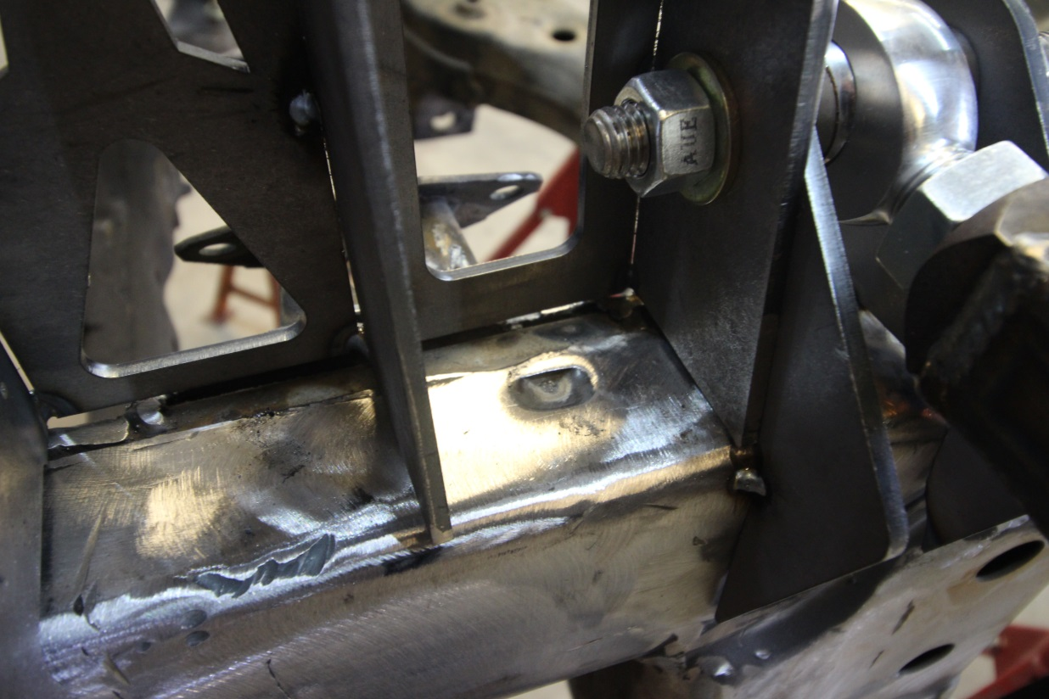
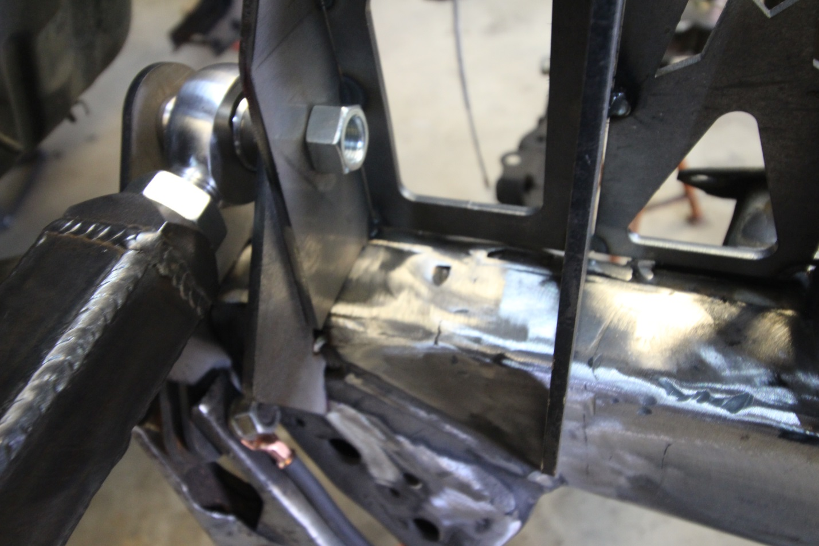
Step 52: Once towers are test fitted you can remove and full weld them. I also paint them everywhere but the areas where it is getting welded to the frame and inner UCA tabs.
Step 53: Fit towers back onto truck. I then tighten the UCA bolts BUT I use not toplock nuts from my own supply. The all metal top lock nuts are only good to tighten once or twice before needing to be replaced. Fully weld the UCA tabs where you can without putting too much heat into the heims andr have a wet rag to cool them off after welding just incase anyways.
Step 54: After welding what you can remove the UCA from the truck so you can install the UCA tab gusset pieces. Before installing the gussets you need to install a spacer to keep the tabs the correct width so the UCA heim with spacer will be able to reinstall easily. I use a piece of all thread and 4 nuts so I can adjust the inner nuts out to make the tabs the perfect width for the UCA heim with spacers to fit. To test the width you can use the tie rod with the 7/8” outer heim and mis spacers, since they are the same as the UCA. Once width is confirmed correct it’s gusset time.
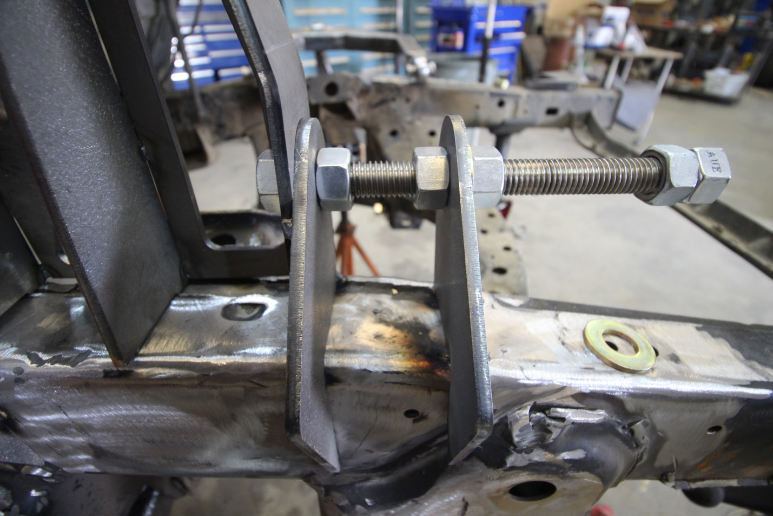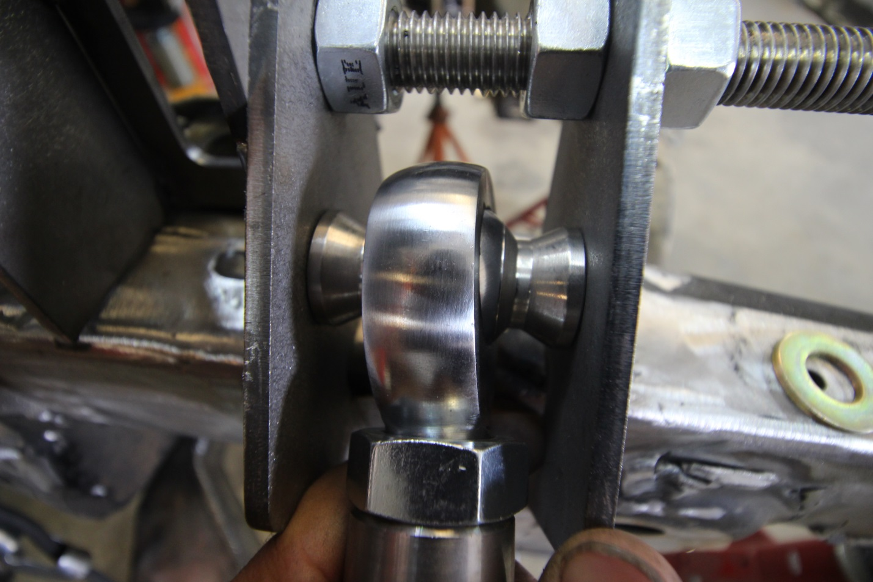
Step 55: There is 4 gussets that come with the kit, 1 for each set of pivot tabs. Tack the bottom at frame where it fits good and the top needs to be setup as an outside corner so they don’t interfere with the UCA heims. You can see there the gusset isn’t perfectly vertical since you can only weld the outer side of them to the tabs and frame.
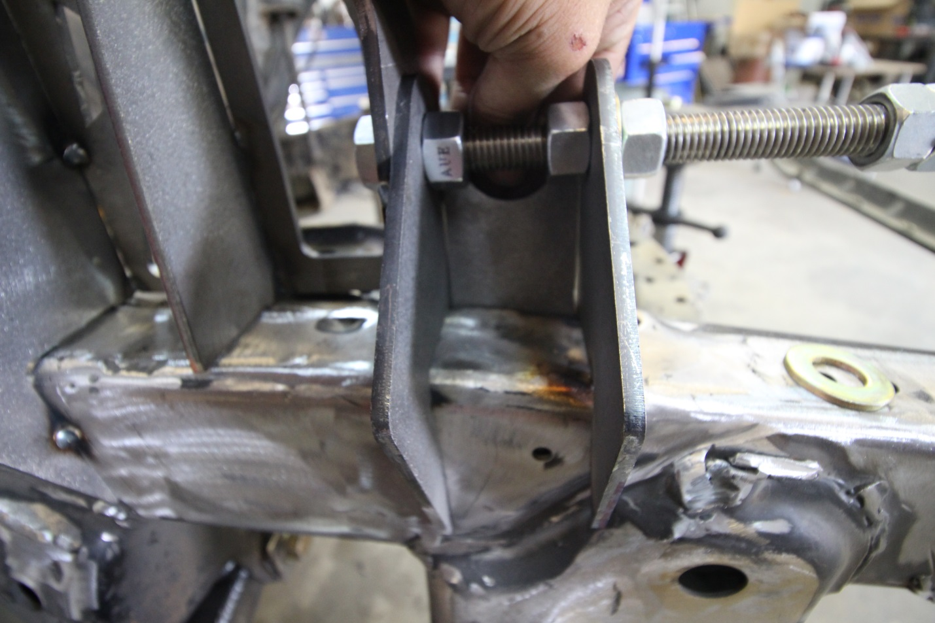
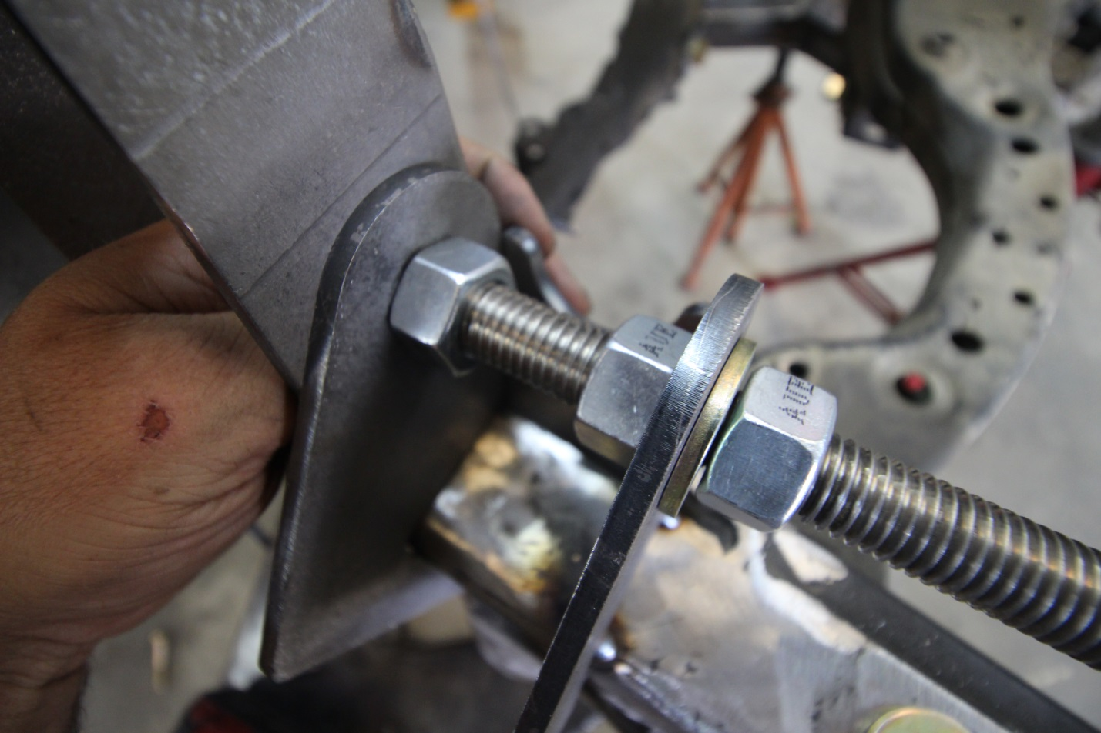
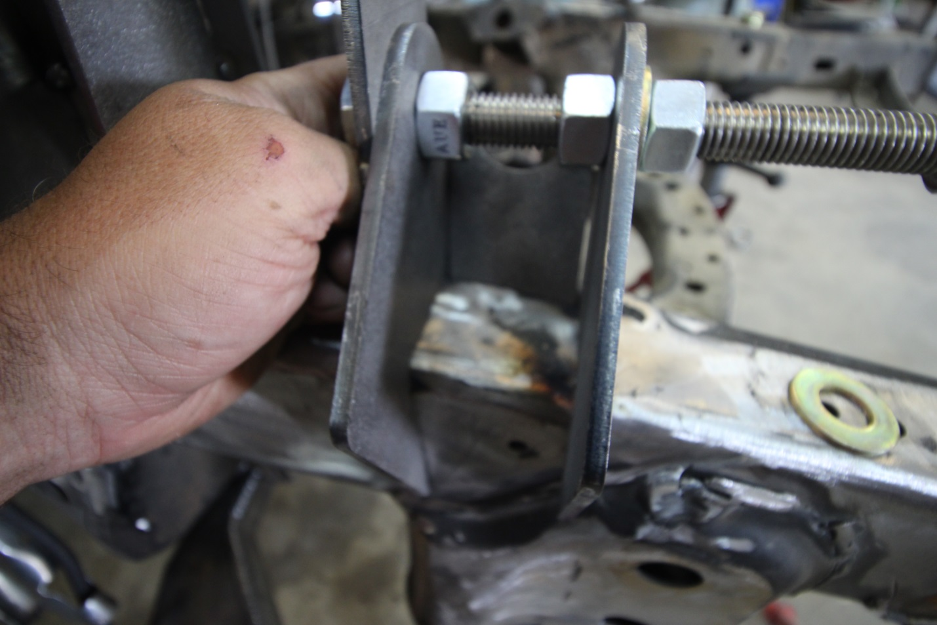

Step 54: Once everything is welded and it’s cooled off, you can reinstall the UCA onto the truck along with shocks. Before Installing the UCA into the spindle It is best to install it into the frame. I do this BEFORE the shocks as well so I can use the bottle jack to adjust the width of the uca so the heims slide in easily as well as the bolts. Loosly install the inner pivot bolts, then bolt the outer uniball to the UCA.
Step 55: Once the UCA is bolted onto the truck now you can install the shocks and cycle to install limit straps and make tabs for those and determine the length of strap you need to go from the LCA to the frame. Accounting for any stretch and I like to keep atleast 1/2” of shock shaft inside the shock which will reduce usually to ¼” of so after the straps stretch.
Step 56: Bolt on heim steering inner clevis and supplied bolts to attach to the factory rack n pinion. I also use Red Loctite on these bolts since you do not want them to come loose at all. To make the inner heim oriented correctly I use a large crescent wrench on the flat ears of the clevis. Then you can torque the bolt, Factory specs is 50 ft lbs on this. I ALWAYS put a paint marker stripe on this bolt so I can visually make sure it is tight since you can’t put a socket on it with inner tie rod installed.
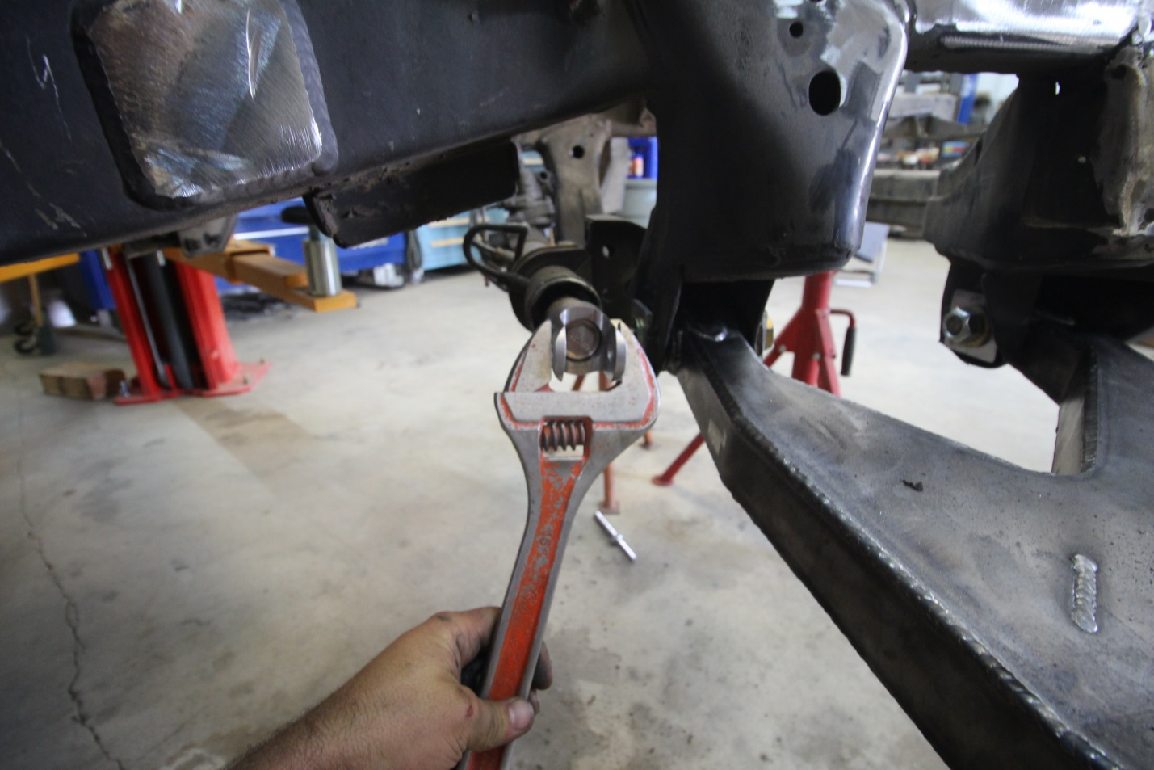
Step 57: Now you can install the supplied tie rod. It has a Left and Right hand threaded heims. The inner is the ¾” Heim. Install the supplied spacers that were included with the clevis and bolt. Then install the 7/8” outer heim with jam nut and misalignment spacers. Use provided grade 8 bolts, washers and nuts. DO NOT TIGHTEN JAM NUTS. YOU WILL NEED TO ADJUST THESE LATER TO GET PERFECT TOE ALIGNMENT.
Step 58: Now that the kit is fully welded and installed onto the truck it is time to torque all the bolts. It is critical also to double check torque on the bolts ever 2-500 miles offroad to make sure nothing has come loose. Normal prep on the desert trucks.
Step 59: The kit is fully installed now but you need to install the supplied hubs. First is to install the spindle onto the upright. Use the provided 3/8”-24 bolts to attach the spindle to upright, I use red Loctite on these to prevent from coming loose. The upright is machined so the load on the wheel/hub will be use the factory shoulder on the spindle to keep the bolts from shearing. Torque specs for the 3/8” -24 threaded Grade 8 bolts by the book is 37 ft lbs. Once spindle is installed assemble the hubs to spec. Look up on google D44 or Toyota Hubs, or if running race hubs look up from the mfg.
Step 60: Now it’s time to install the brakes. If I supplied the hubs they are designed to run the stock Tacoma Rotors and calipers. The calipers are a 12mm bolt factory BUT I run ½” bolts to attach them to the upright. So drill out the caliper mounting bolt holes to ½”. Then install the calipers onto the truck with ½” grade 8 bolts and metal top lock nuts.
Step 61: Install the provided brake lines. They connect to factory hard line and bracket at the frame. Install the new copper crush washers on the banjo bolt end, 1 washer on each side. Then tighten the steel braided line up.
Step 62: Add brake fluid and bleed the brakes. I always jack under the LCA to lift the tire then spin and apply brakes to make sure it is working correctly before driving. Do this on both sides, OR put block behind truck a couple feet and roll it back and apply brakes to make sure they work correctly.
Step 63: Double check that every nut and bolt is tight on the truck. Shocks and limit straps are installed.
Step 64: Put the wheels/tires back on the truck and set it down for the first look at your new race inspired prerunner, not done yet
Step 65: Align the front end. The upright is designed with the rear of upright at 90deg to bottom of frame you will have 7 degree’s of caster. You mainly need to adjust the camber, screwing in/out the uca heims. Then with it sitting on the ground at ride height double check the angle of frame/upright to get them even from side to side, close to 90 degree’s as possible. If both are within .5 degrees then that’s fine. If both are more than 1 degree, OR are not within a a couple tenths than adjust. I would adjust the heims in/out to get the top of the upright to move forward or backwards as needed. Once the camber/caster is fixed it’s time to adjust the toe. I personally run 0 - 1/16” Toe in if at all possible.
Step 66: Take it for a test drive down the street and make sure brakes are working as they should. Lightly turn the wheel side/side to feel how the truck leans when it turns.
Step 67: Bring it back into the driveway/shop. Give it a visual look over to make sure no leaks and that you didn’t miss tightening any bolts.
Step 69: I had to make it to step 69, because now it’s time to enjoy your new prerunner. Again recheck all bolts after 200 or so miles and then as regular prep before any offroad trip. Before any offroad trip I suggest checking the wheel bearings, all bolts including the tie rod clevis bolt, make sure the paint stripe you did on step 57 is still oriented correctly as it was when you first installed it.

Thanks for the support and enjoy your new offroad beast and the best 1st gen Tacoma/3rd gen 4runner kit on the market. Your truck is more capable offroad now and with that comes the risk of serious injury/accident. Next page is our product disclaimer. This is designed for Off Highway Use Only. Using this on the highway you are accepting any and all liability, and release that from TT Motorsports LLC Feel free to call or email if you have any questions or concerns.
Phone #: 805-878-8743
Email: TTMotorsports805@gmail.com
Thanks, Tommy T aka TT, Not Trophy Truck but you’ll feel like you have one when driving the Tacoma with this kit on it.
BREAK IN PERIOD. After every installation we recommend checking the torque of all
nuts and bolts to assure that the torque has taken after driving 500 miles. Some minor
adjustments may need to be made.
The customer assumes all responsibility for the use of all equipment and the proper
maintenance of said equipment.

Liability Release Form
“Off Road/Competition Use” Vehicles

Buyer releases TT Motorsports LLC from any liabilities (expressed or implied, arising by
law or otherwise) that may occur from the use of products sold or Fabricated by
TT Motorsports LLC and purchased by Buyer. These products are being sold for “Off
Road/Competition Use” only and may be used only on vehicles used solely for “Off
Road/Competition”. No other applications are intended or implied. The Buyer of this
product acknowledges and agrees that Seller disclaims any warranty and expressly
disclaims any liability for personal injury or damages or any damages to vehicle or
expensed occurred. TT Motorsports LLC will uphold the warranty of the manufacture of
the product sold (if any). In the event a manufacturer’s warranty exists, it is agreed and
stated that Under no circumstances shall the seller or manufacture be liable for any labor charged or travel time incurred in diagnosis for defects, removal, or reinstallation of thisproduct, or any contingent expenses.
Buyer: Please sign and date below to acknowledge that you have been made aware of the fact that the product that you are purchasing may void your vehicle’s factory warranty and you have been advised that this product is not EPA/CARB certified and could result in a fine of up to $27,500 per vehicle, and other possible penalties, and the product is for “Off Road/Highway/Competition Use” only. The Buyer will not hold any liability against TT Motorsports LLC and will hold TT Motorsports LLC harmless from any liability as a result of selling, purchasing and/or installing product.
WARNING: MODIFIED VEHICLES MAY ROLL OVER
TT Motorsports LLC aftermarket suspension products and accessories modify a vehicle
for uses which exceed conditions anticipated by the vehicle manufacturer. The uses
include the high-performance demands required during off-road. These conditions vary in the degree of extremity and cannot be controlled by the vehicle or product manufacturer.
If the components within the suspension system or accessories become worn due to
frequent and/or extreme off-road use, the safety and reliability of the vehicle is at risk.
The maintenance of aftermarket equipment to ensure the vehicle occupants safety is
entirely your responsibility. Do not purchase TT Motorsports LLC manufactured
products or components unless you are willing to accept this responsibility. Do not install any TT Motorsports LLC suspension products or accessories unless you feel competent at installing the product without causing present or future injury to yourself or other vehicle occupants; seek an authorized installation center.
TT Motorsports LLC suspension systems were designed for off-road use only. This
suspension system is not to be modified from its original design in any way. TT
Motorsports LLC is not liable nor held responsible for any injury’s or death that can
occur from off-road use or as the result of product failure. Customer/driver assumes all
liability in assuring that the suspension system is properly installed, maintained, and
operating in safe conditions. The following are guidelines for maintaining a safe
operating vehicle. Safety and reliability are our number one concern.
Visually inspect all equipment for clearance and unusual wear.
Regularly clean and inspect equipment such as suspension components, heim joints,
polyurethane bushings and all hardware. Replace items as necessary. We strongly
recommend the suspension system be installed by an authorized installation center. TT
Motorsports LLC reserves the right to warranty any components that we have determined to be product or material defective. Off-road abuse can damage suspension components.

BREAK IN PERIOD. After every installation we recommend checking the torque of all
nuts and bolts to assure that the torque has taken after driving 500 miles. Some minor
adjustments may need to be made.
The customer assumes all responsibility for the use of all equipment and the proper
maintenance of said equipment. This equipment will alter the center of gravity of your
vehicle and also the handling characteristics that you may be accustomed to. Even though your vehicle may have a wider track width it is capable of rolling over. Please wear your seat belt and demand that all passengers do so as well.
Please remember that no matter how well your vehicle is built it is only as safe as you
drive it. This equipment is designed to improve the performance of your vehicle.
INCREASING PERFORMANCE ALSO INCREASES YOUR RISK WHILE
OPERATING THIS VEHICLE. The operator must know and understand the vehicles
handling characteristics. None of this equipment is guaranteed to be free of defect or to
protect the driver or occupants from death or injury in the event of a collision. Please
drive in a safe and sane manner.

